**Board Game Project**

**PHASE-1**

**Private environment through VPC: Using the default one**

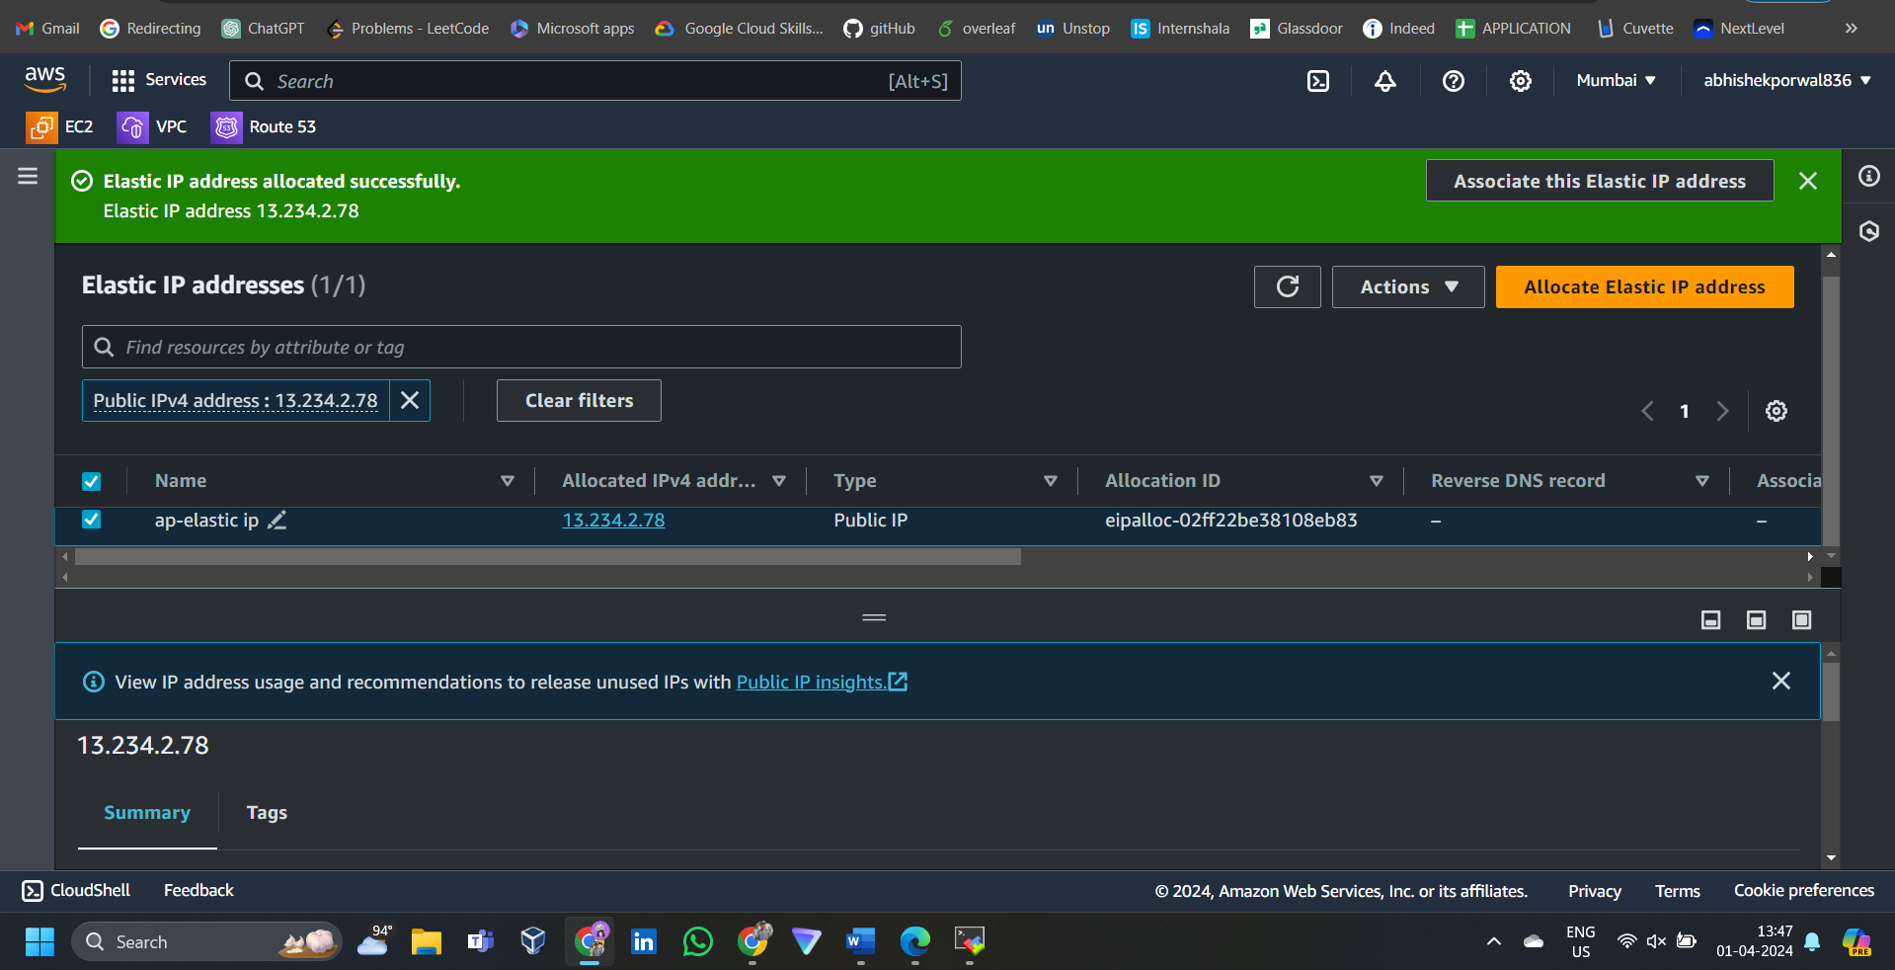

**Security Group:**

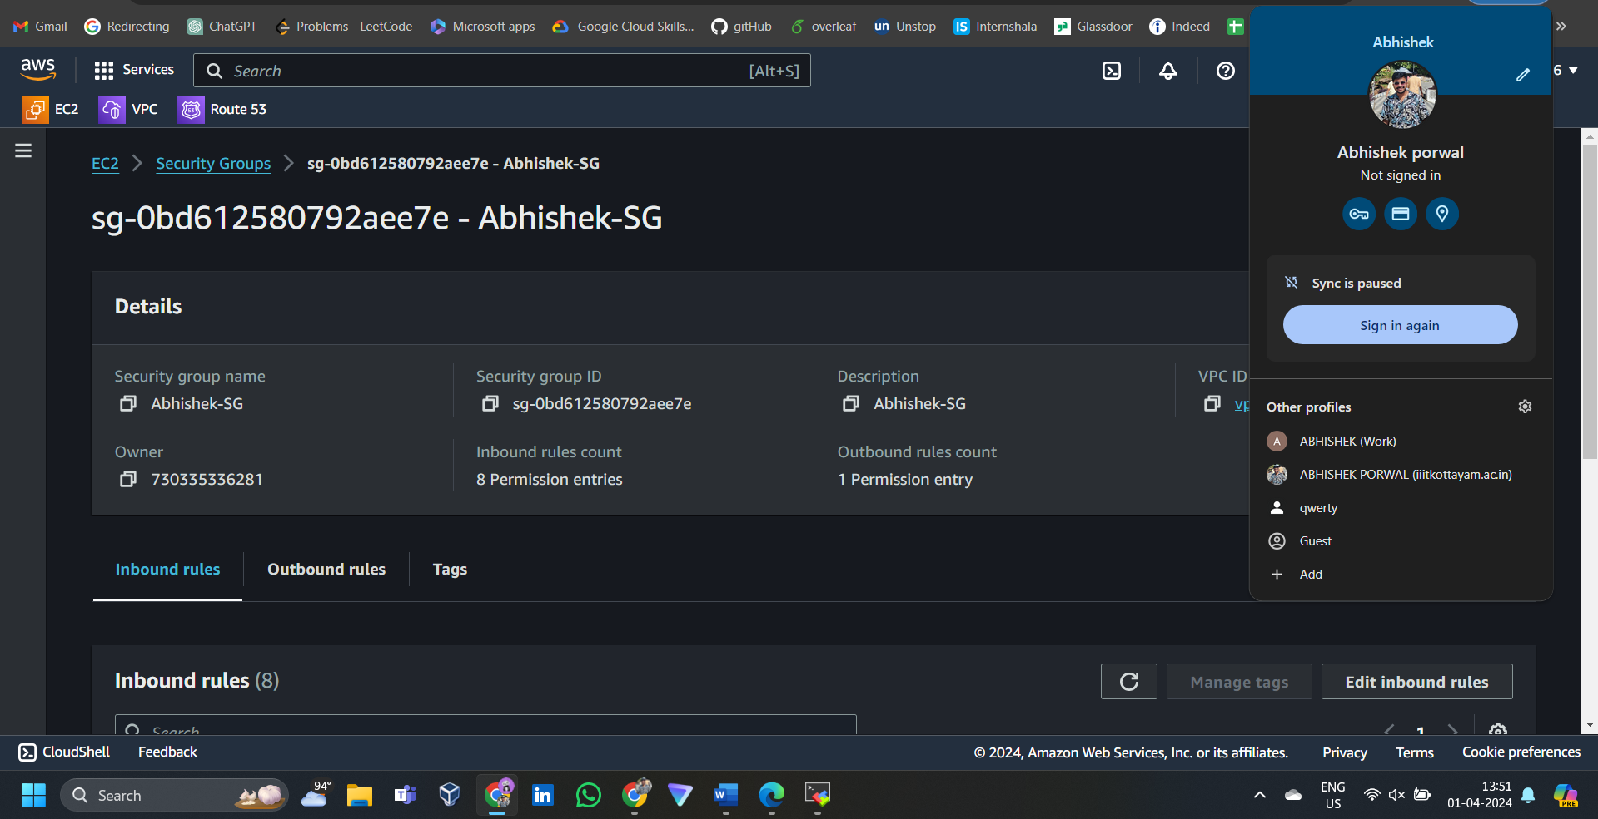

**Associate inbound rules**

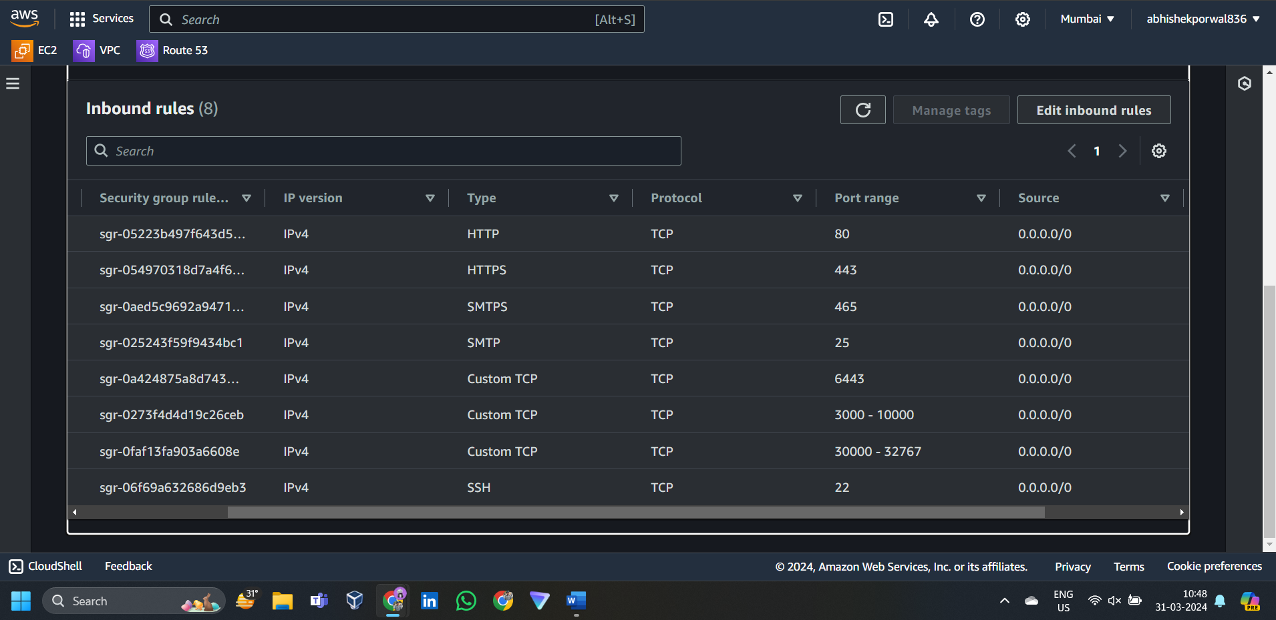

**VMs:3 vms for Kubernetes cluster:**

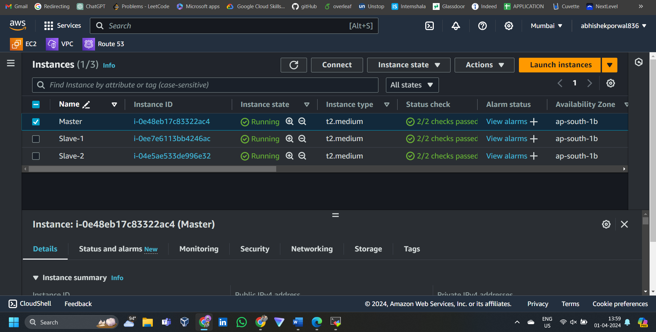

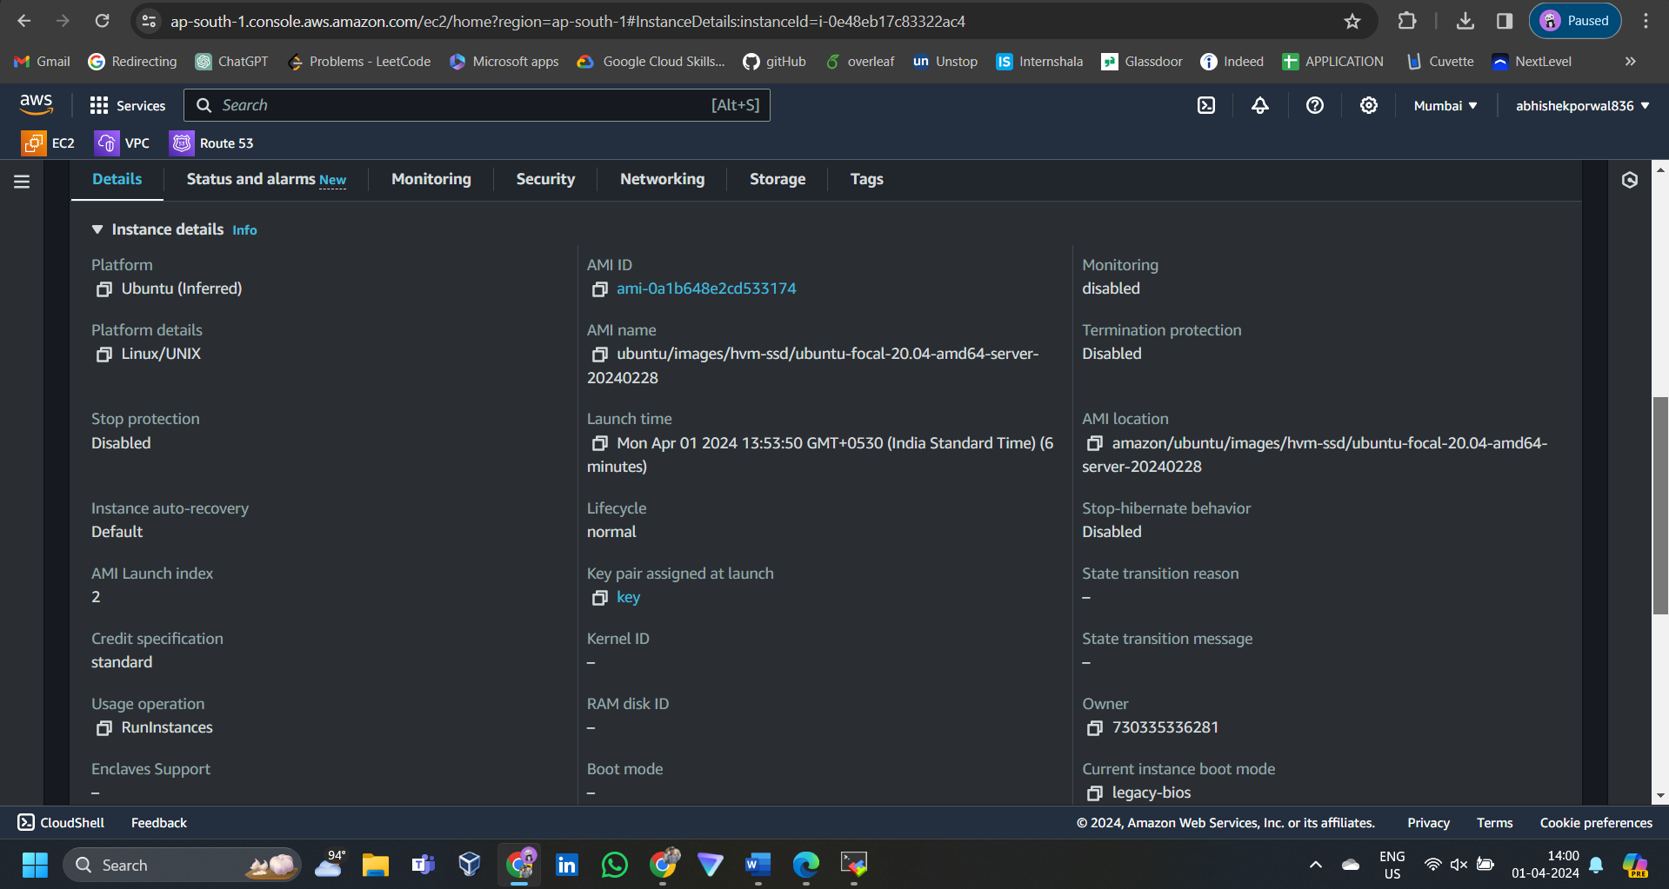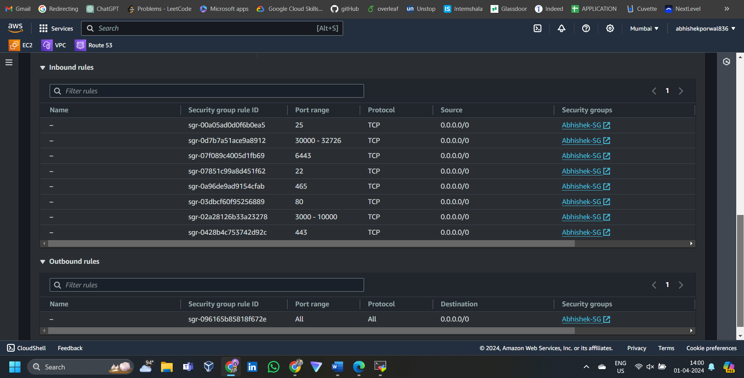

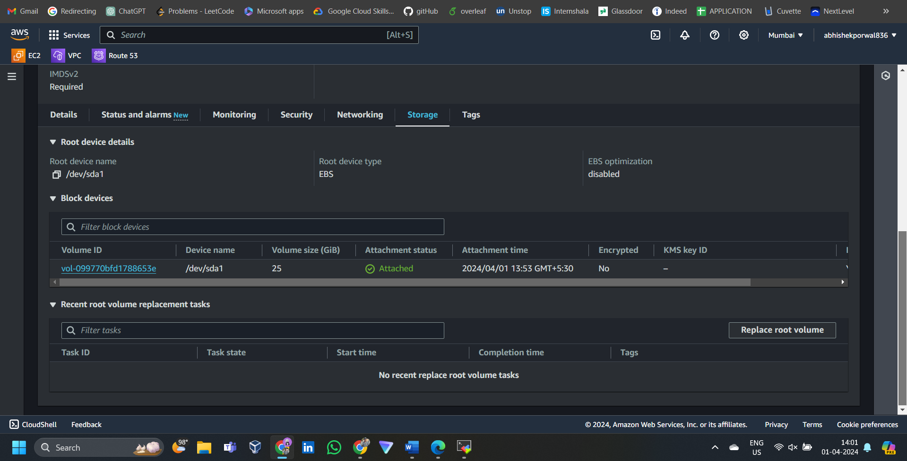

**SSH into the VM’s using MobaXterm:**

**Master-node:**

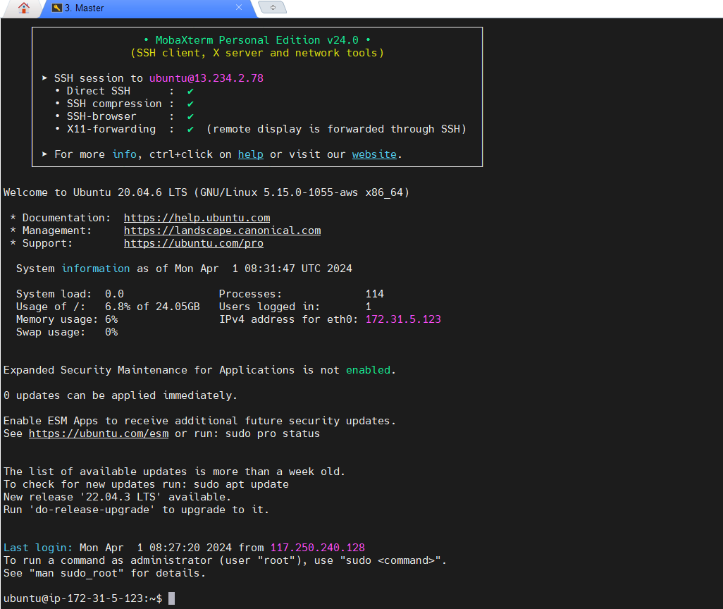

**Slave-1|:**

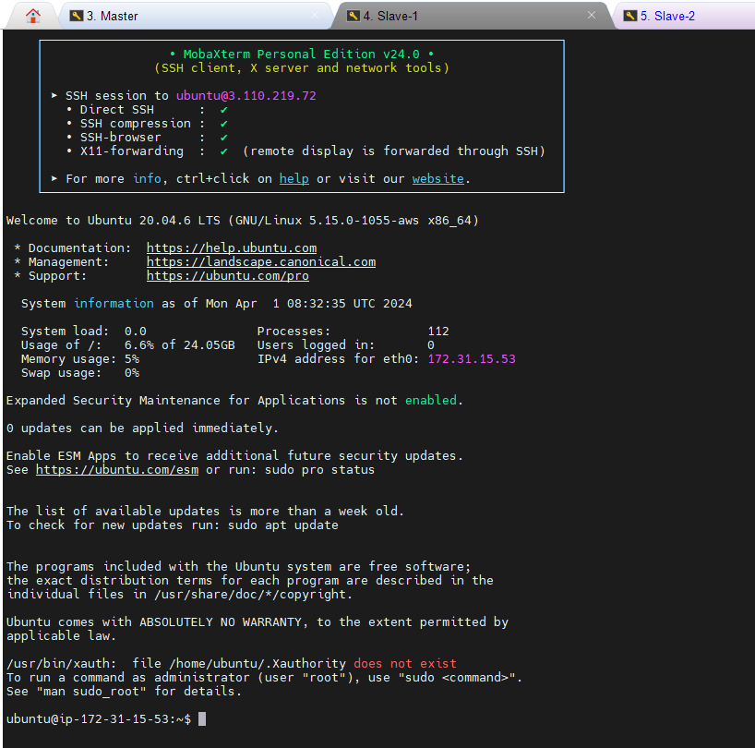

**Slave-2:**

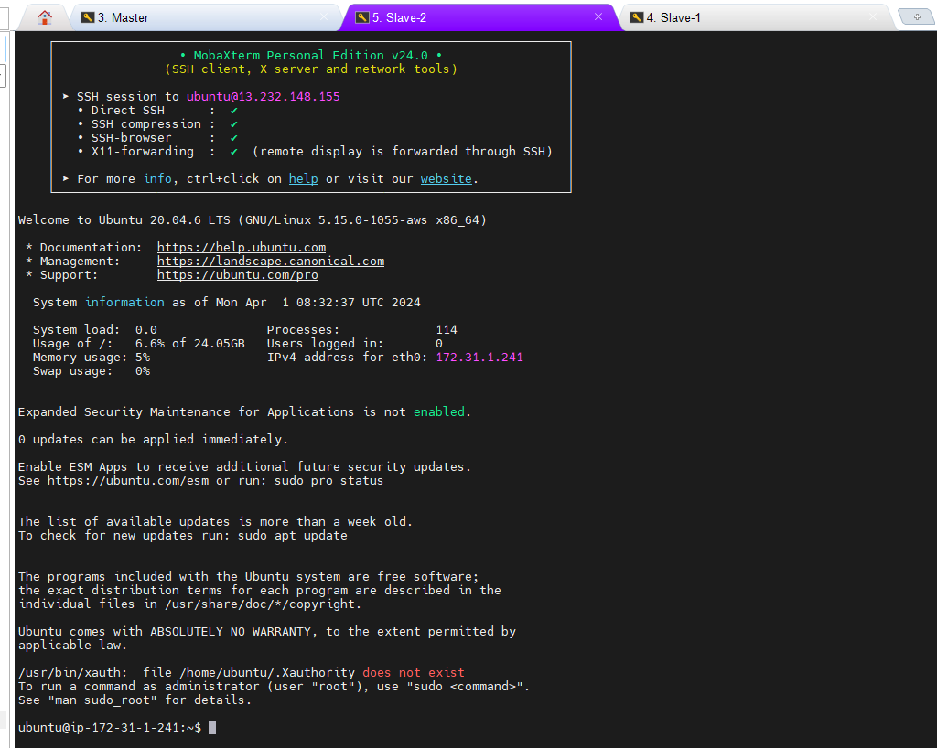

**sudo su: to become root user on each instance**Now we need to run the commands to install Kubernetes cluster:  
by creating shell script:

Vi 1.sh then save using :w nad exit using :wq

Give the executable permissions to the file using :

Chmod +x 1.sh

Execute the file : ./1.sh

**WHATS INSIDE 1.sh**

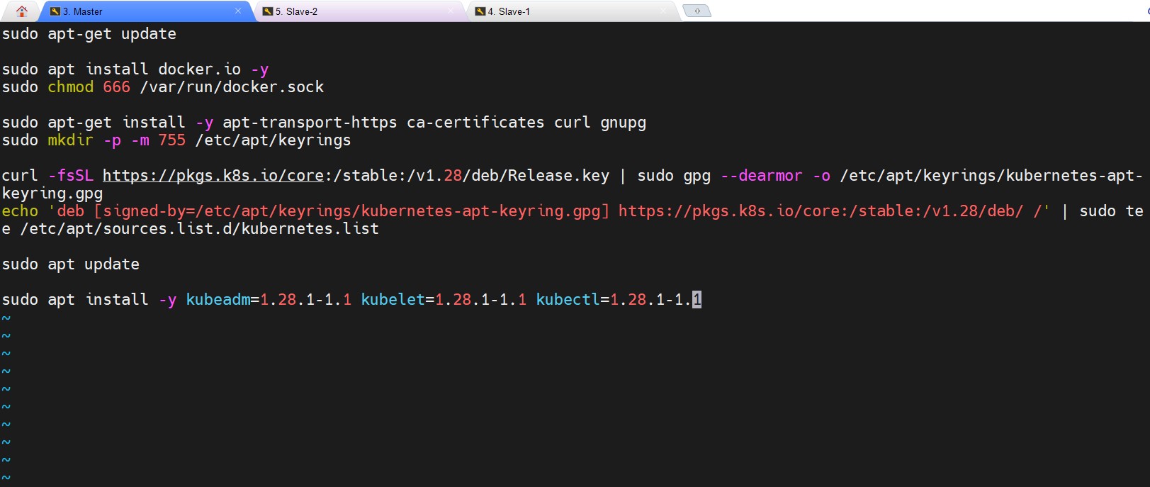

**Setup K8-Cluster using kubeadm : refer that in phase 1**

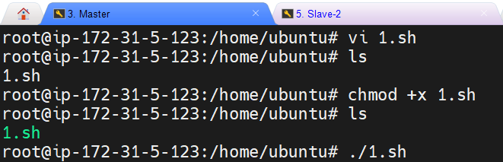

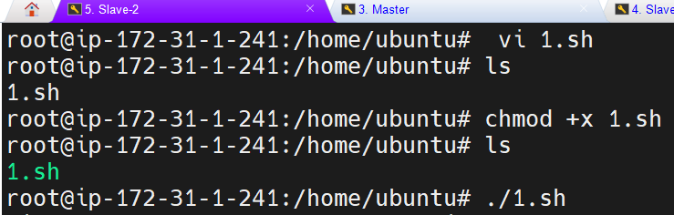

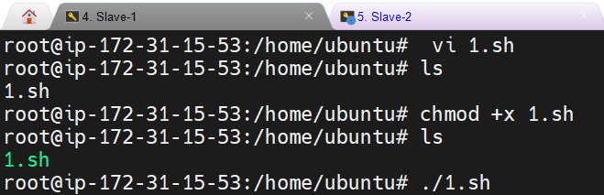

**Run the corresponding commands to setup the k8.  
after running sudo kubeadm init --pod-network-cidr=10.244.0.0/16 on master node we get**

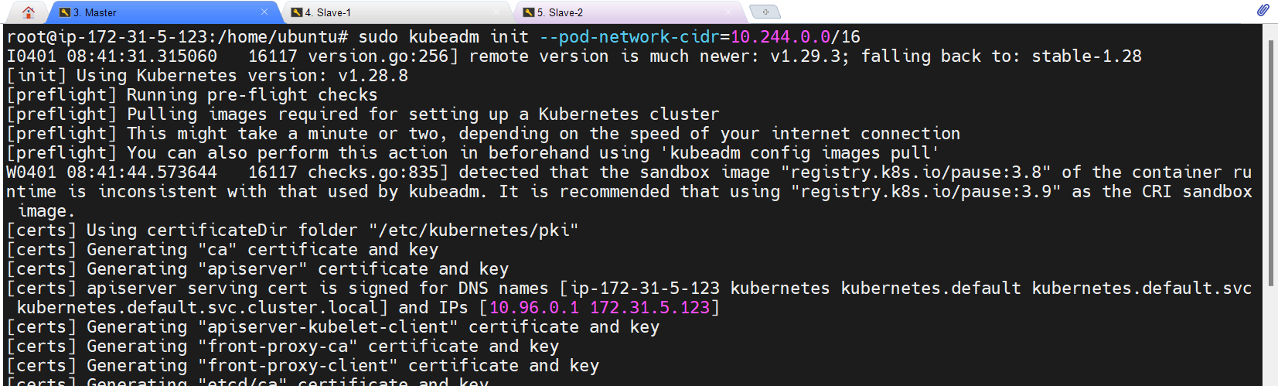

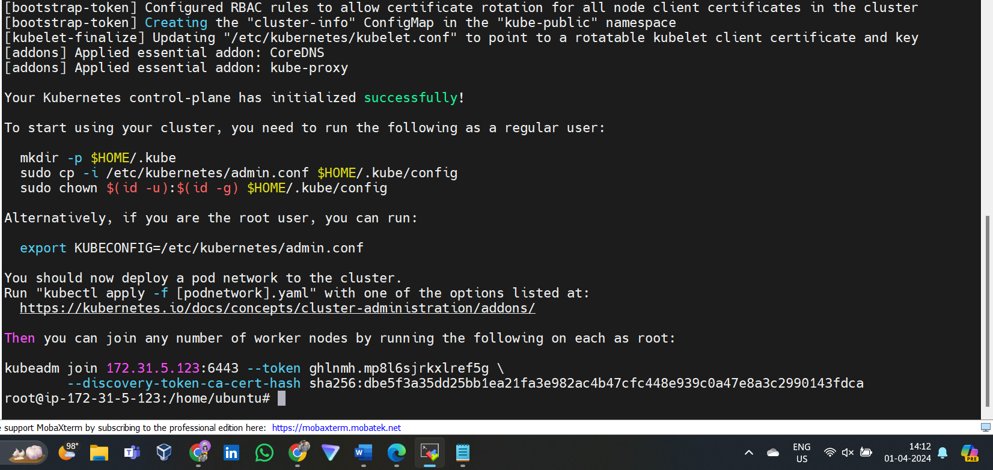

**On slave rode after running the command:**

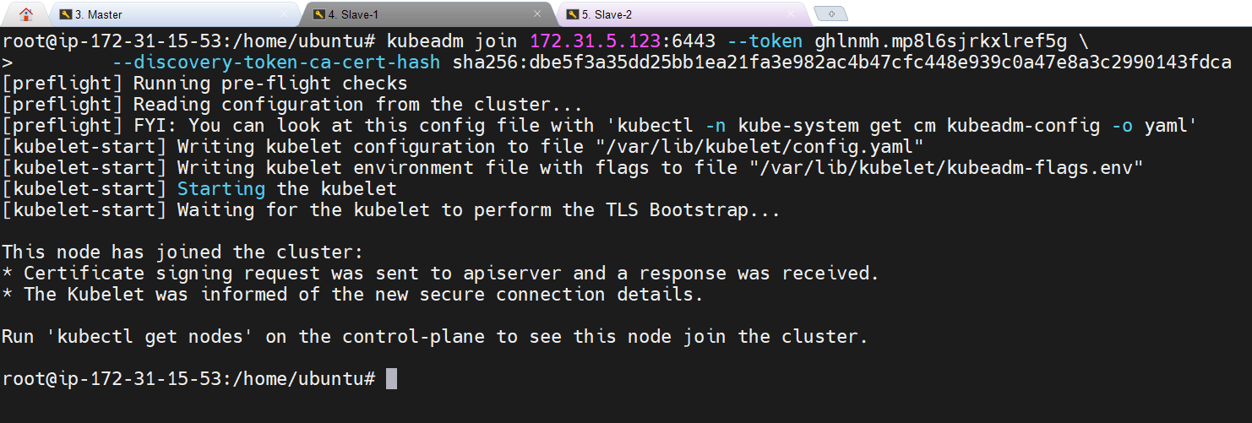

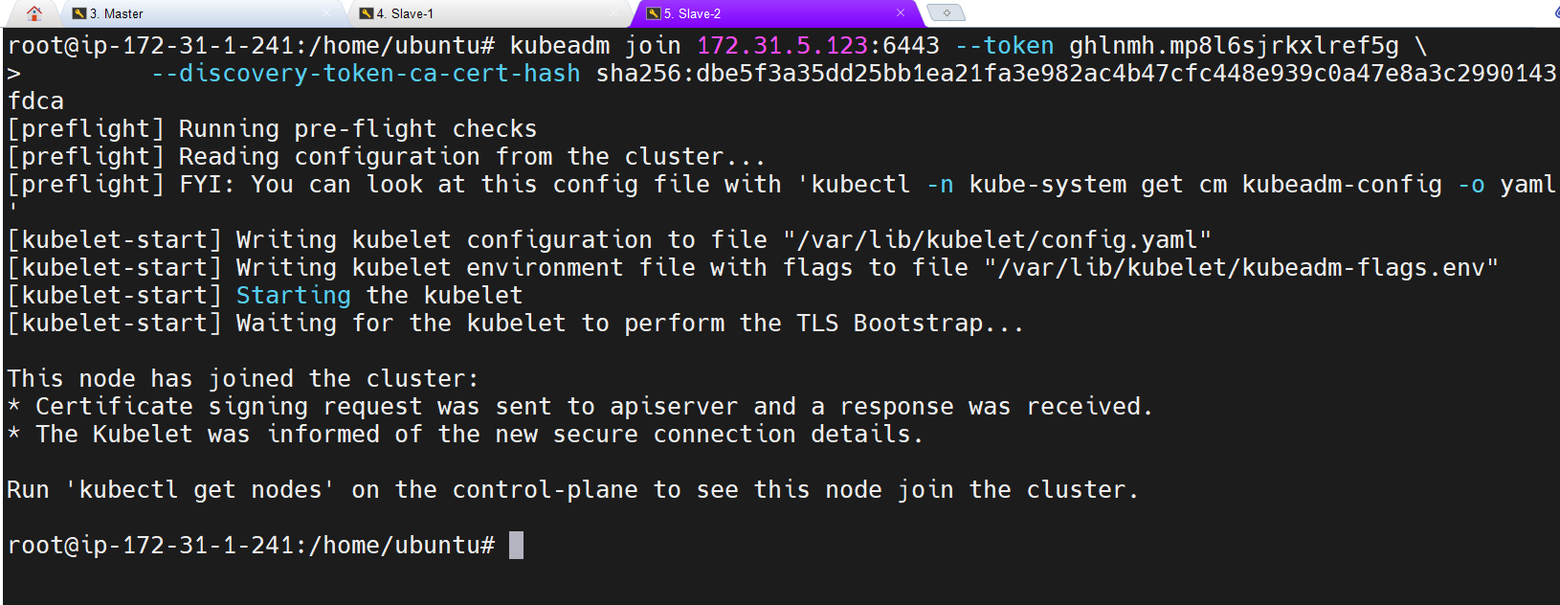

Getting the node by running kubectl get node on Master node

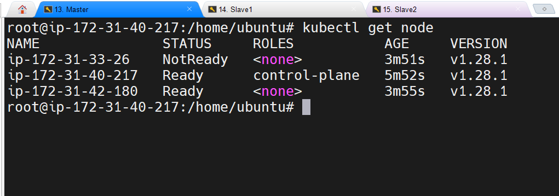

**Deploy Networking Solution (Calico) [On MasterNode]**

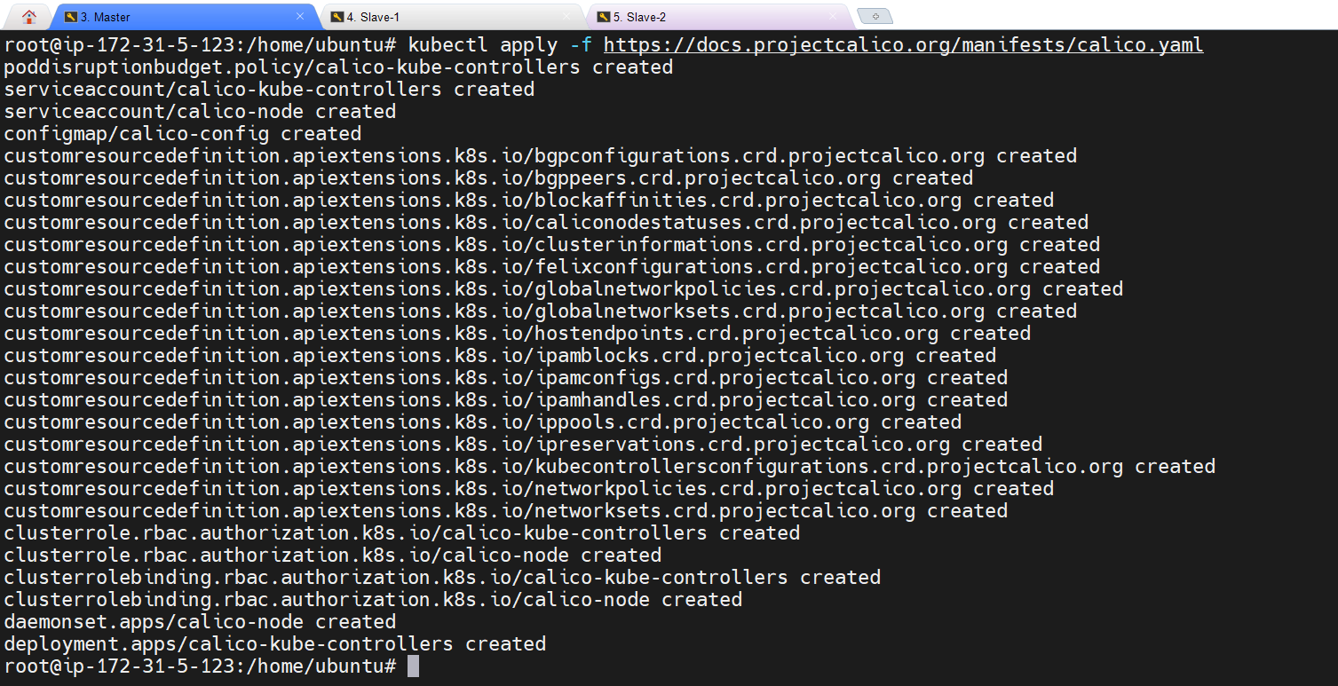

**Deploy Ingress Controller (NGINX) [On MasterNode]**

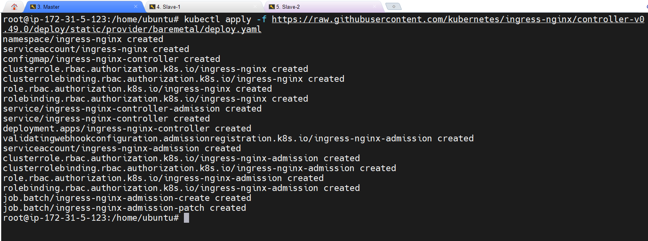

**KUBEAUDIT:**

wget https://github.com/Shopify/kubeaudit/releases/download/v0.22.1/kubeaudit_0.22.1_linux_amd64.tar.gz

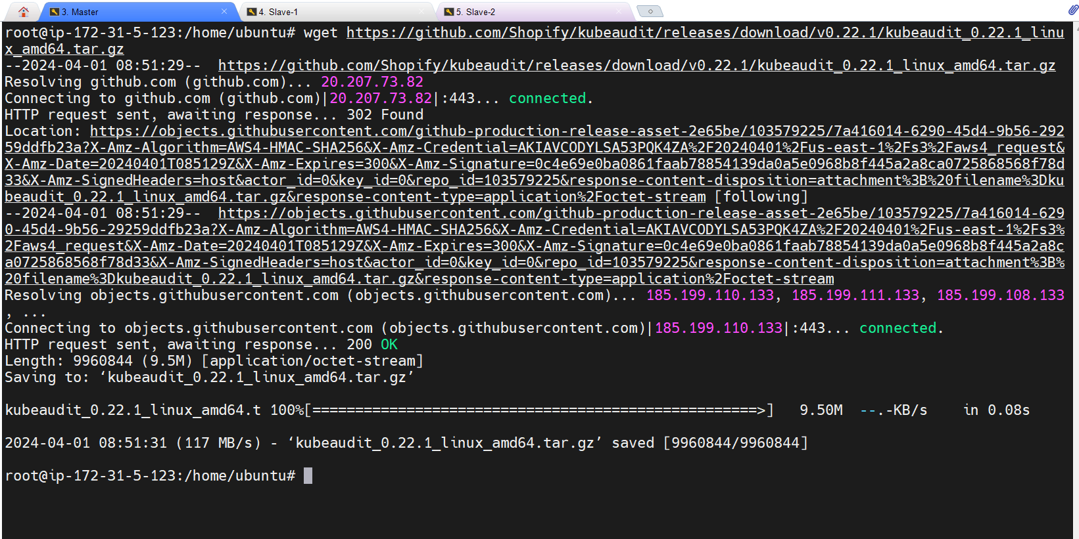

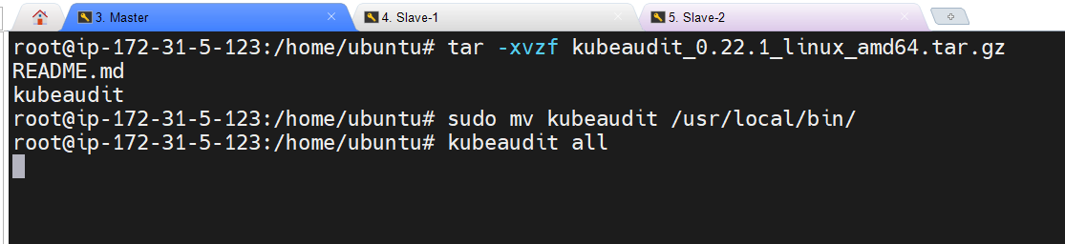

**Kubeaudit all we will get the report:**

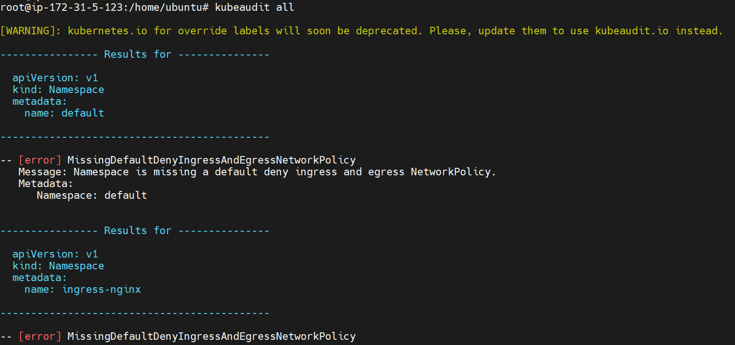

**Create sonarkube and nexus server and connect to them through MobaXterm:**

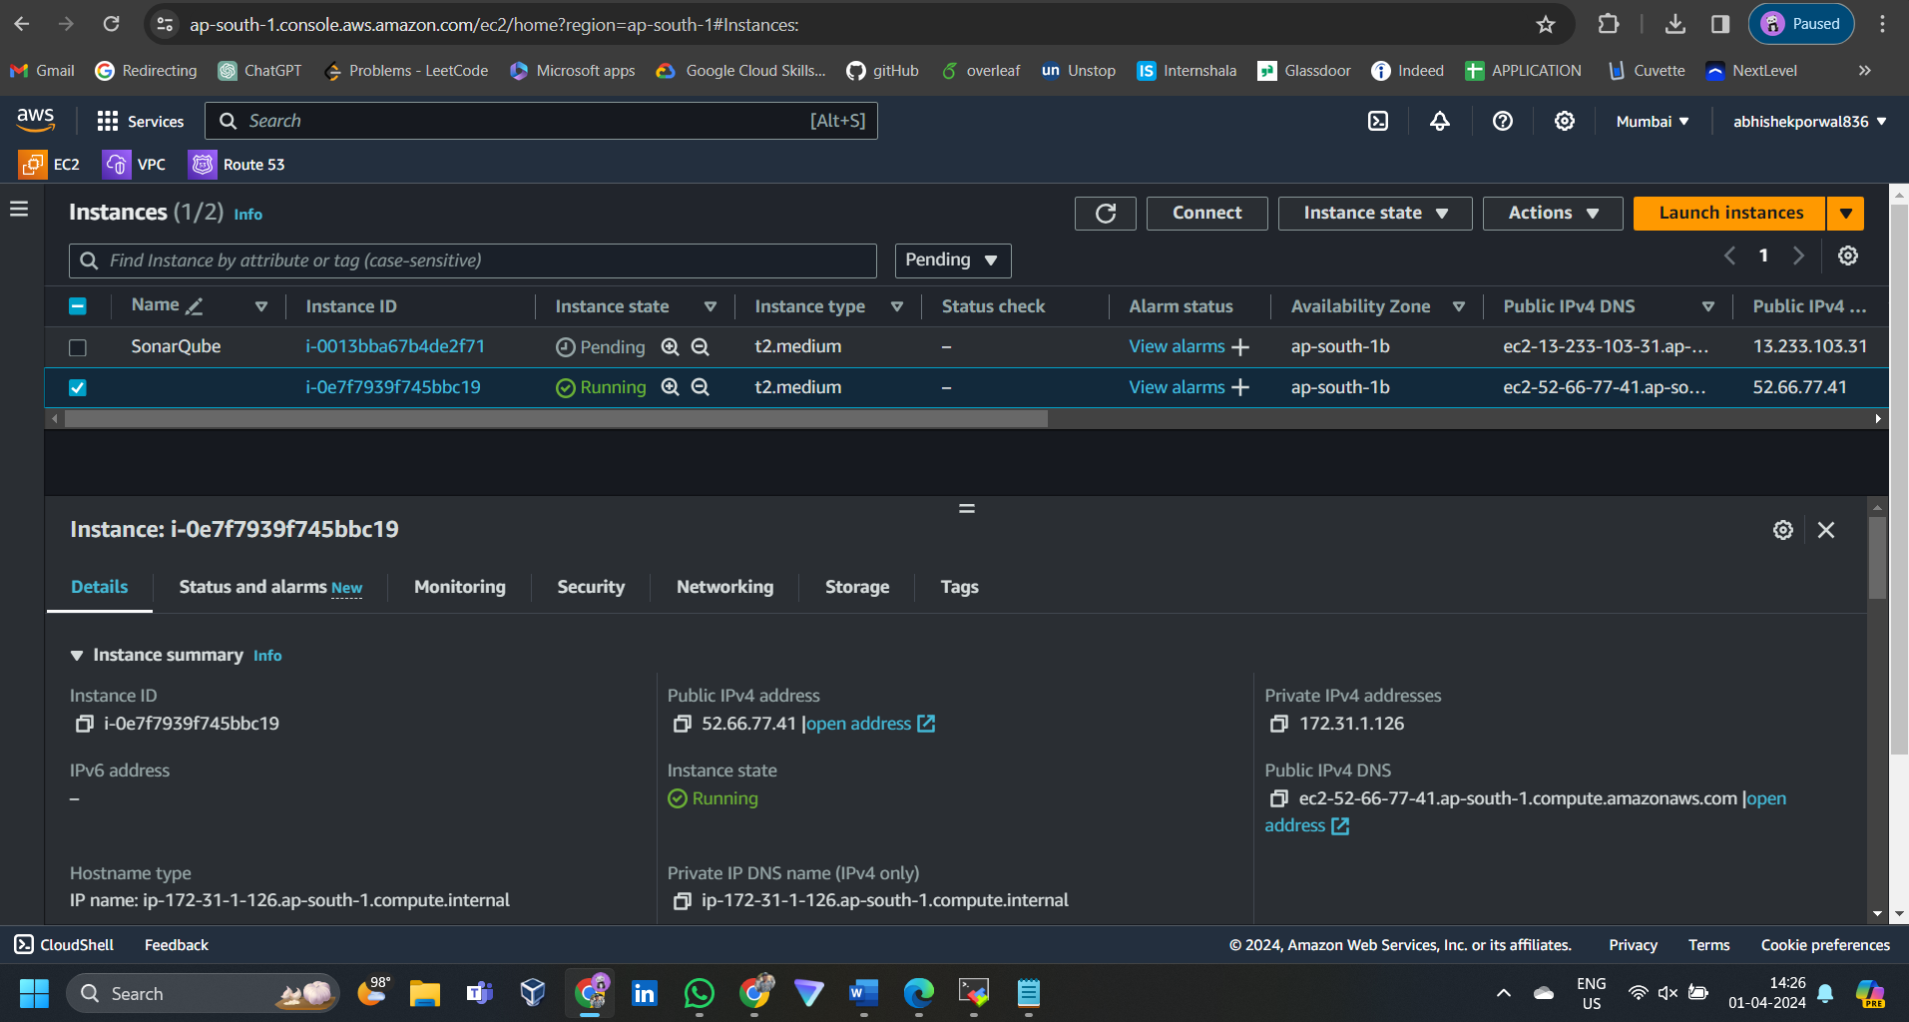

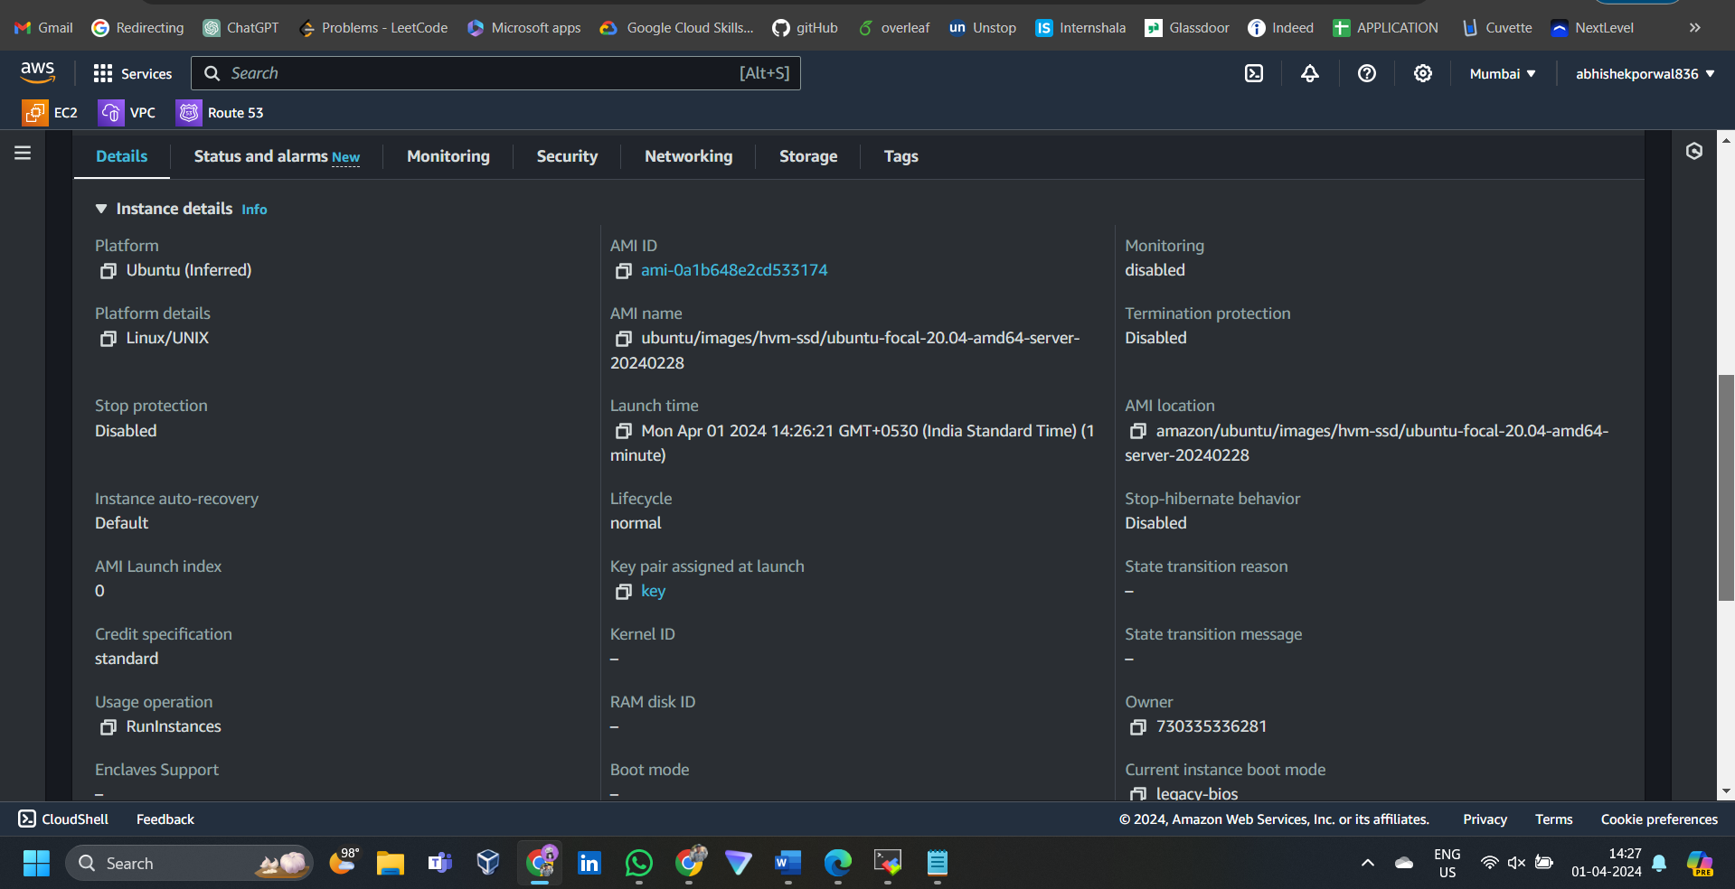

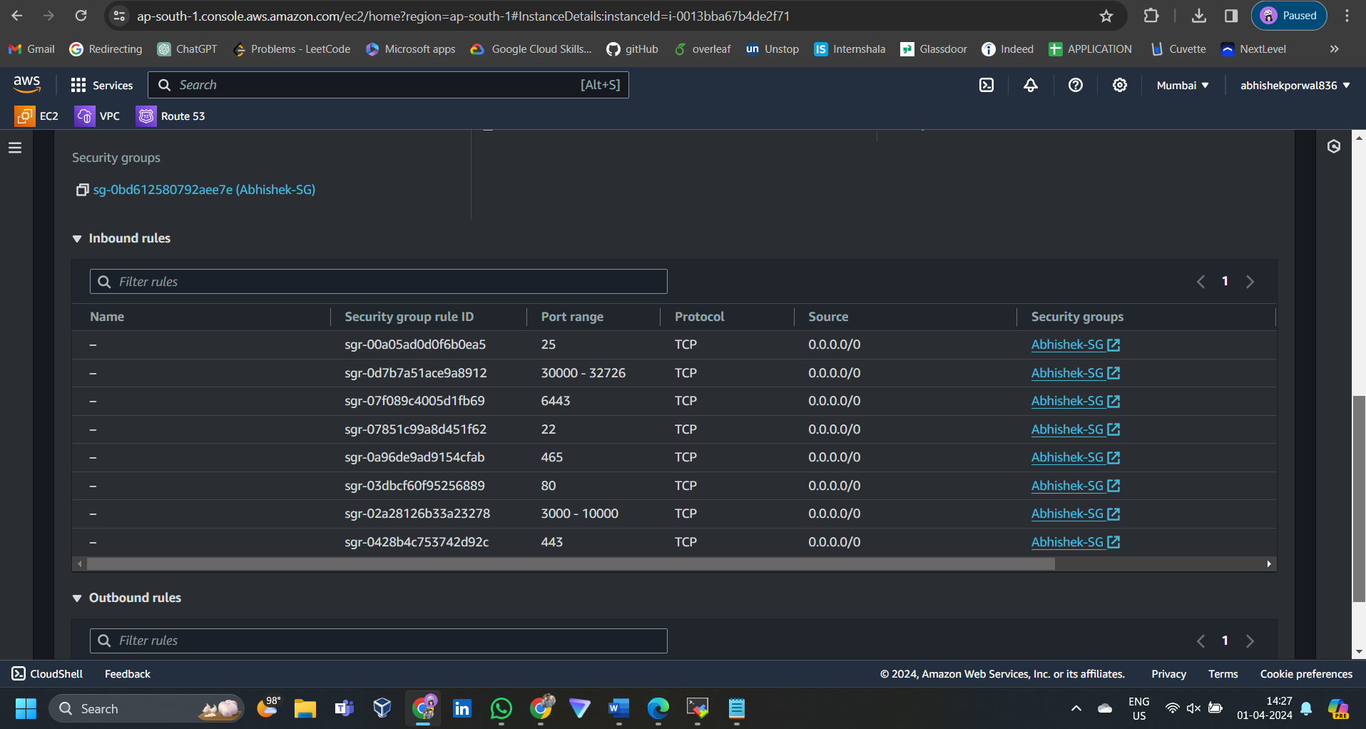

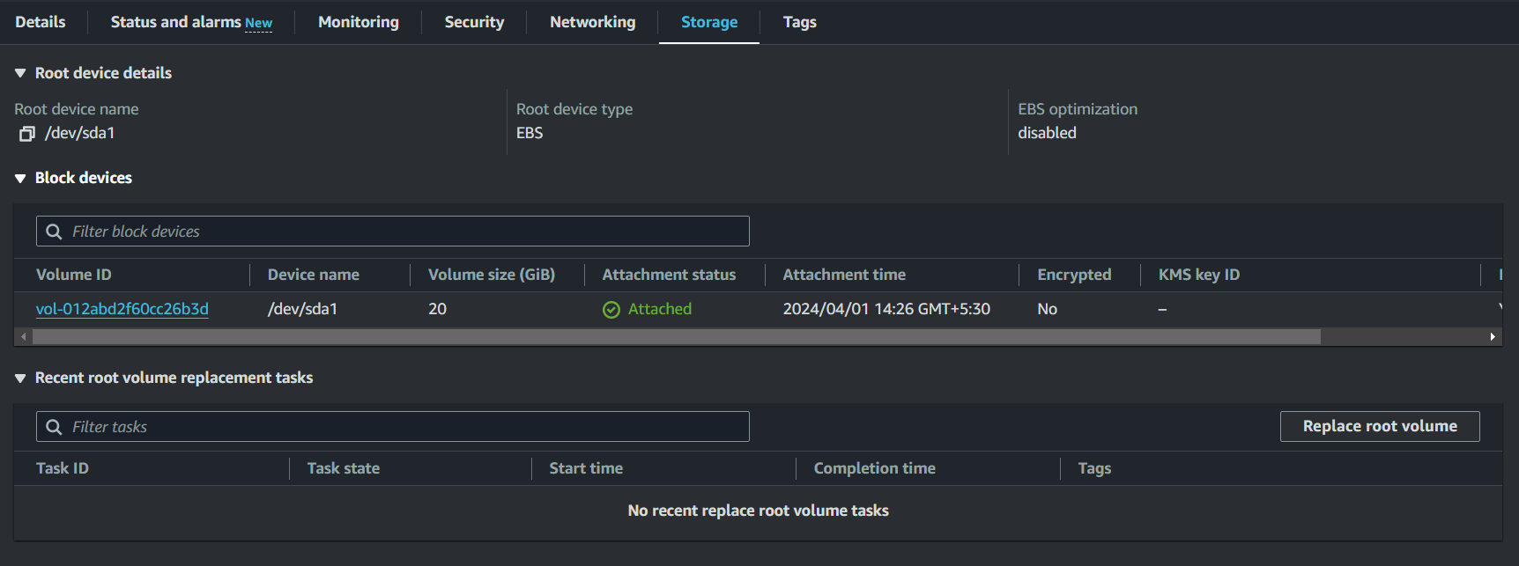

**SonarQube server and ssh into it through MobaXterm:**

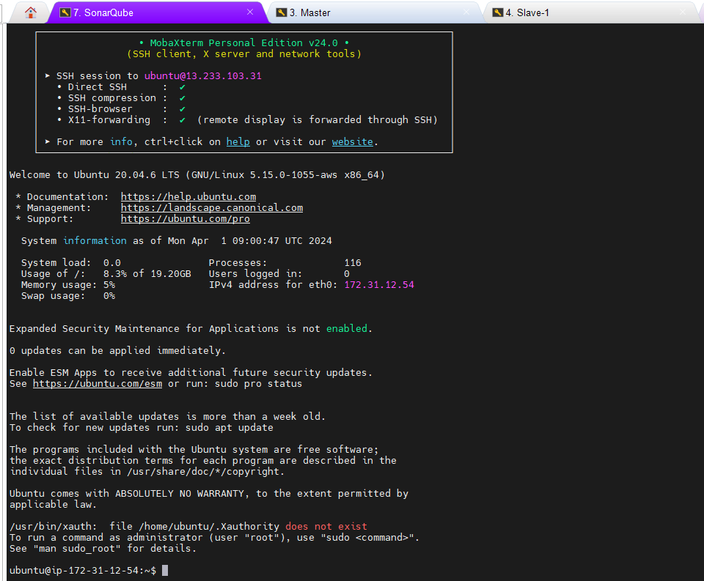

**Nexus server and ssh into it through MobaXterm:**

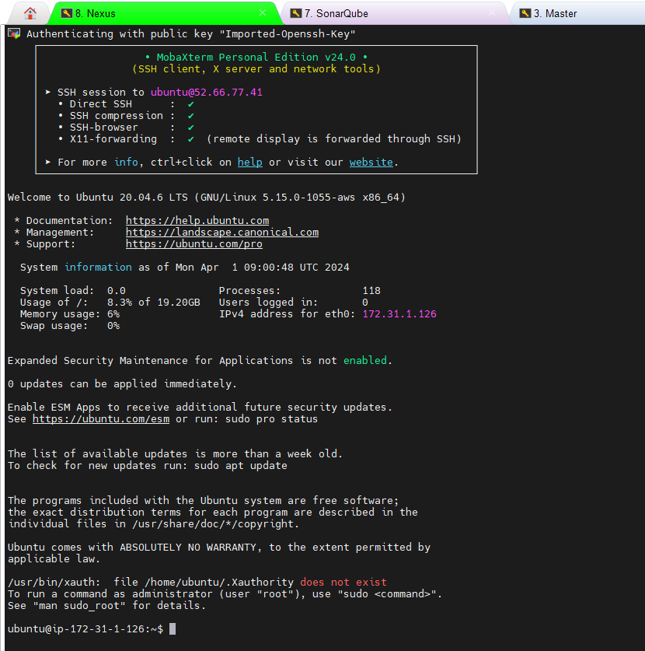

**Create Jenkins server and ssh into it through MobaXterm:**

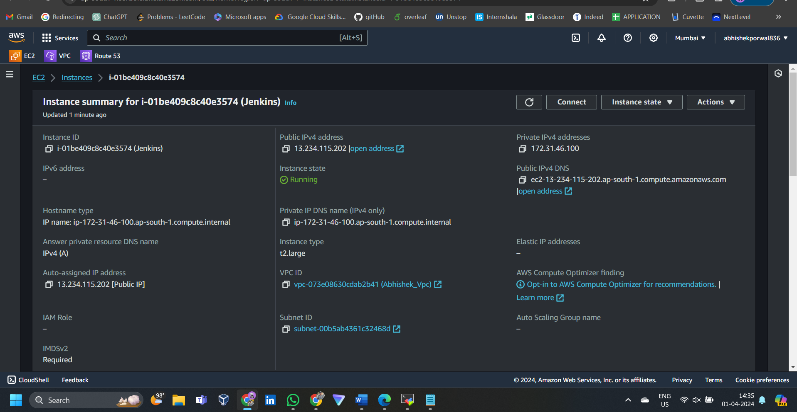

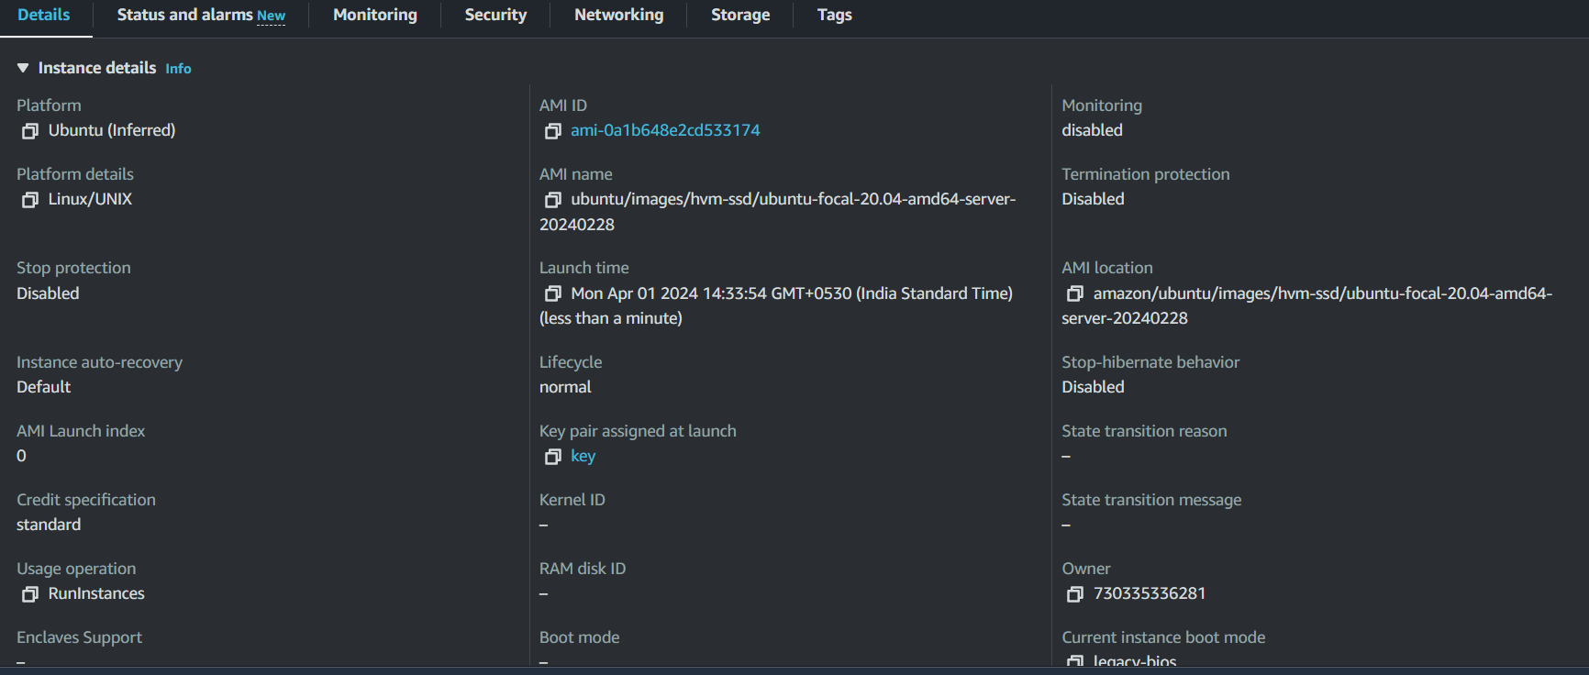

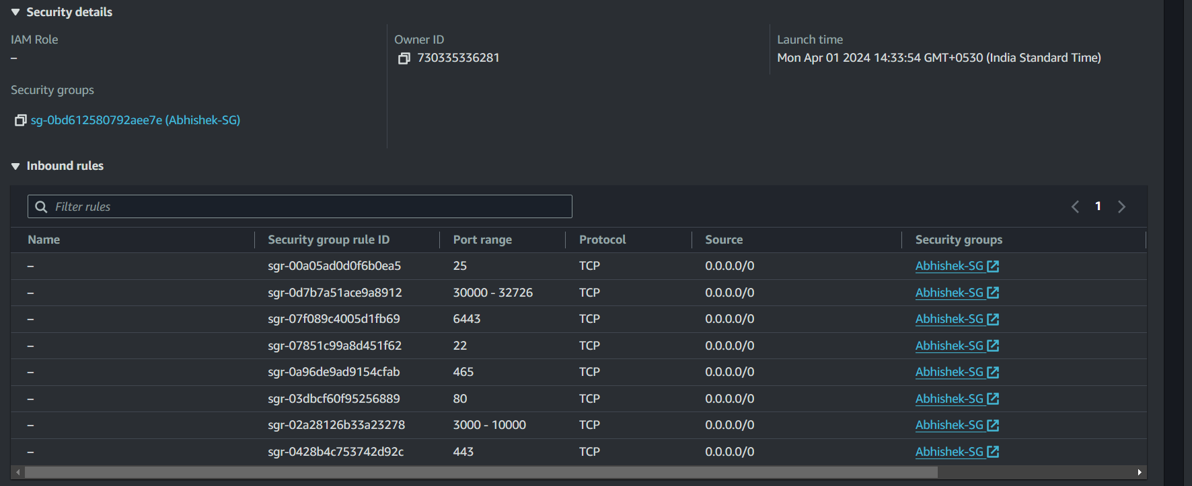



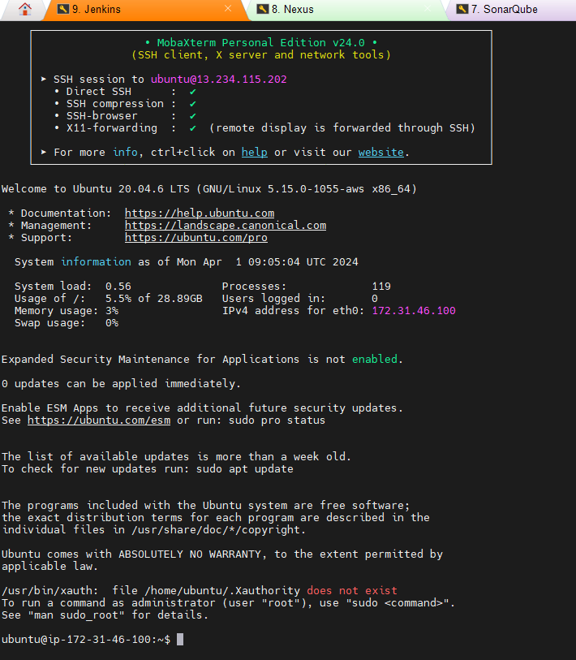

**Setting up Sonarkube :**

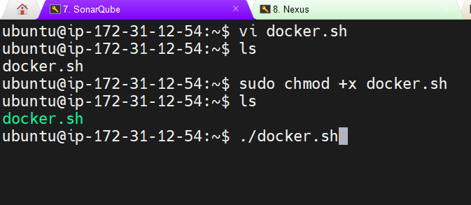

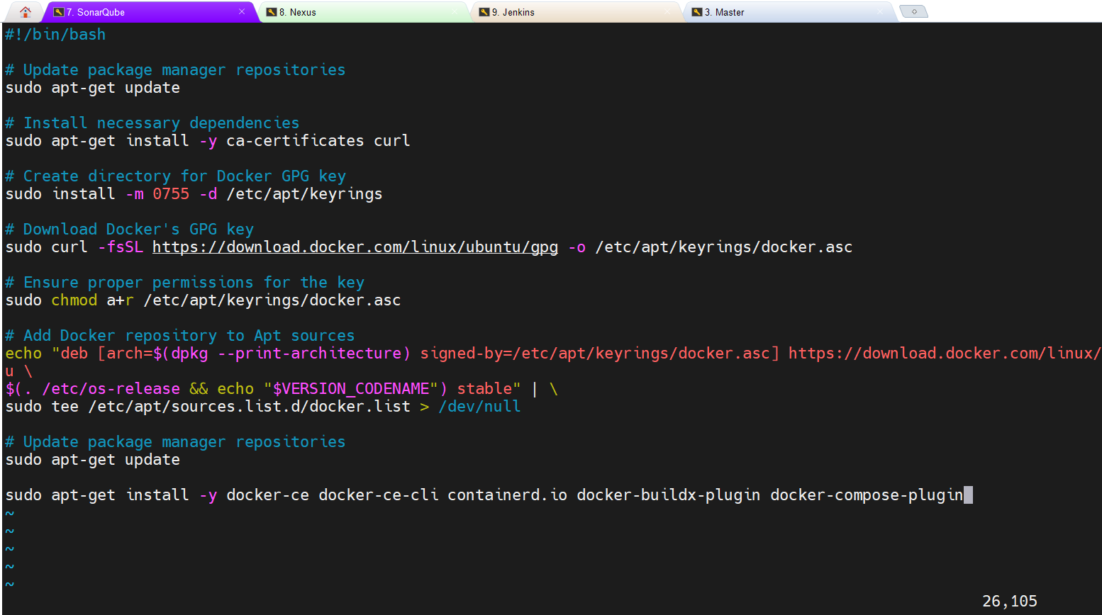

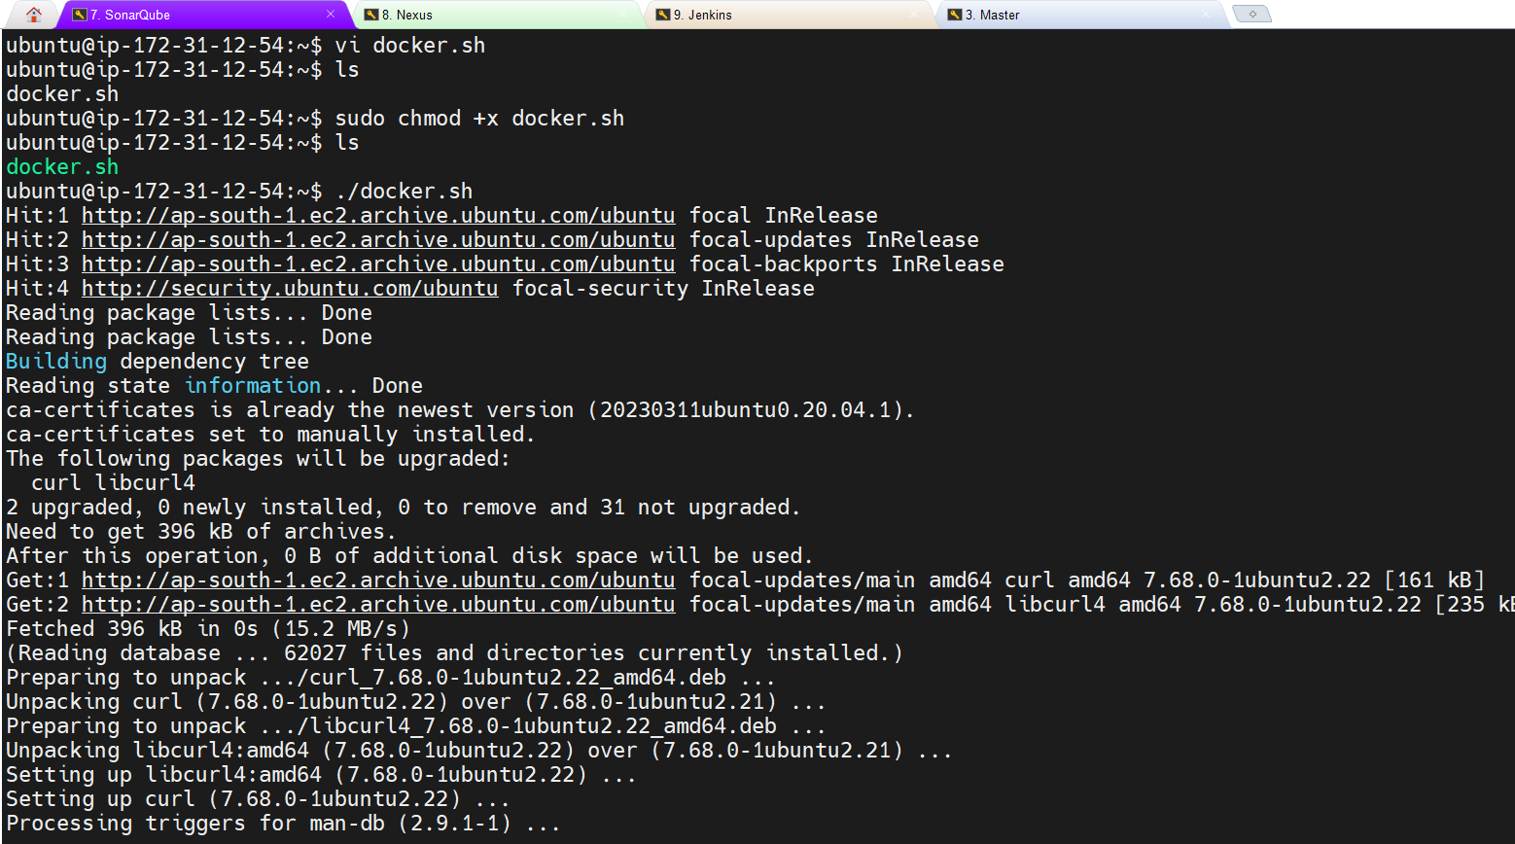

sudo chmod 666 /var/run/docker.sock run this cmd to give access eo all the users

**Verifying docker is installed**

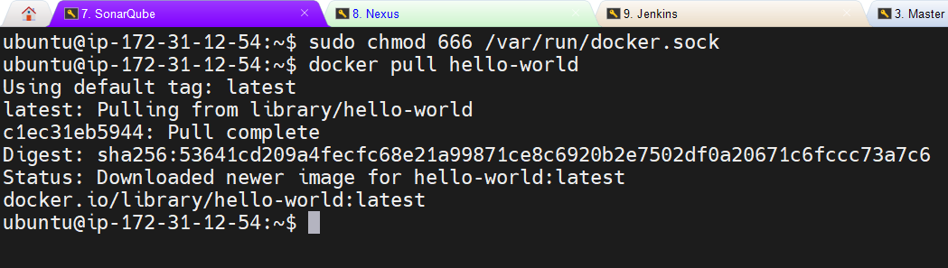

**Running docker container of sonarqube** 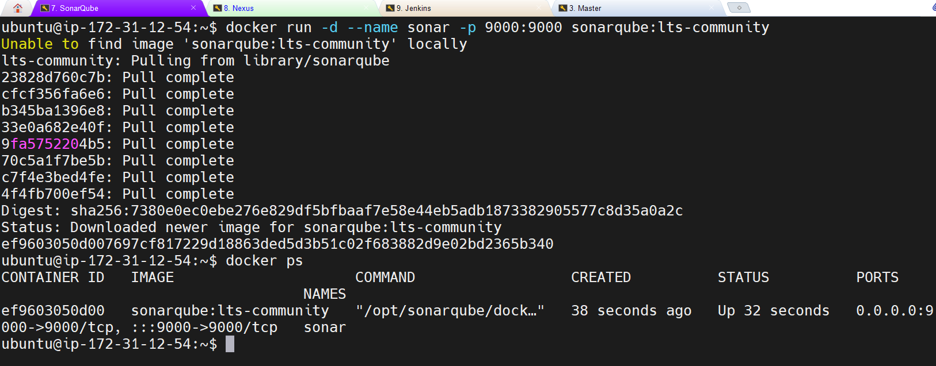

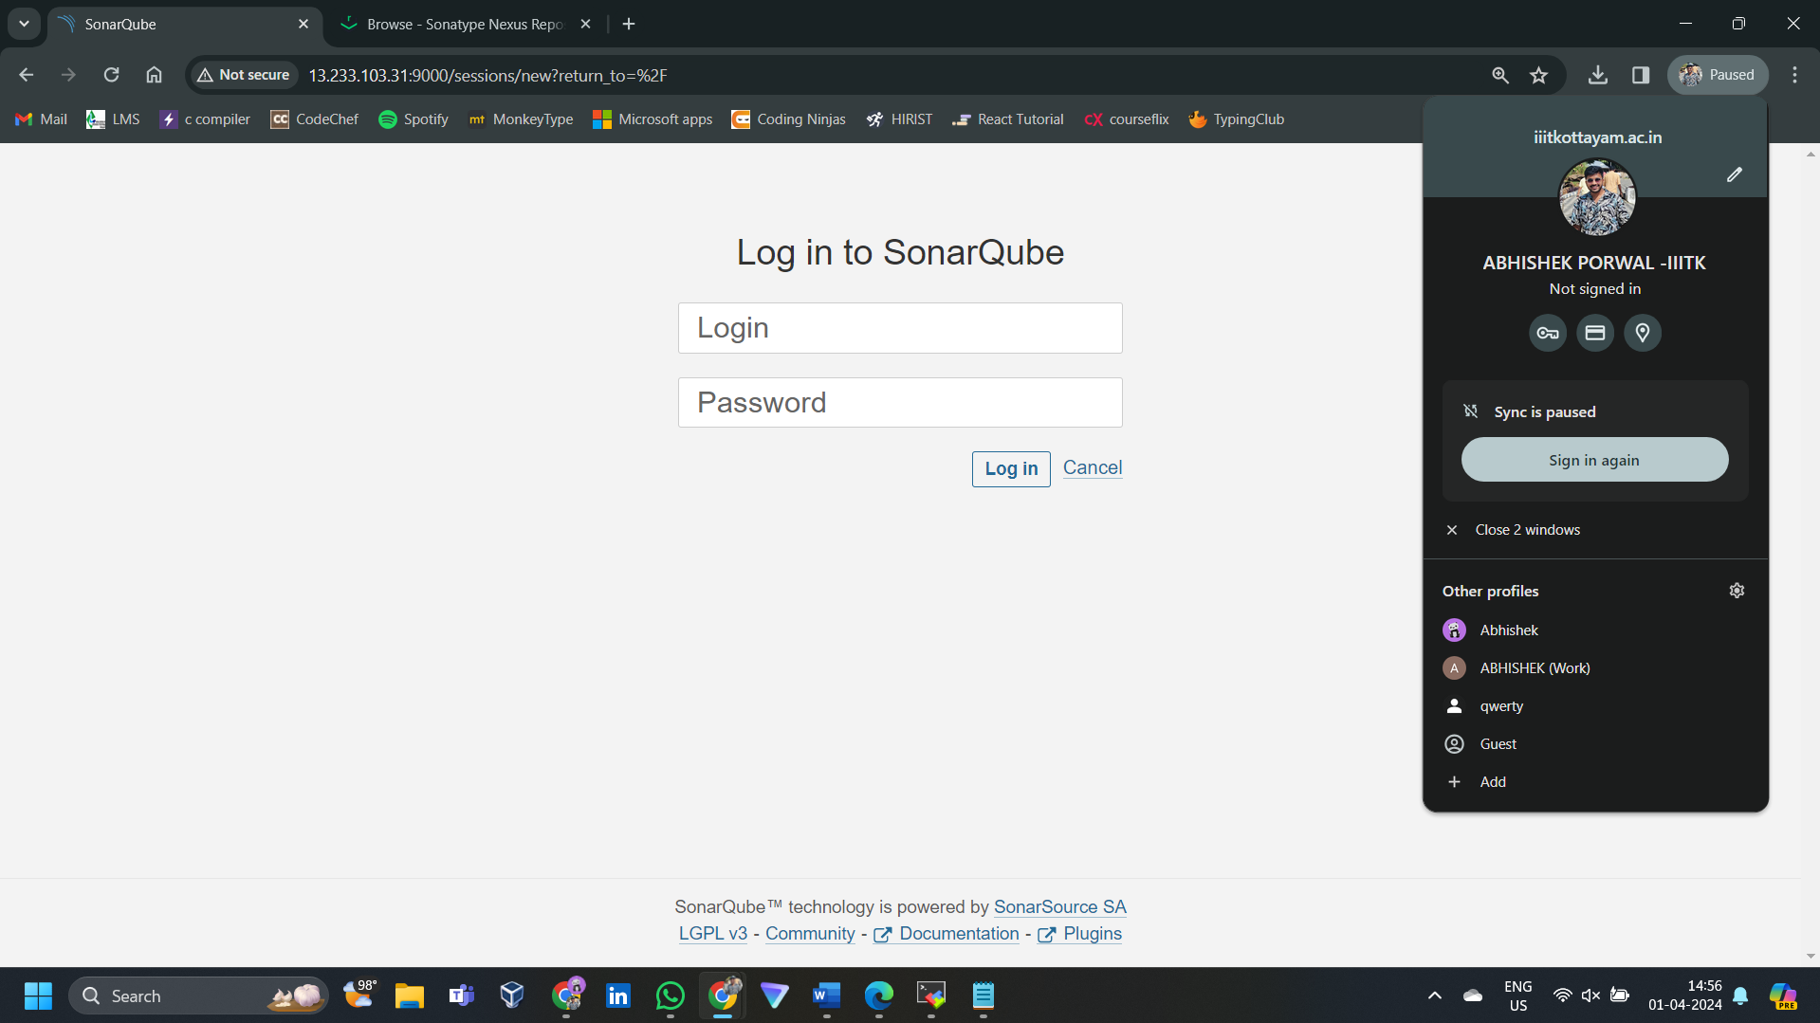

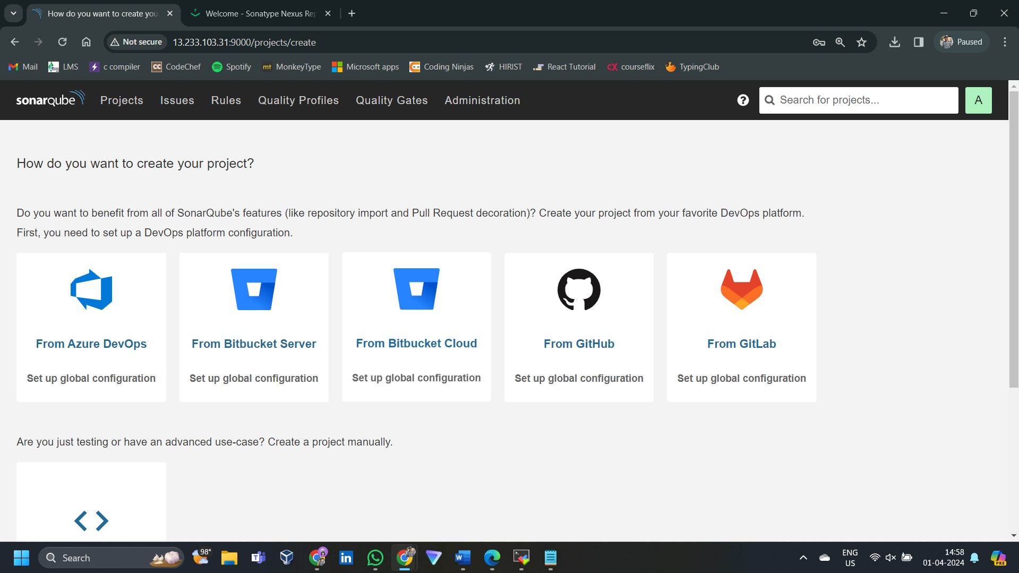

**Setting up Nexus:** 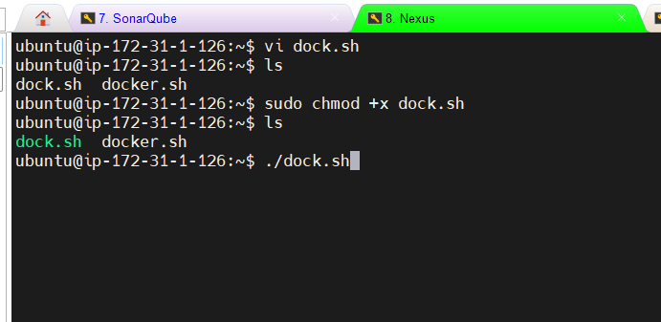

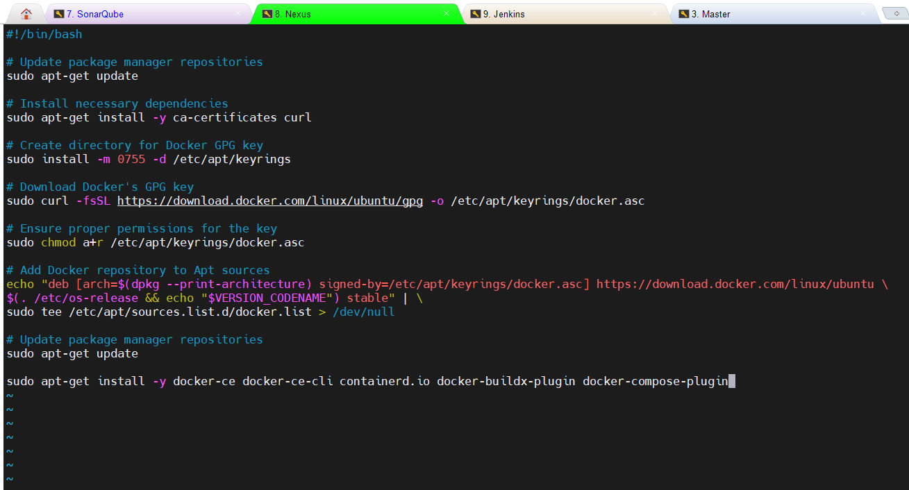

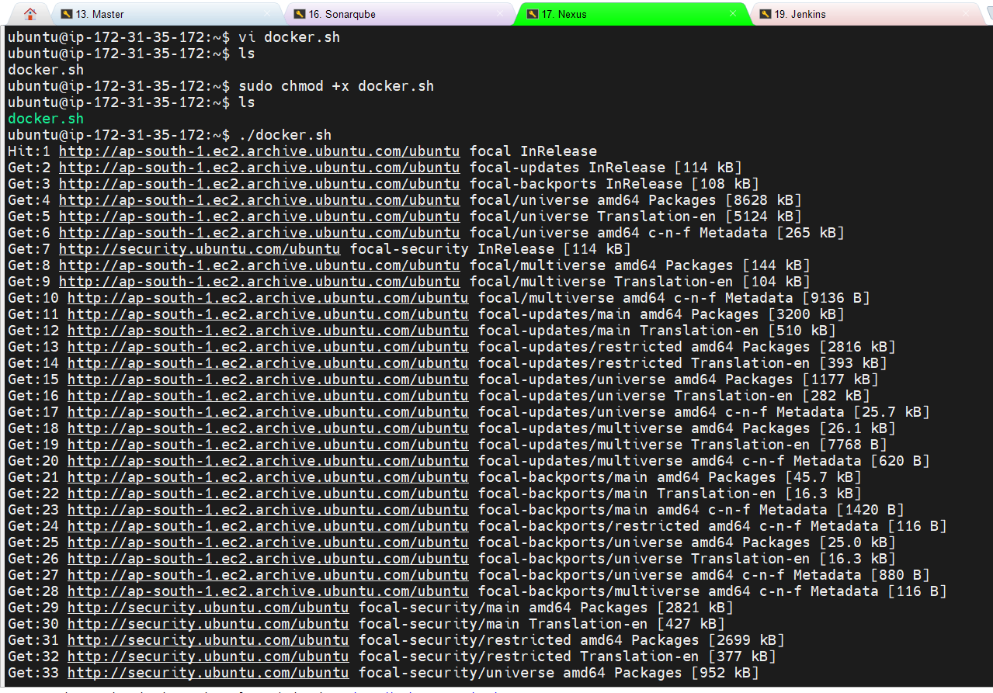

sudo chmod 666 /var/run/docker.sock run this cmd to give access eo all the users

**Verifying docker is installed**

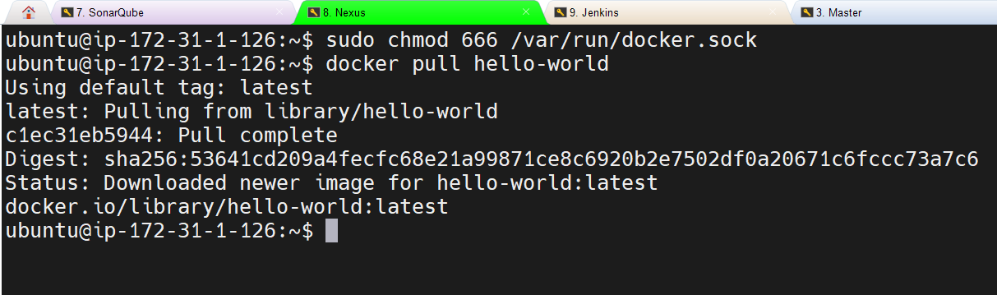

Run docker container of nexus: 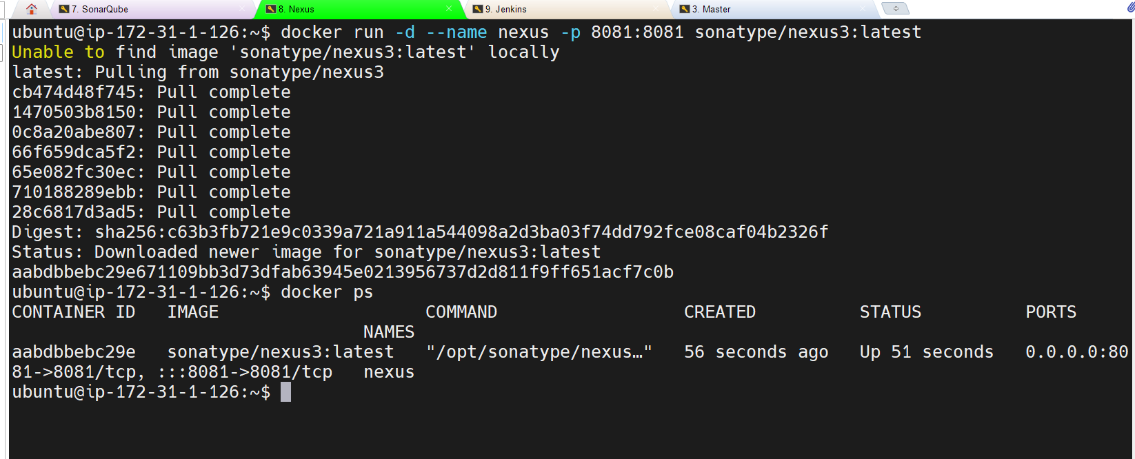

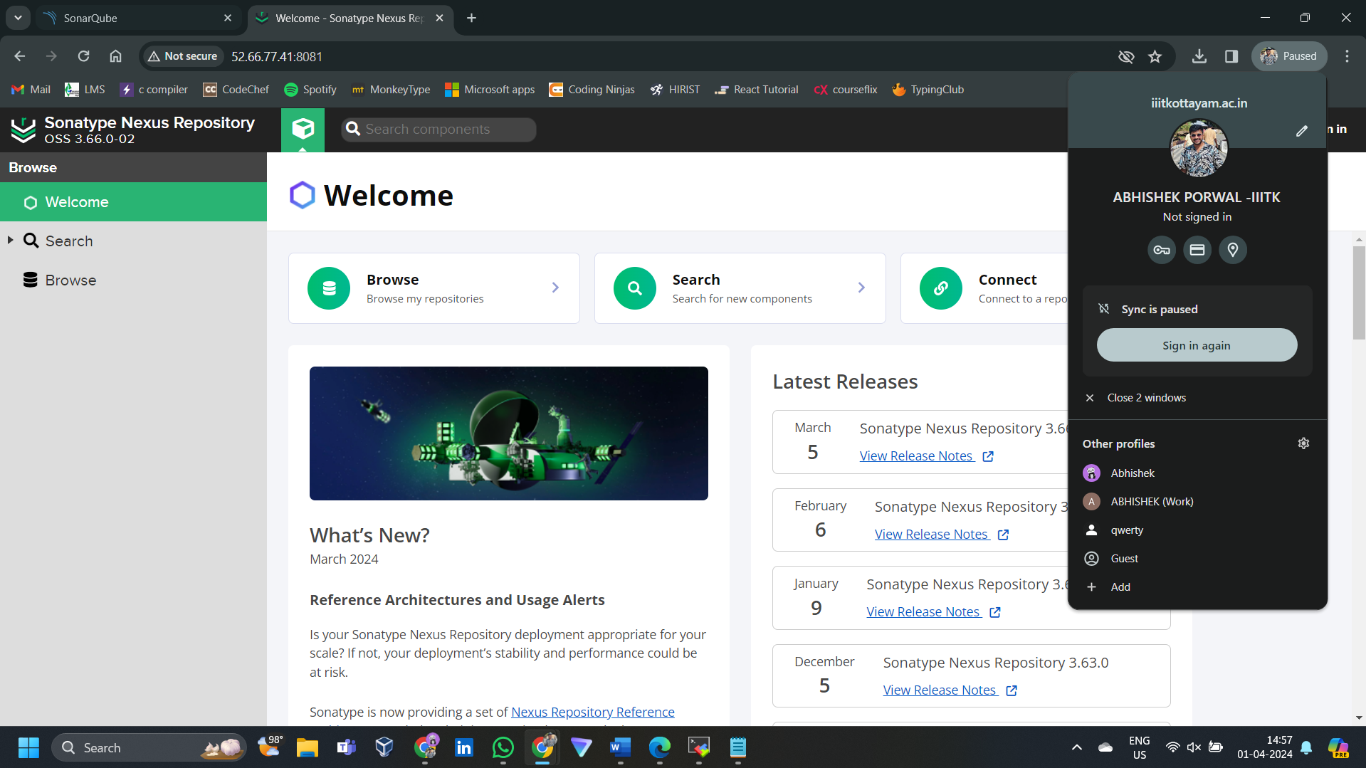

Docker exec -it(interactive terminal)) <container id> /bin/bash for password: 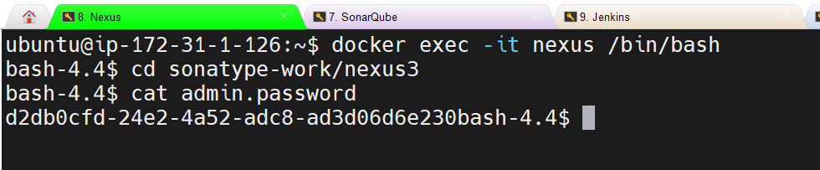

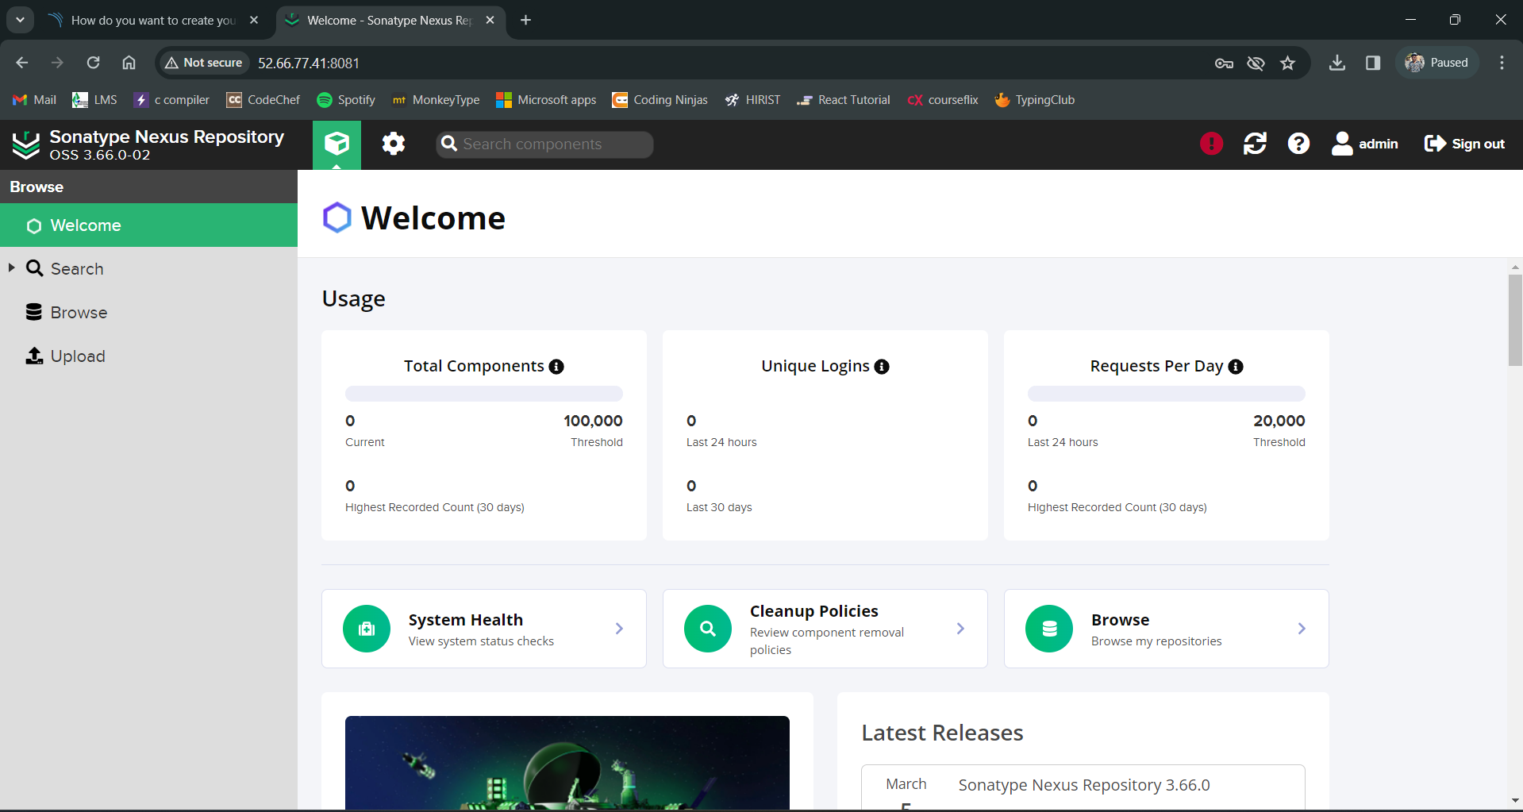

Set up Jenkins:

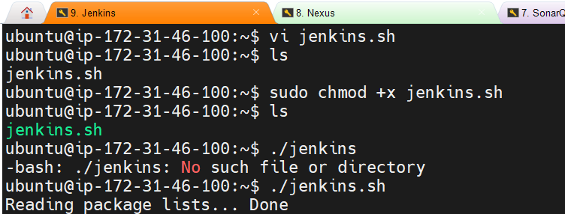

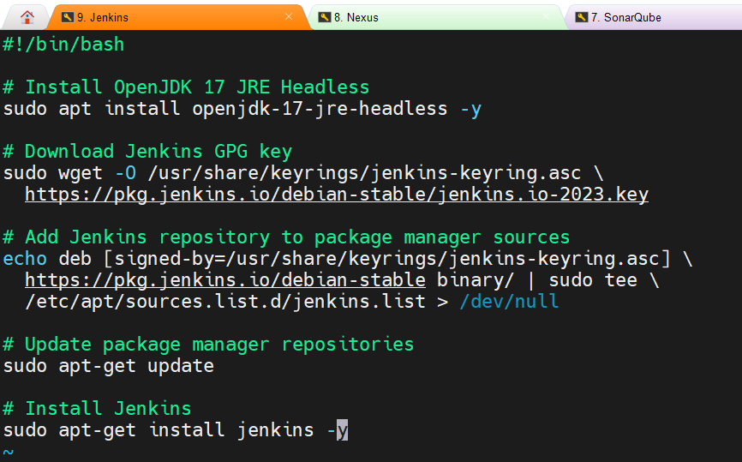

Install docker on Jenkins server

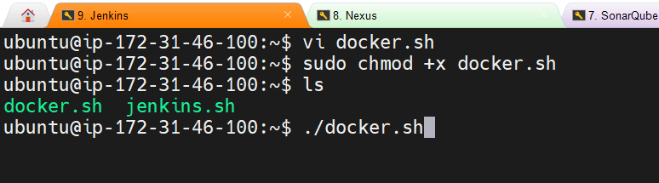

sudo chmod 666 /var/run/docker.sock run this cmd to give access eo all the users

Accesss Jenkins after retrieving password:

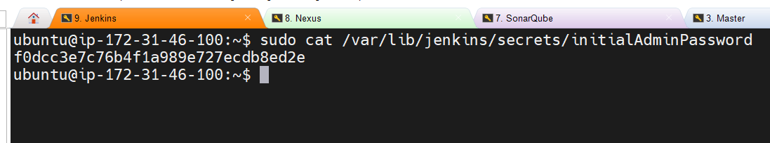

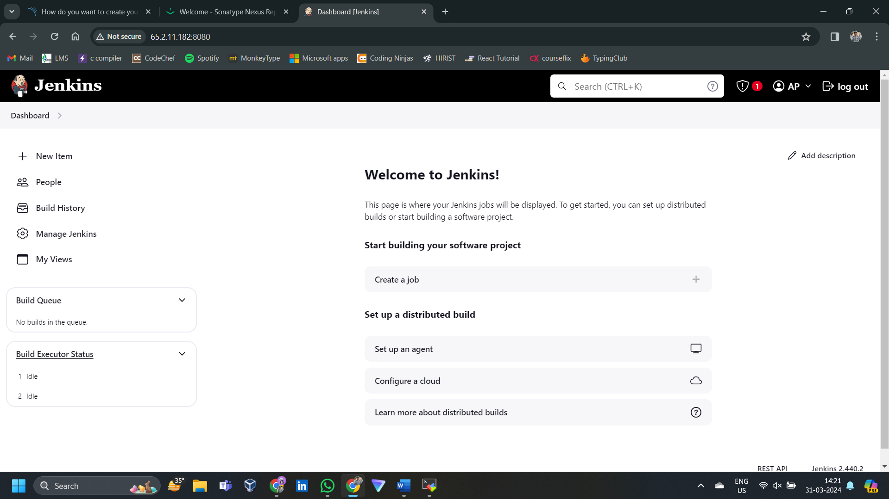

**PHASE 2 : Git repo setup**

**PHASE 3: cicd**

**Install Jenkins plugins:**

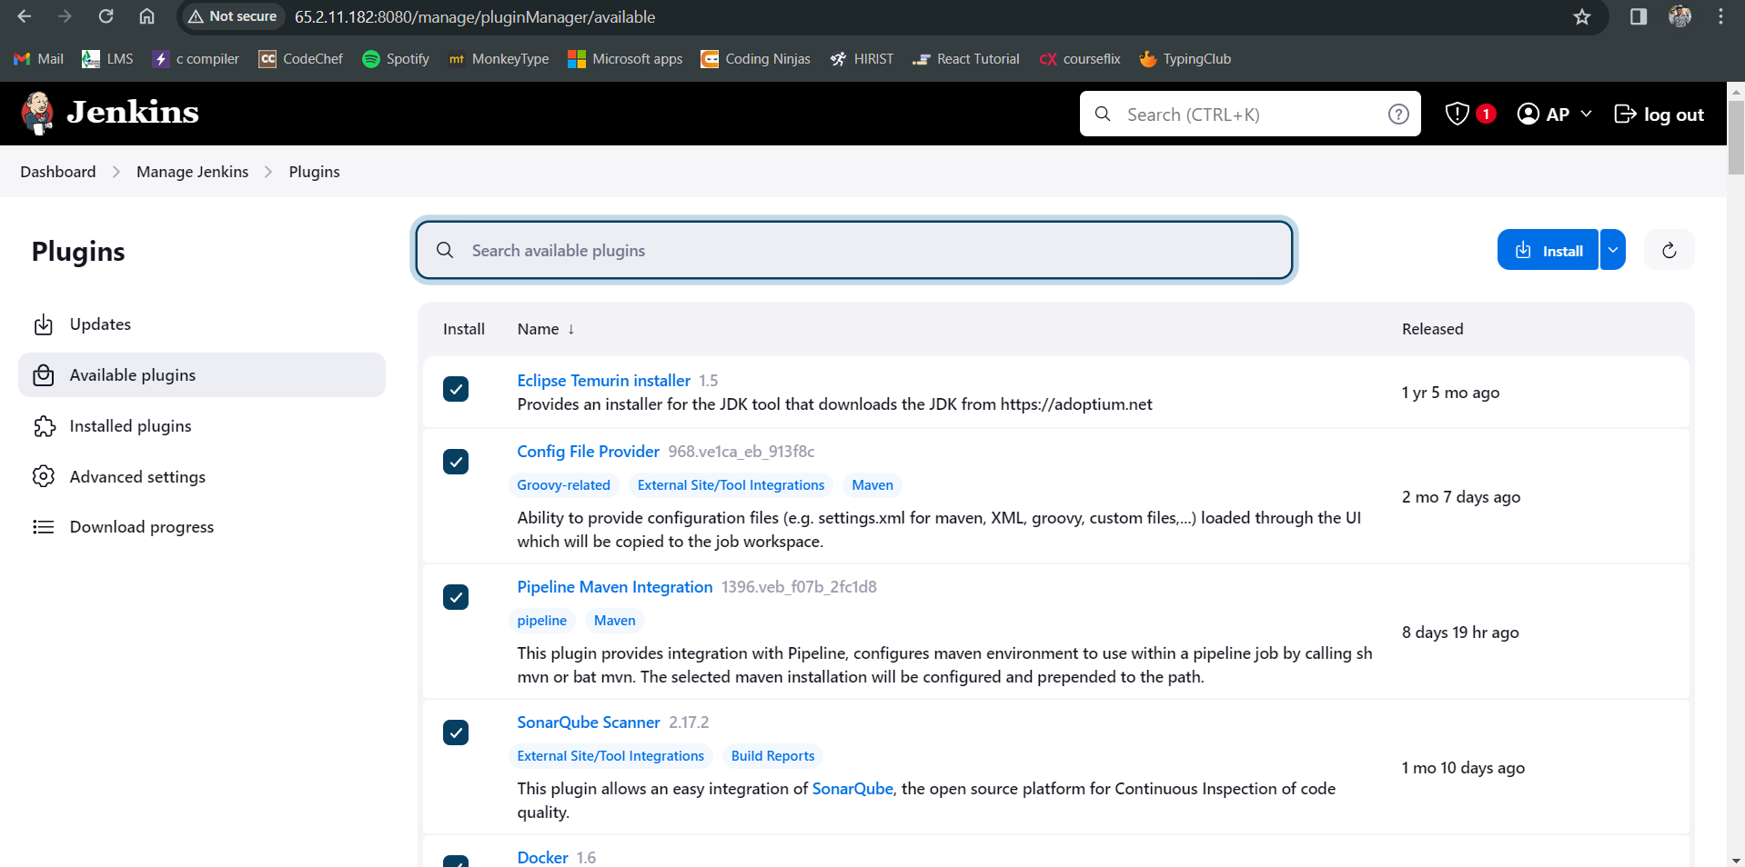

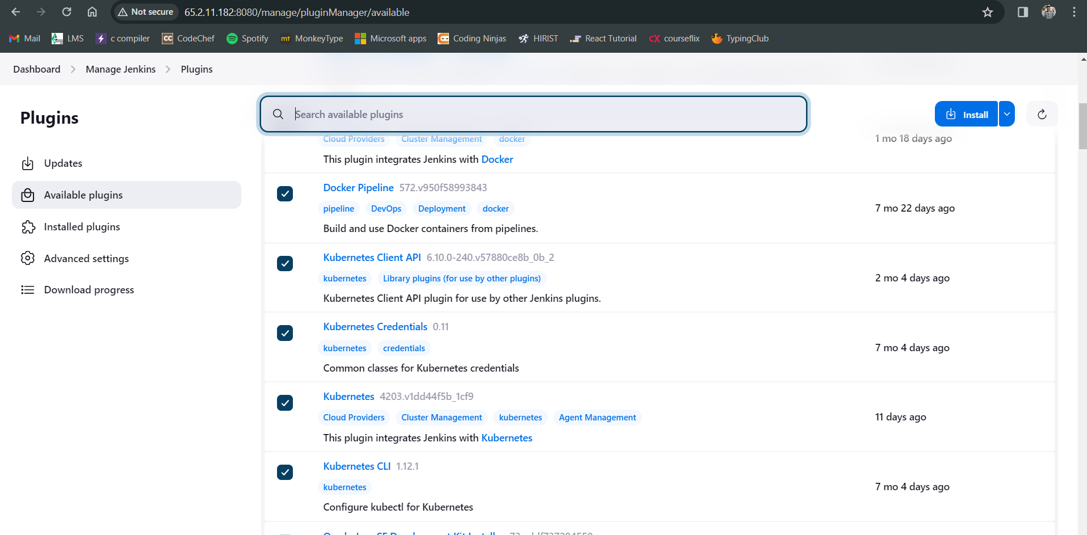

**Configuring TOOLS in Jenkins:**

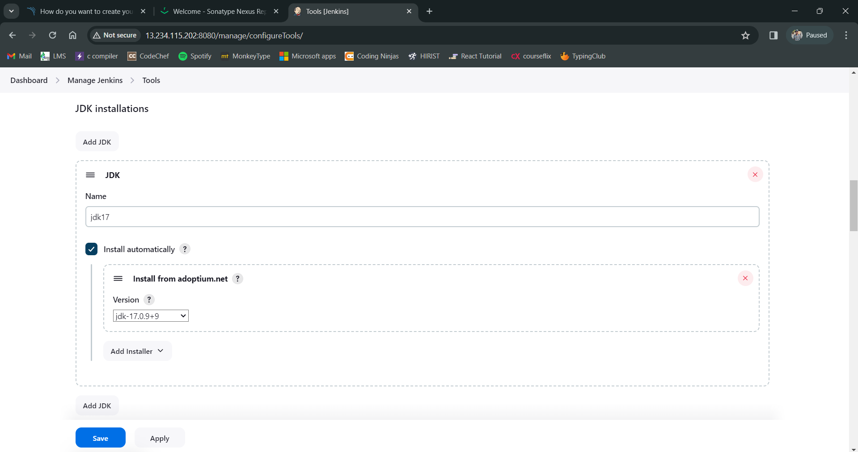

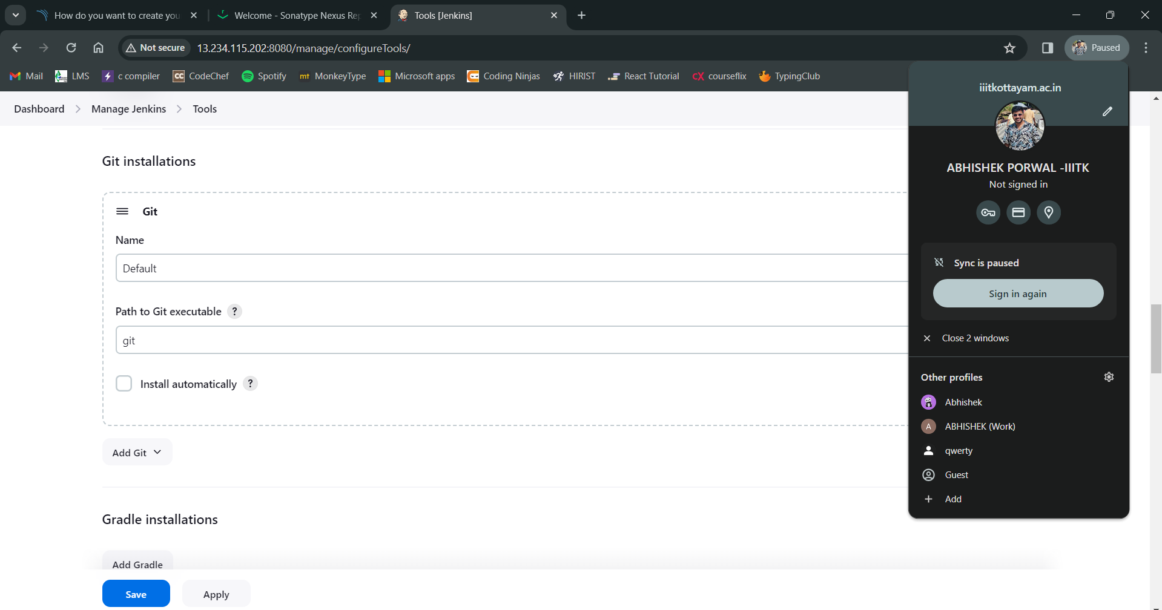

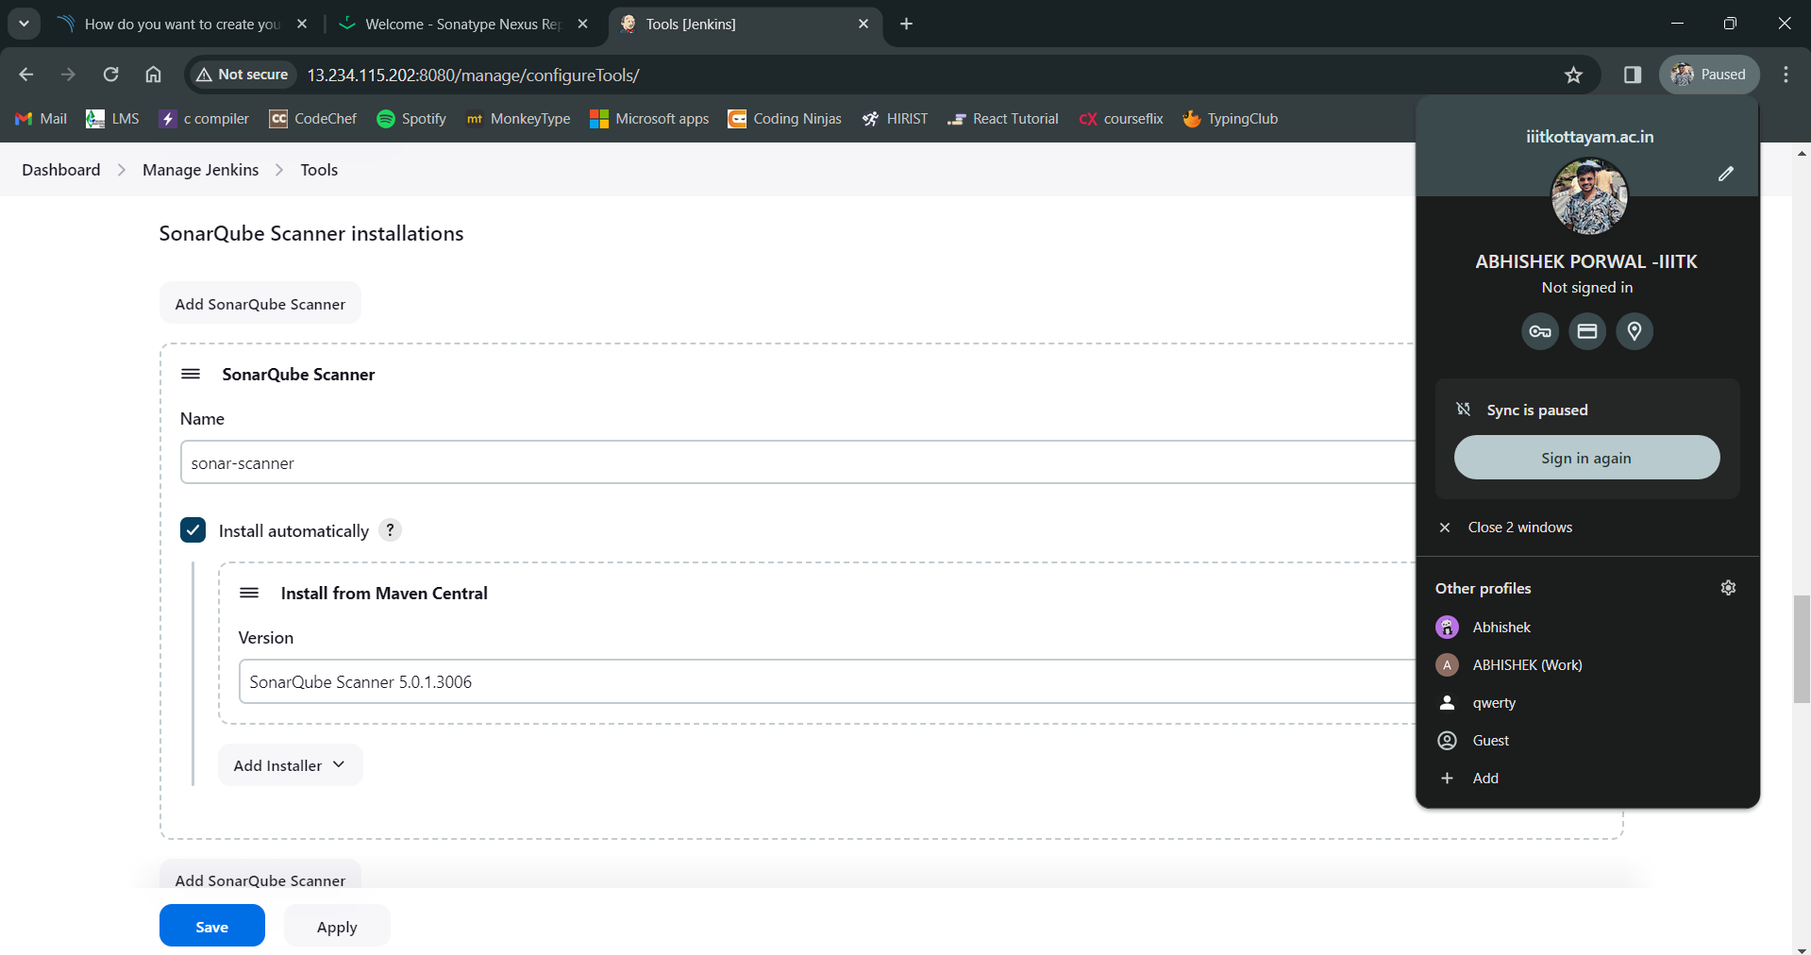

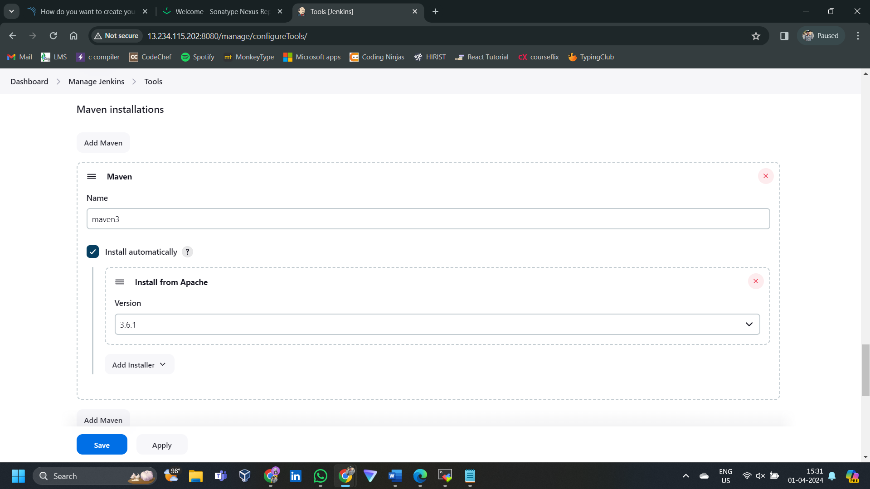

**Installing trivy on Jenkins server as the plugin is not there**

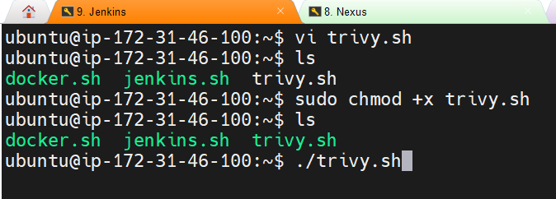

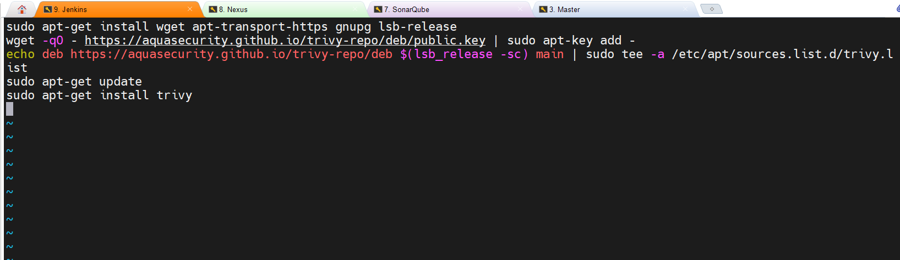

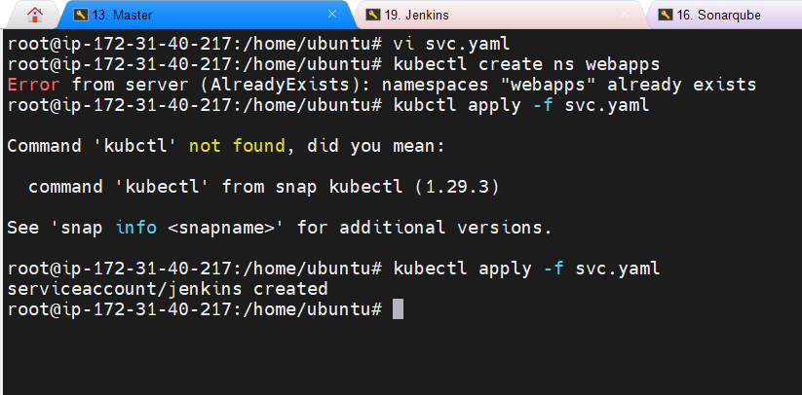

**Creating Pipieline**

**SonarQube Server:**

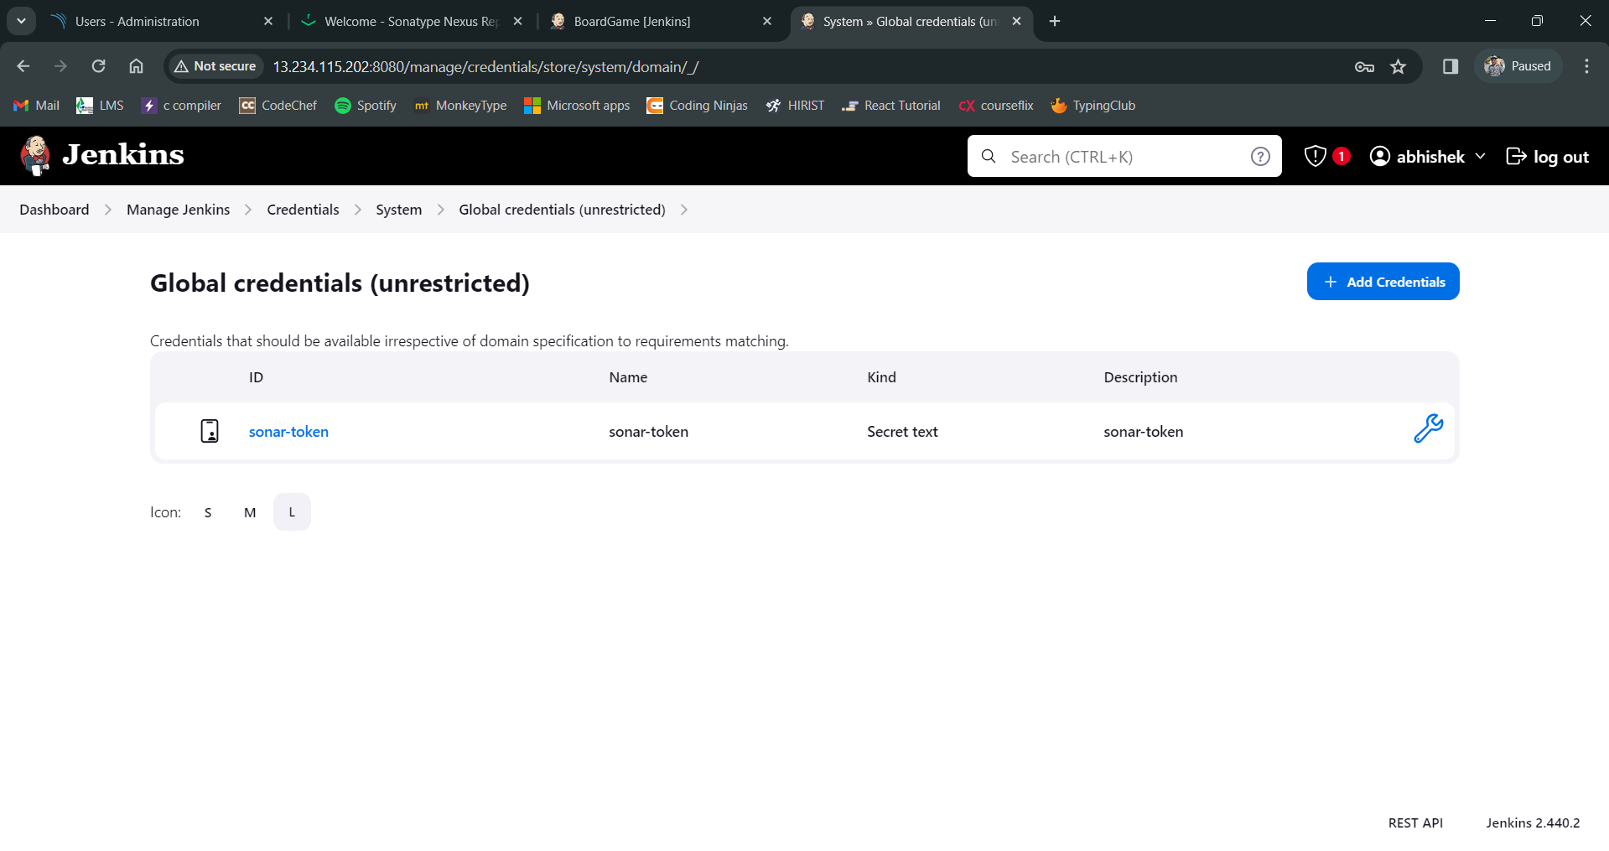

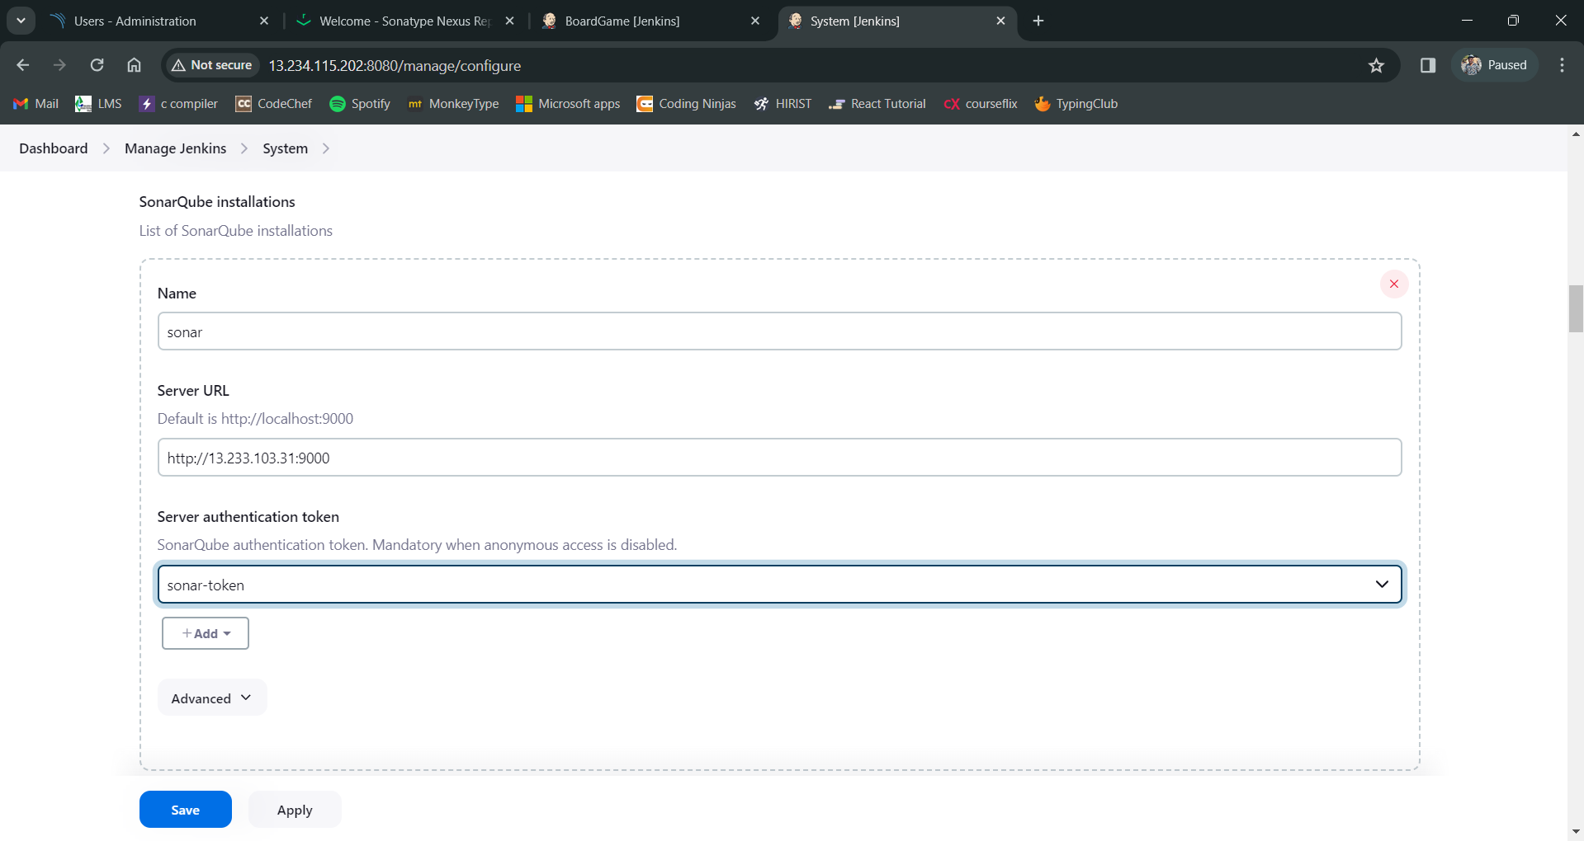

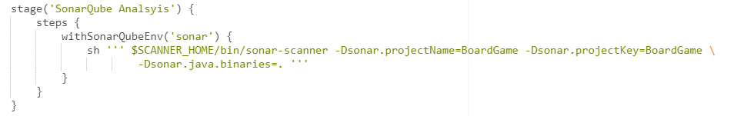

**Creating web hooks for quality gate Stage**

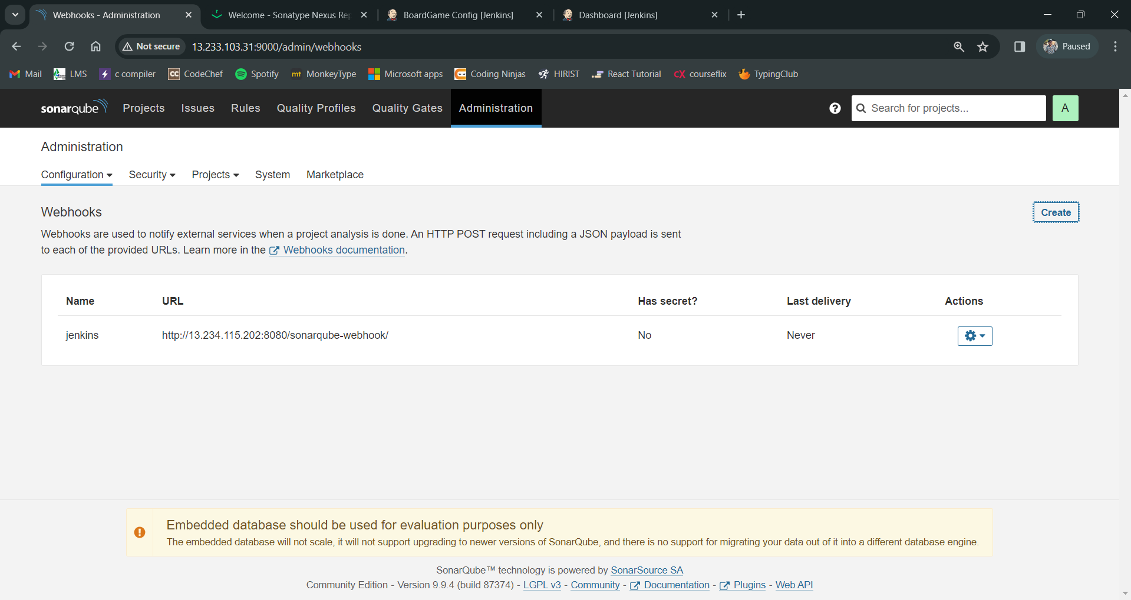

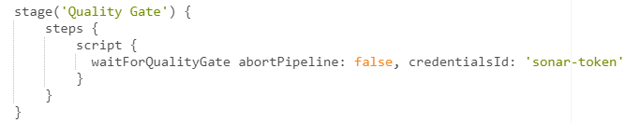

**Publich artifact to neaxas:**

Add the nexus repo urls in the pom.xml file in git repo.

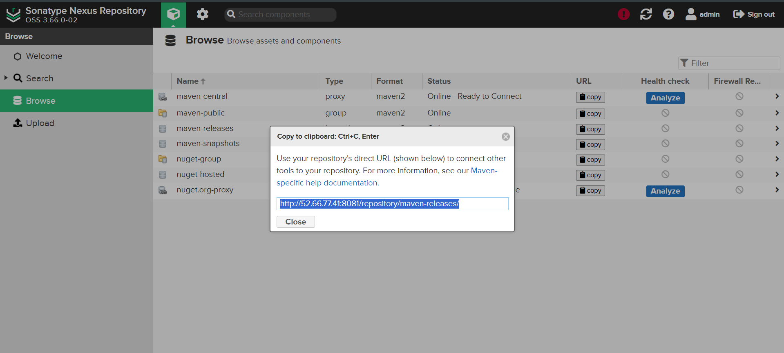

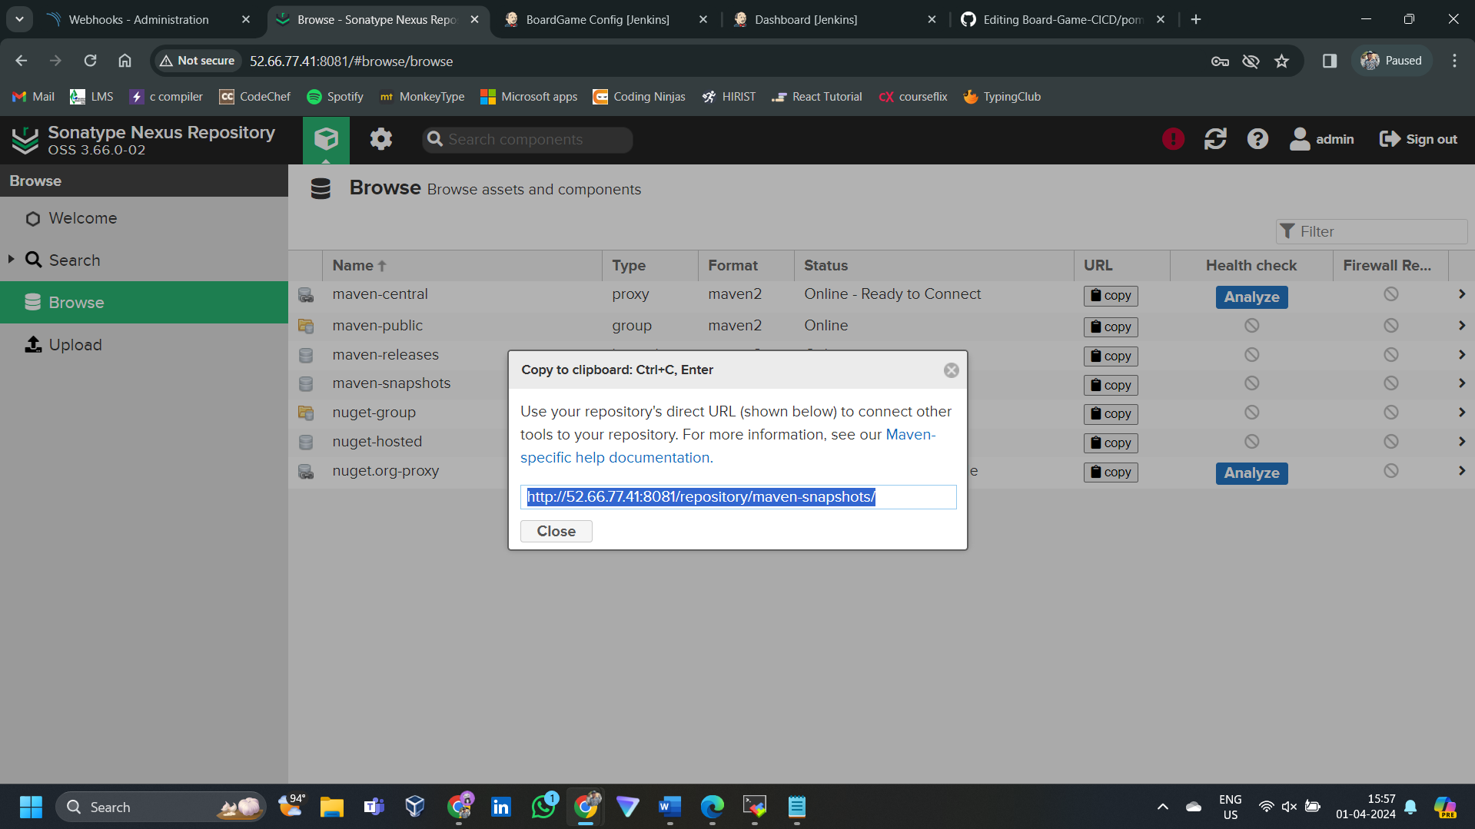

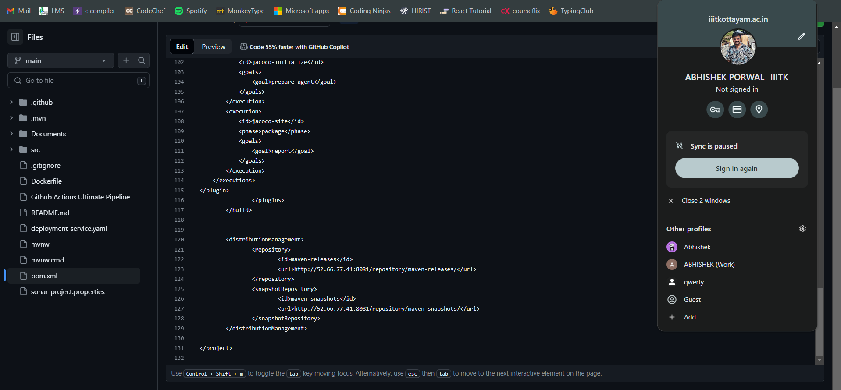

Add credential to Jenkins to access the repository.

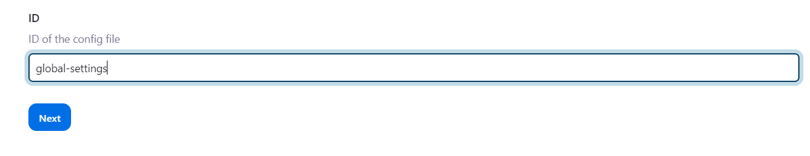

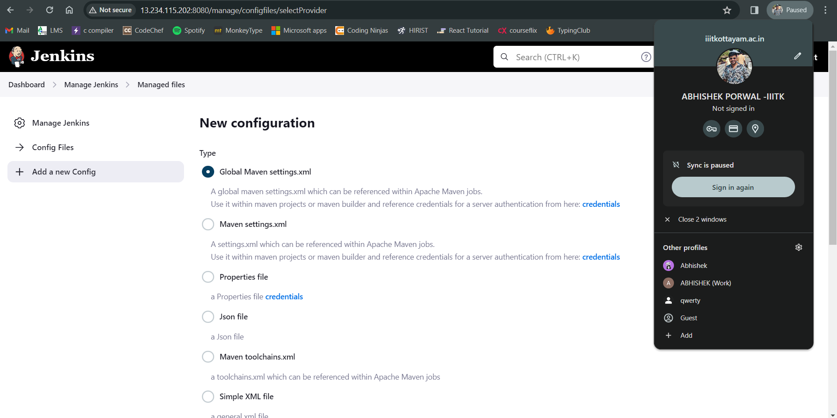

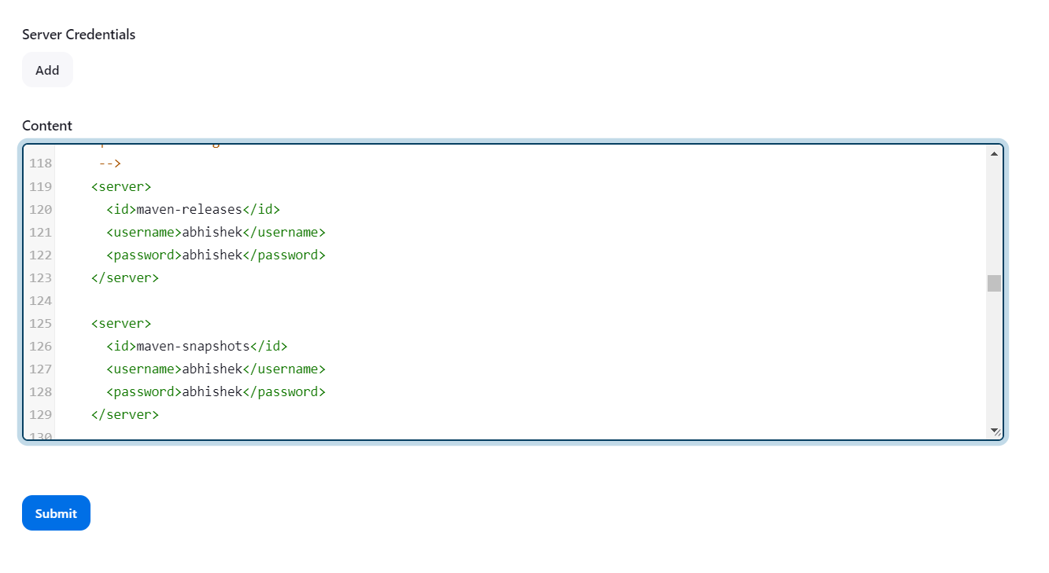

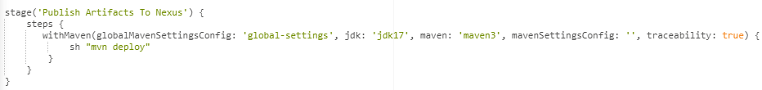

Build & Tag Docker Image:

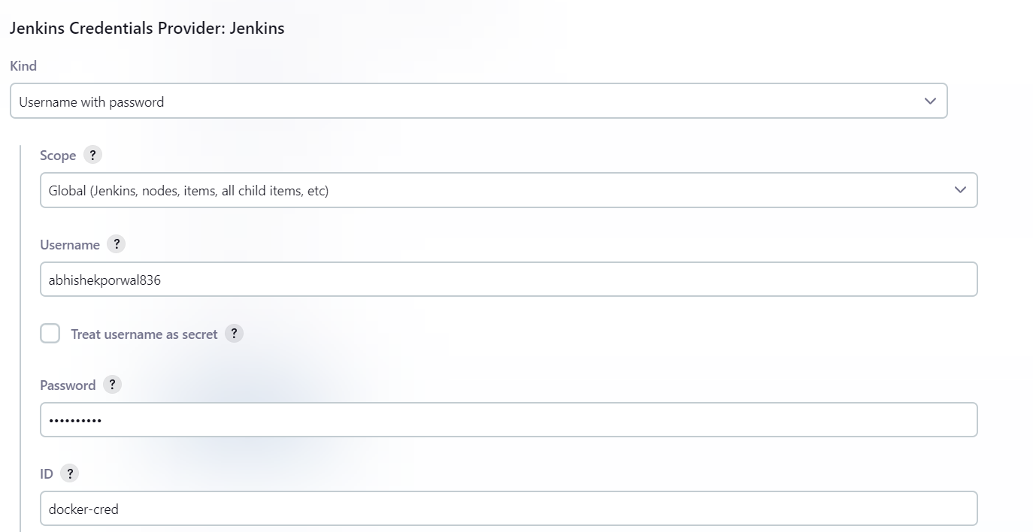

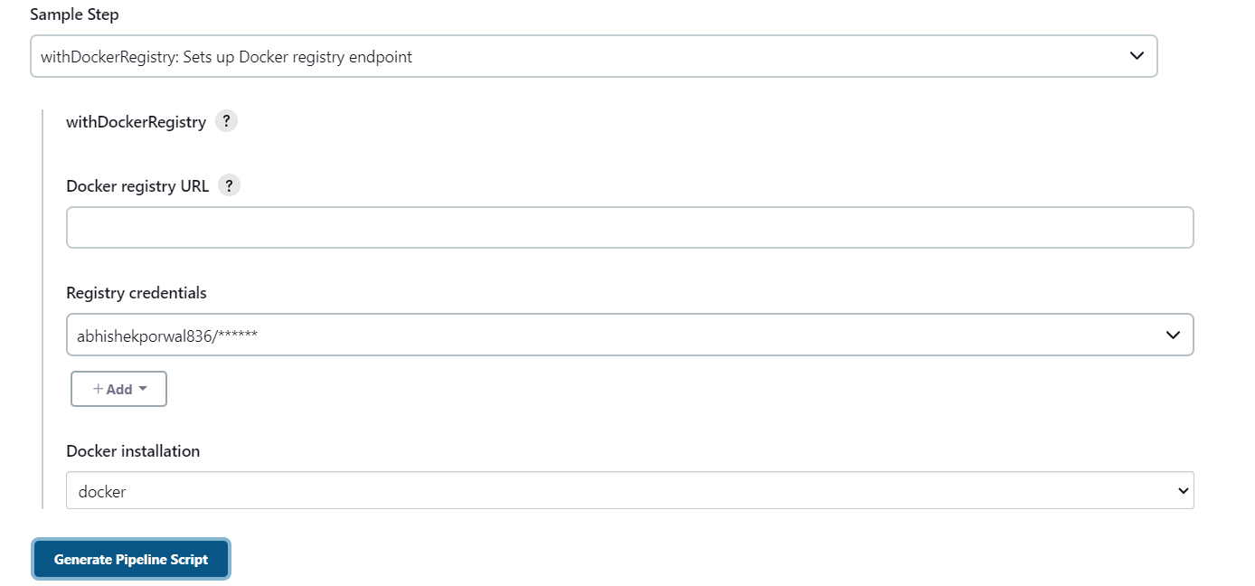

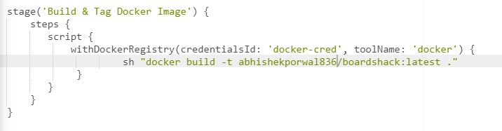

Docker image Scan using Trivy and then push it :

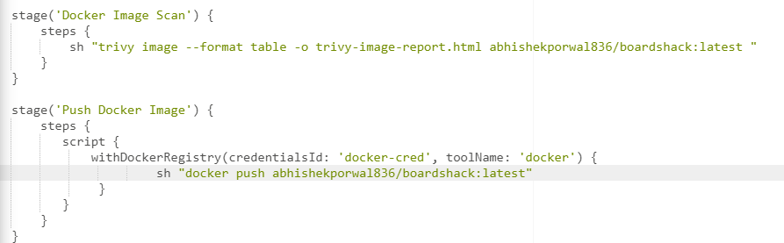

Role Based Access Control (RBAC) in Kubernetes

Master Node:

1. Create Service Account:

svc.yaml

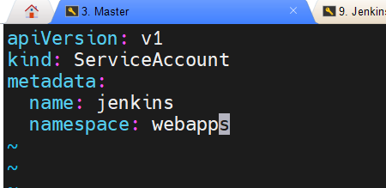

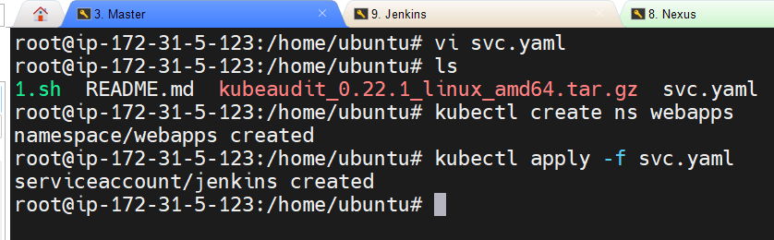

1. Create Role(role.yaml)

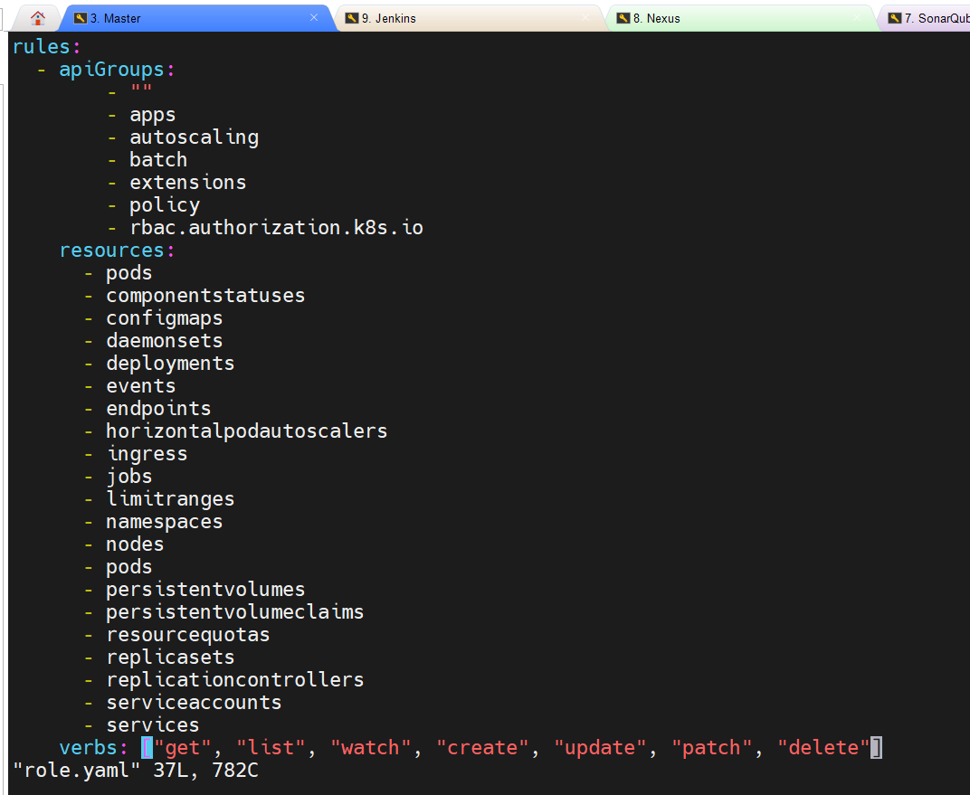

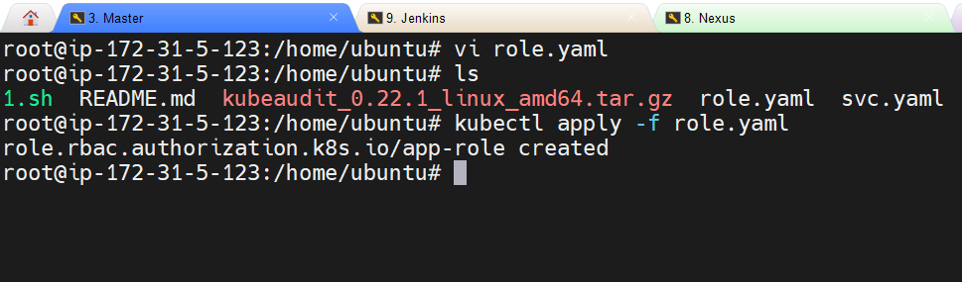

1. Assign the role to service account (bind.yaml)

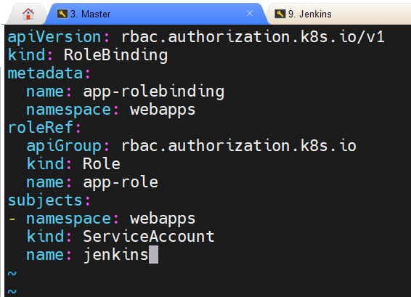

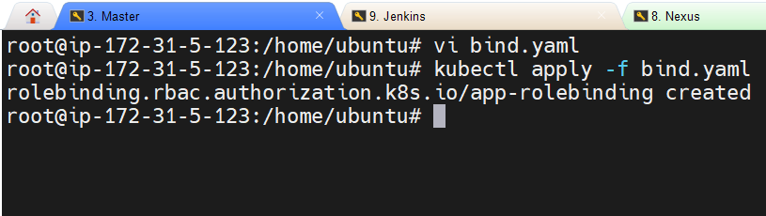

Now Jenkins user is having the permission to perform deployments and other tasks related to Kubernetes

Create a token for authentication:

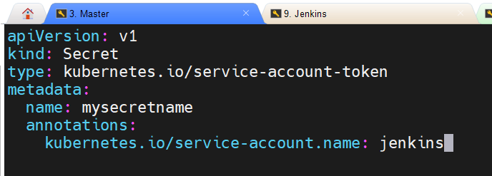

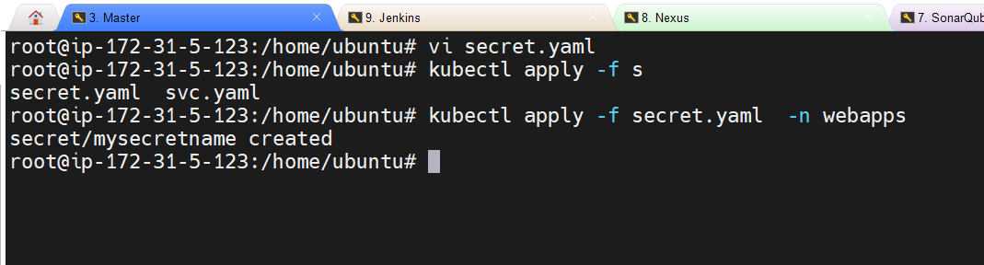

Got the token by command:

kubectl describe secret mysecretname -n webapps

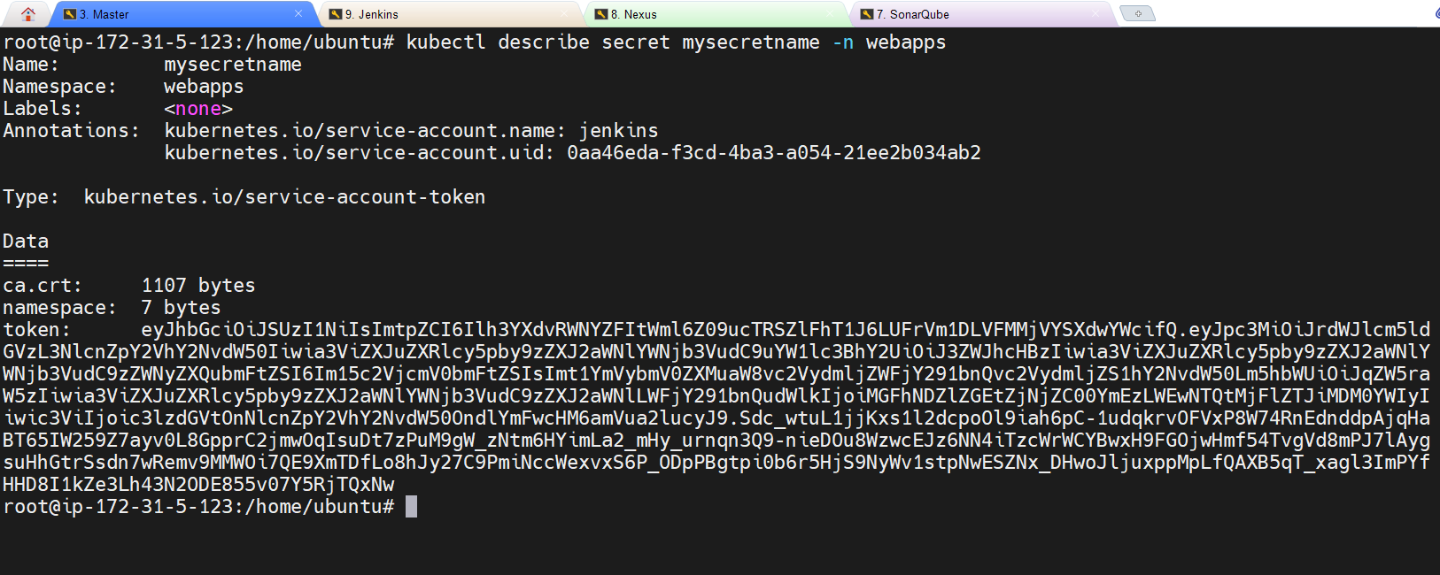

Adding the credentials to Jenkins:

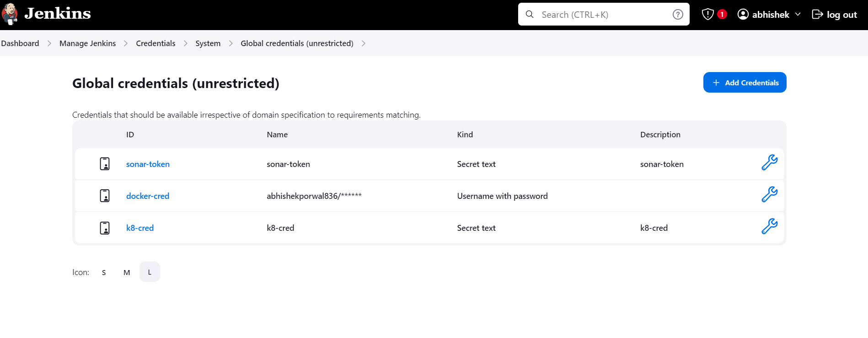

Accesss Details of our cluster by running on master node:

cd ~/.kube -> ls-> cat the file

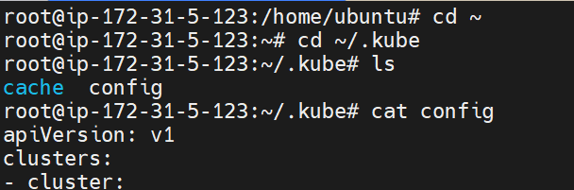

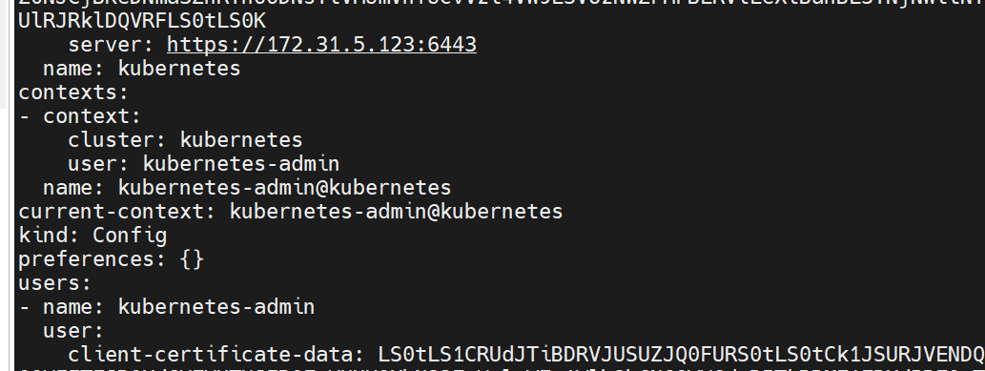

stage('Deploy To Kubernetes') {

steps {

withKubeConfig(caCertificate: '', clusterName: 'kubernetes', contextName: '', credentialsId: 'k8-cred', namespace: 'webapps', restrictKubeConfigAccess: false, serverUrl: 'https://172.31.5.123:6443') {

sh "kubectl apply -f deployment-service.yaml"

}

}

}



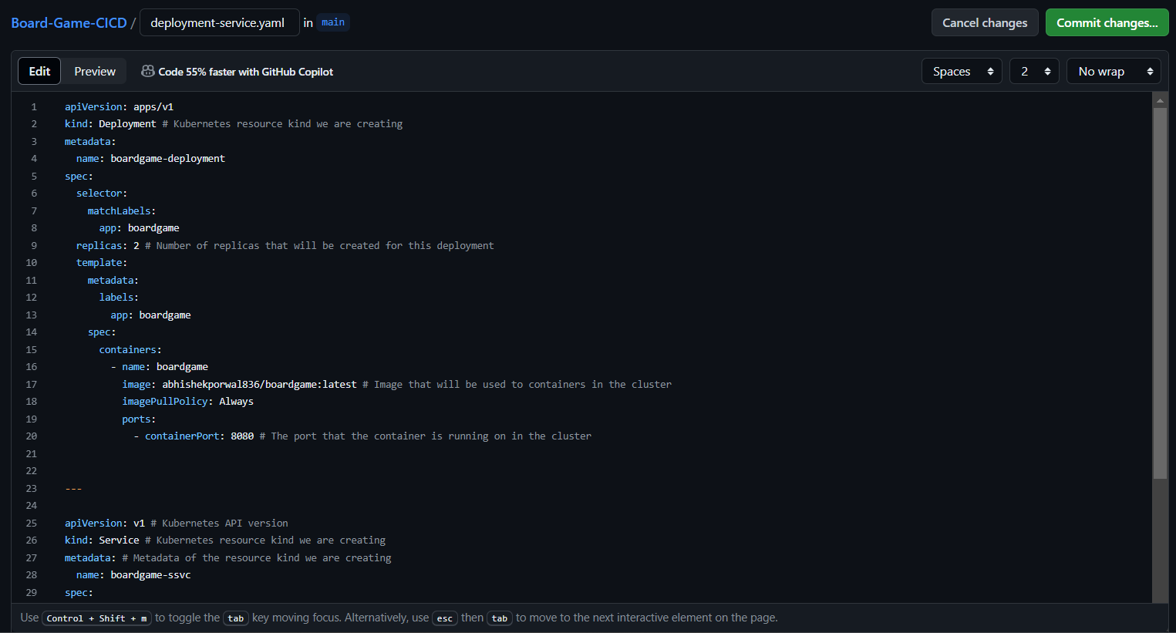

Install kubectl on Jenkins:

curl -o kubectl https://amazon-eks.s3.us-west-2.amazonaws.com/1.19.6/2021-01-05/bin/linux/amd64/kubectl

chmod +x ./kubectl

sudo mv ./kubectl /usr/local/bin

kubectl version --short –client

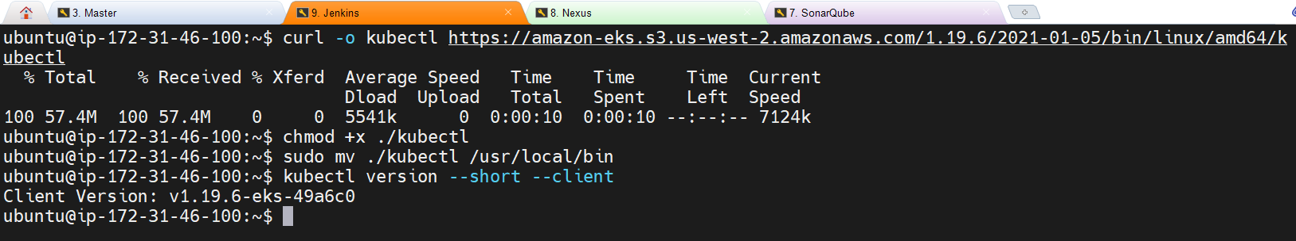

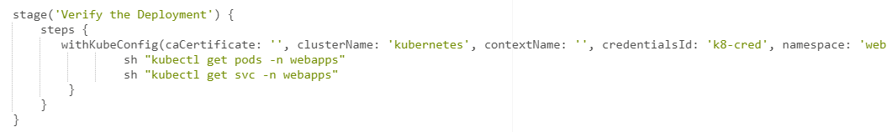

**Configuring the Mail Notification:**

Enable 2 step verification on your google account

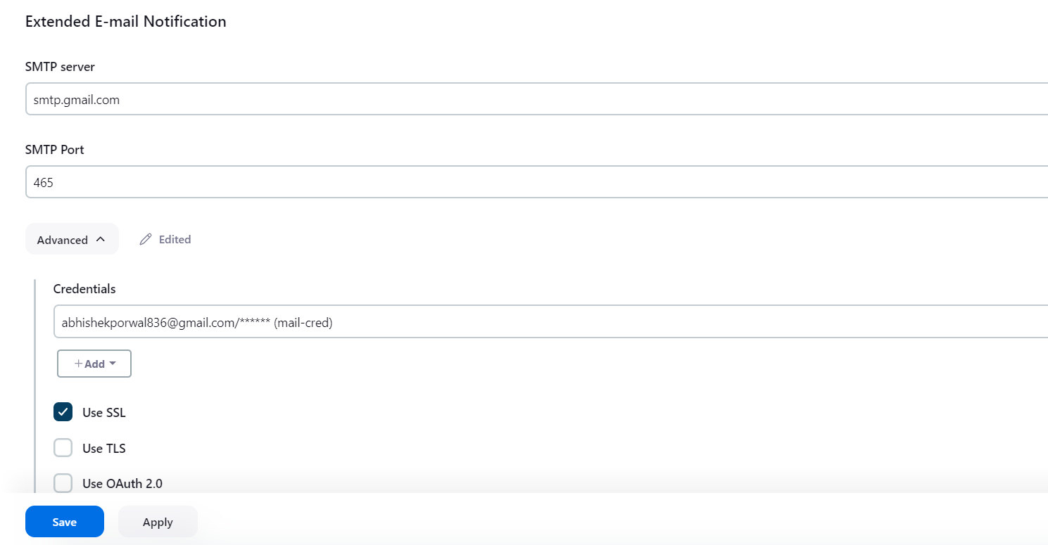

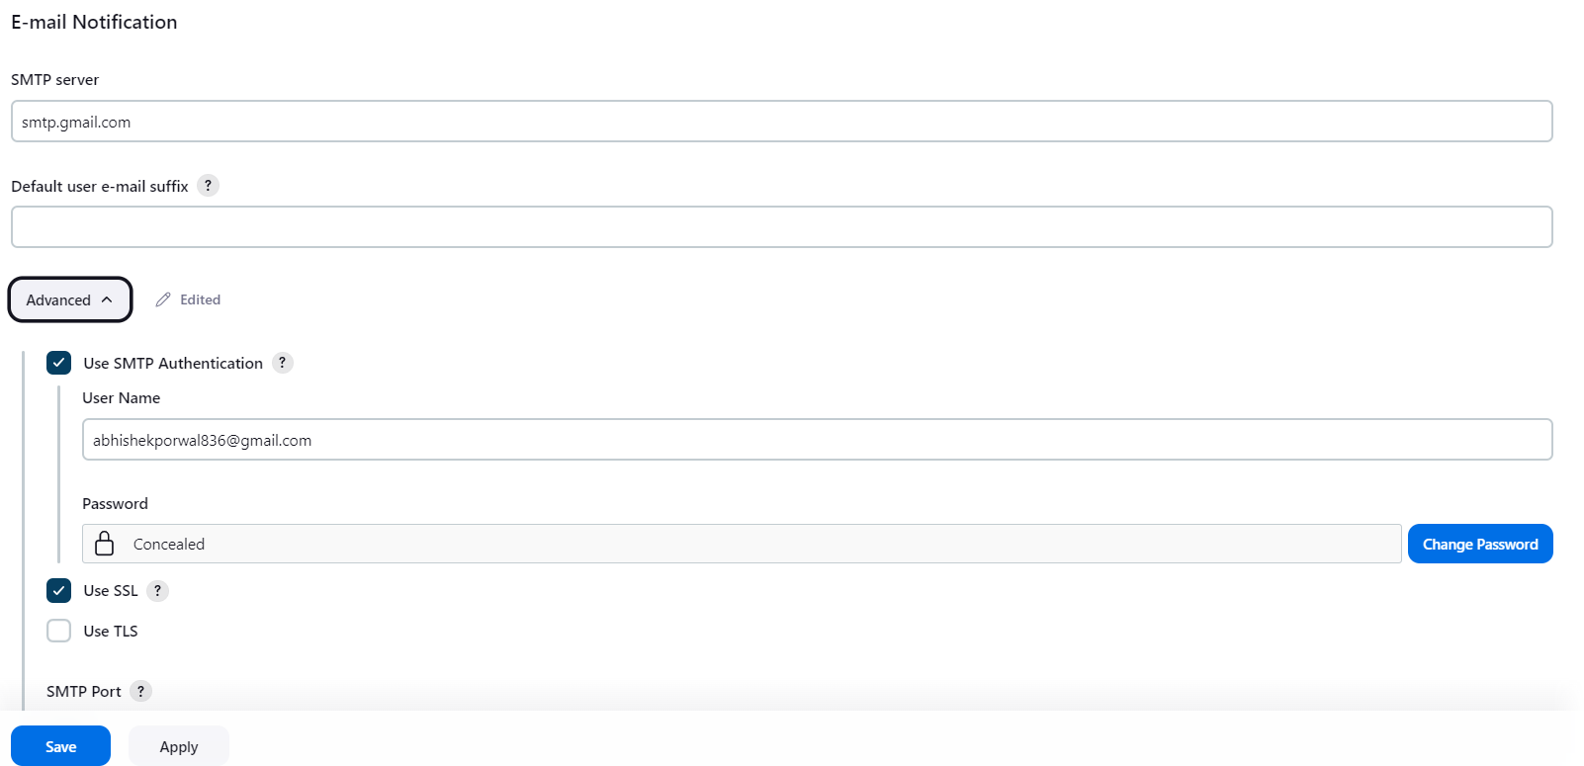

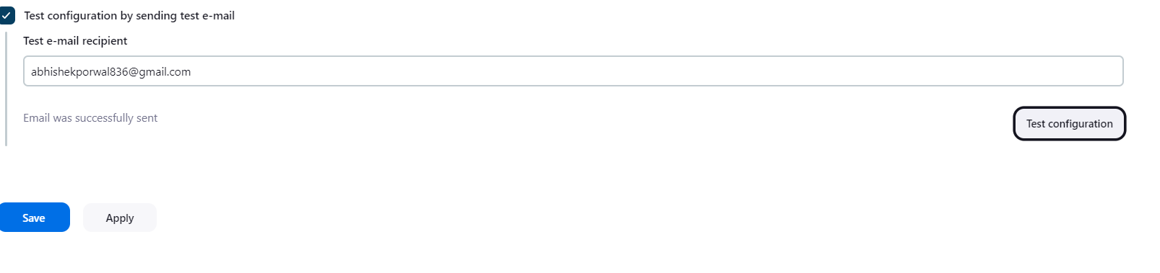

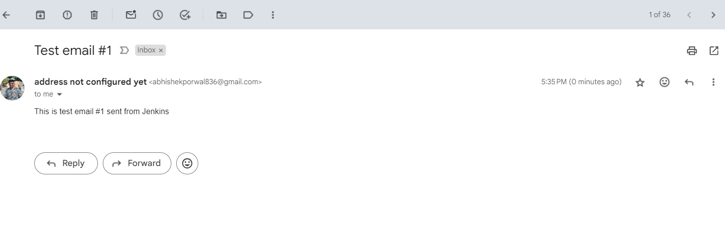

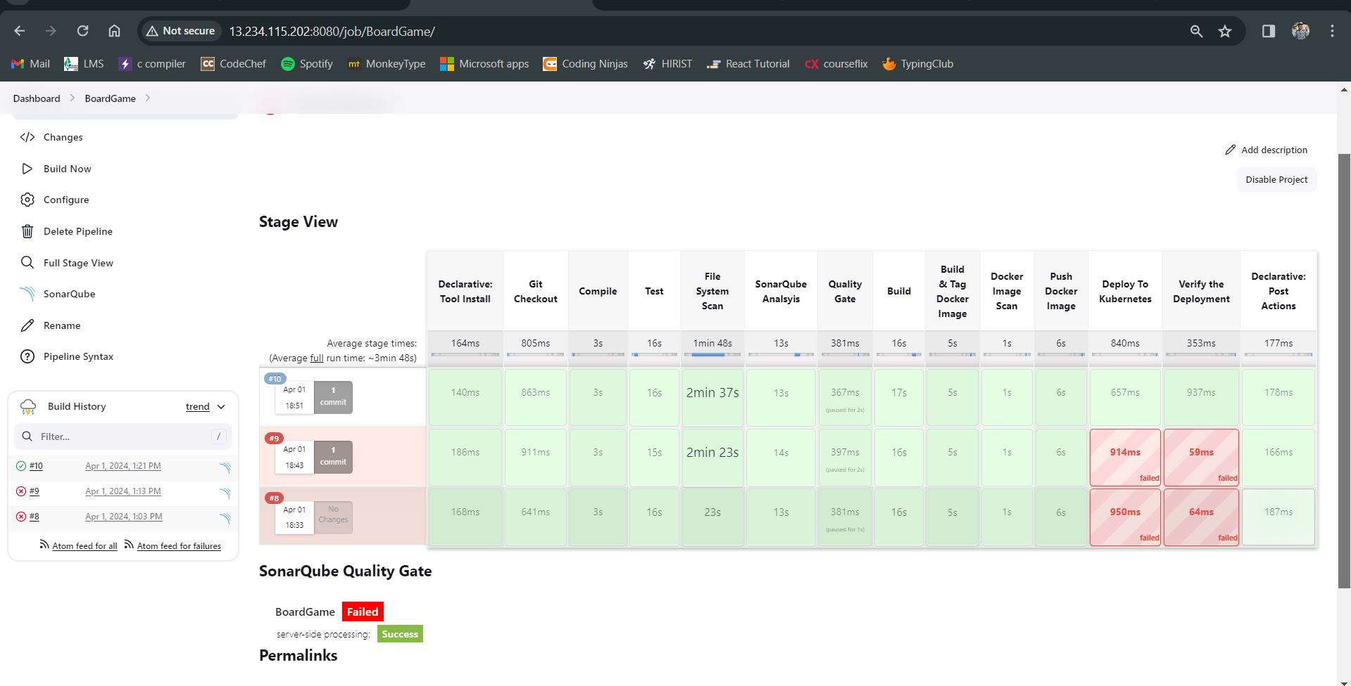

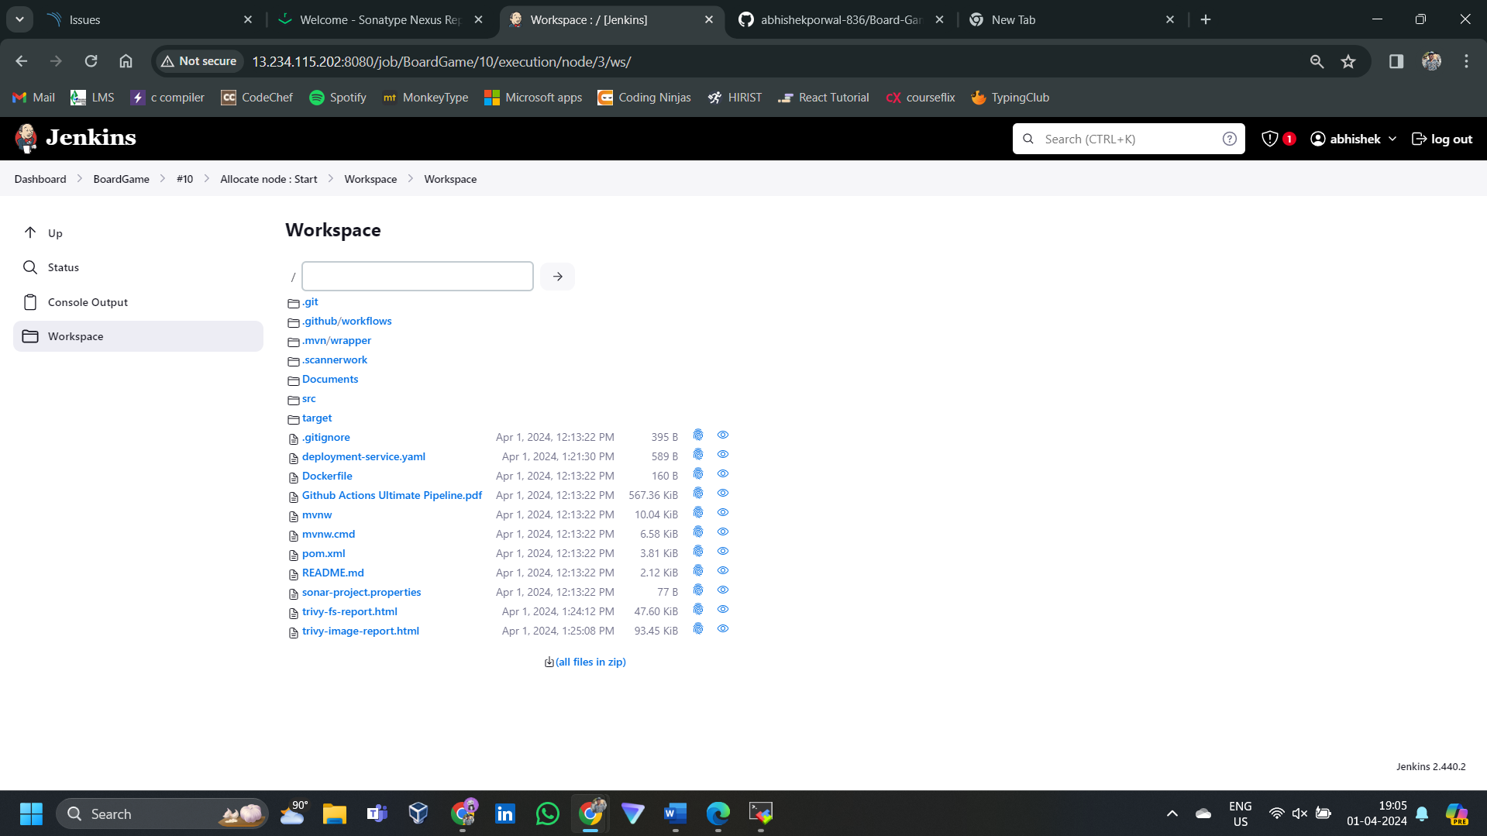

Access the aopplication

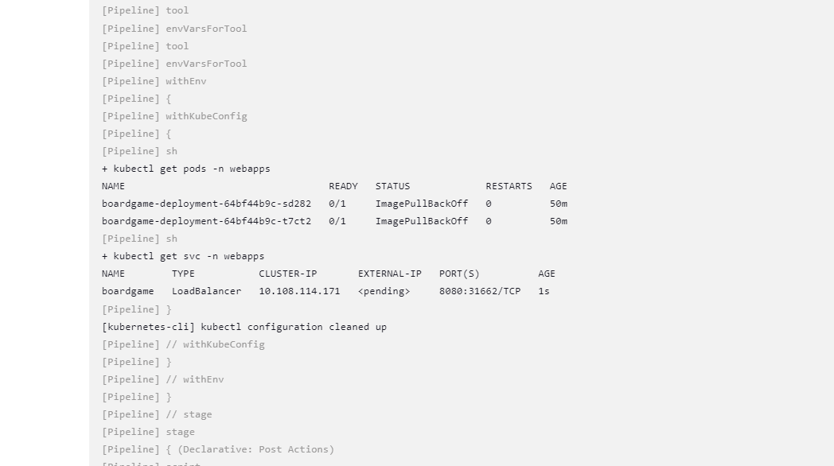

Success

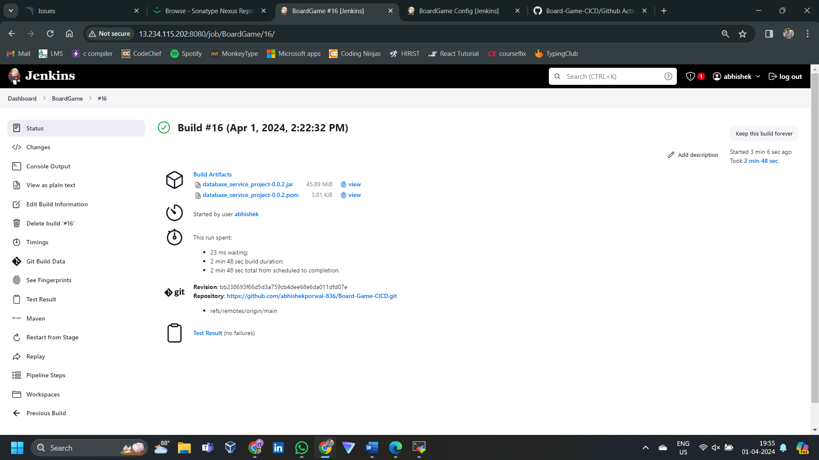

Unable to access the application

**Monitoring tools:**

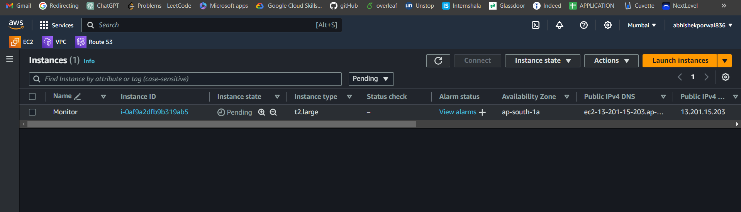

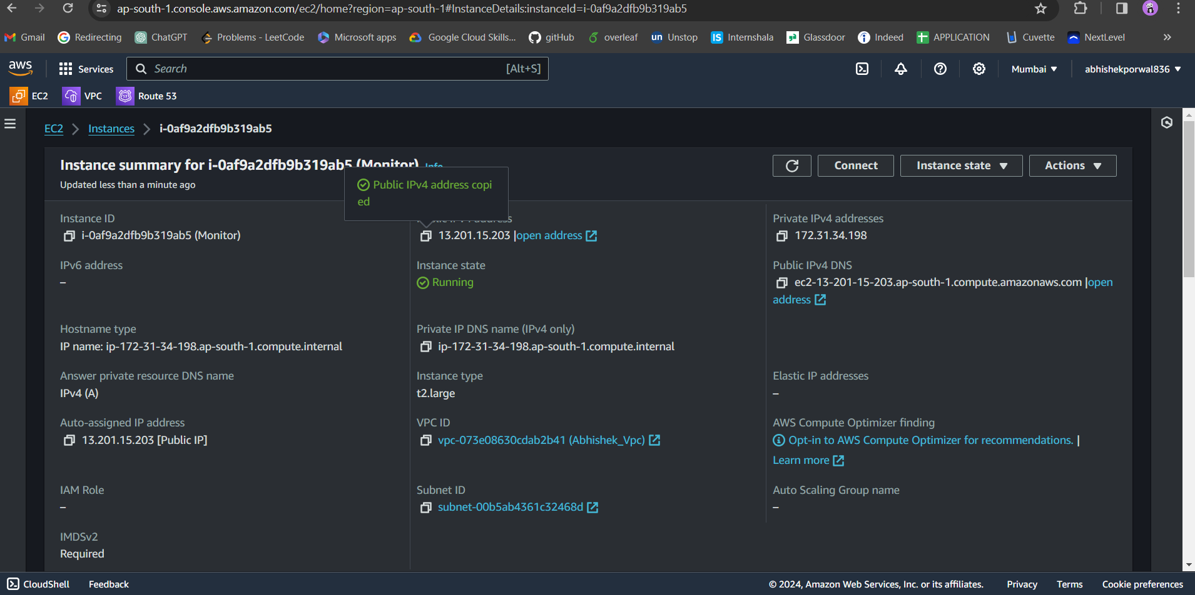

Prometheus

Wget <https://github.com/prometheus/prometheus/releases/download/v2.51.1/prometheus-2.51.1.linux-amd64.tar.gz>

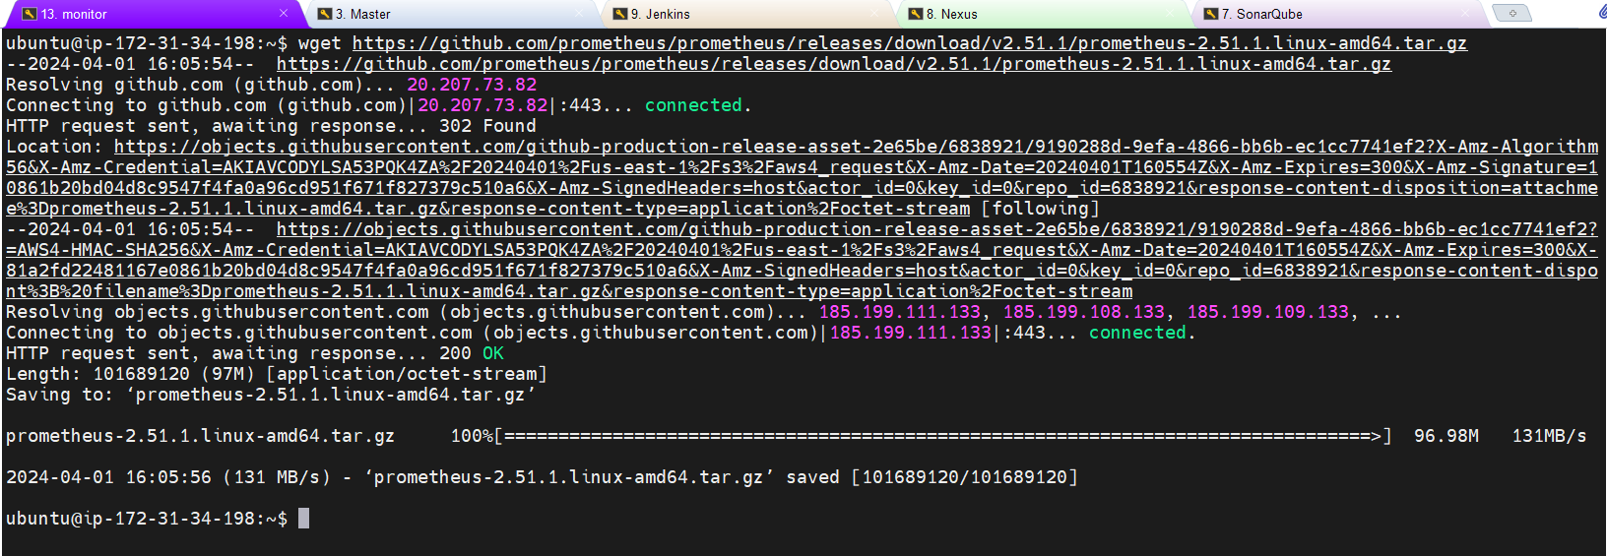

Extracting the file

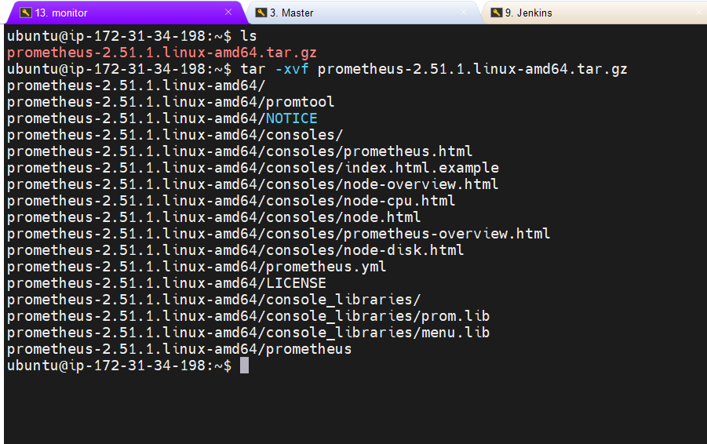

Execution protheus file by accessing the folders

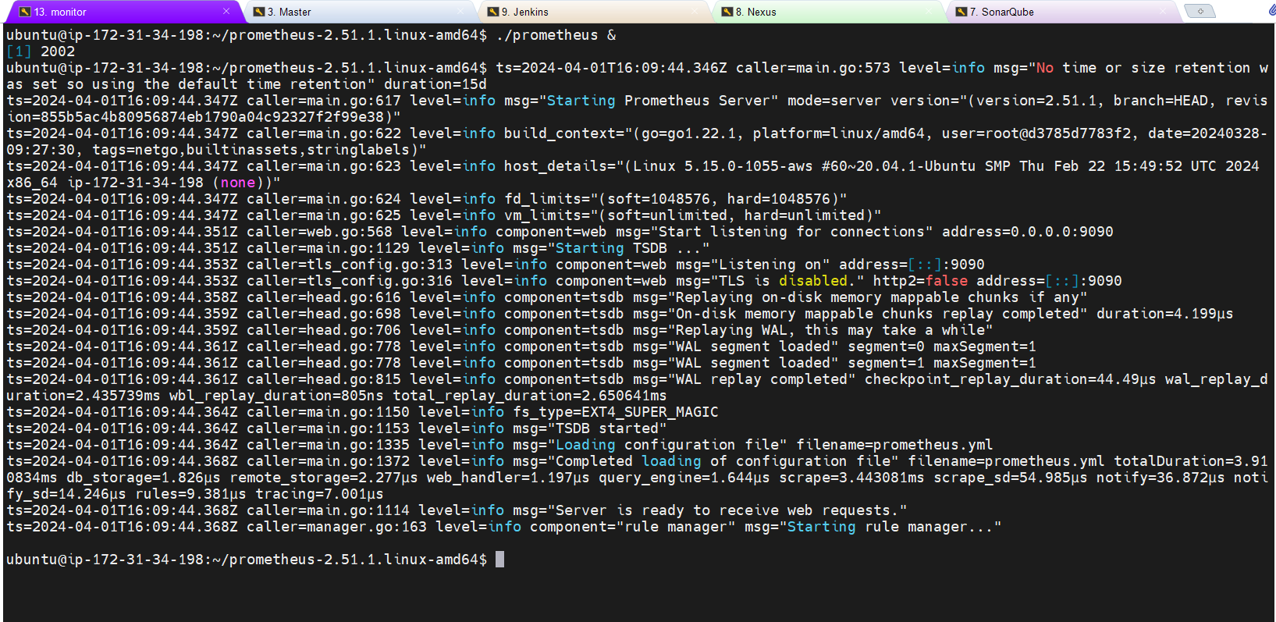

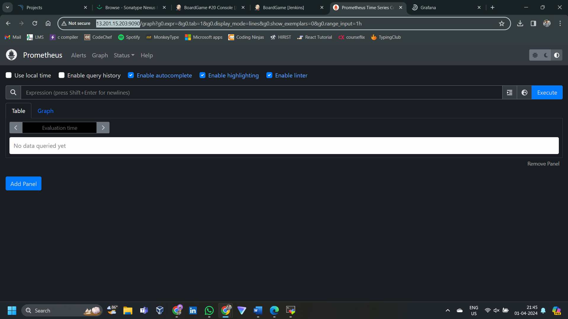

Grafana

sudo apt-get install -y adduser libfontconfig1 musl  
wget <https://dl.grafana.com/enterprise/release/grafana-enterprise_10.4.1_amd64.deb>  
sudo dpkg -i grafana-enterprise_10.4.1_amd64.deb

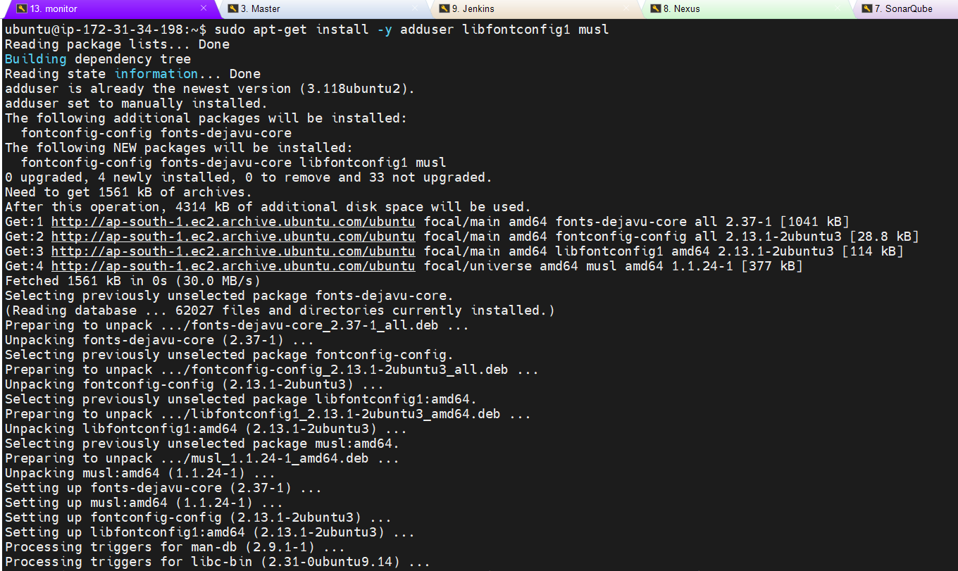

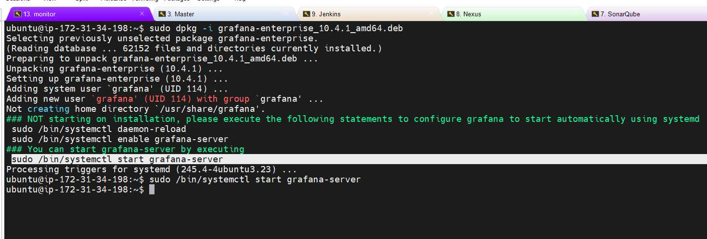

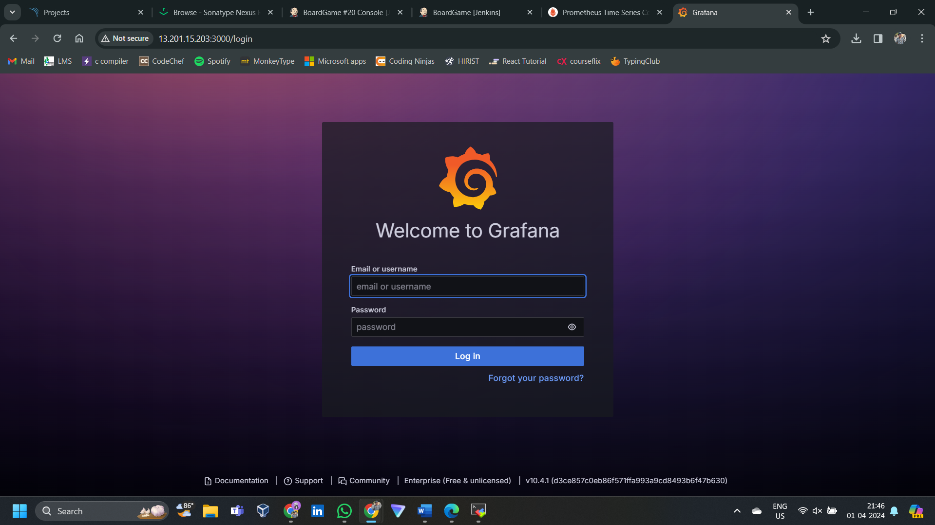

Blackbox-exporter: get the link on Prometheus webpage only

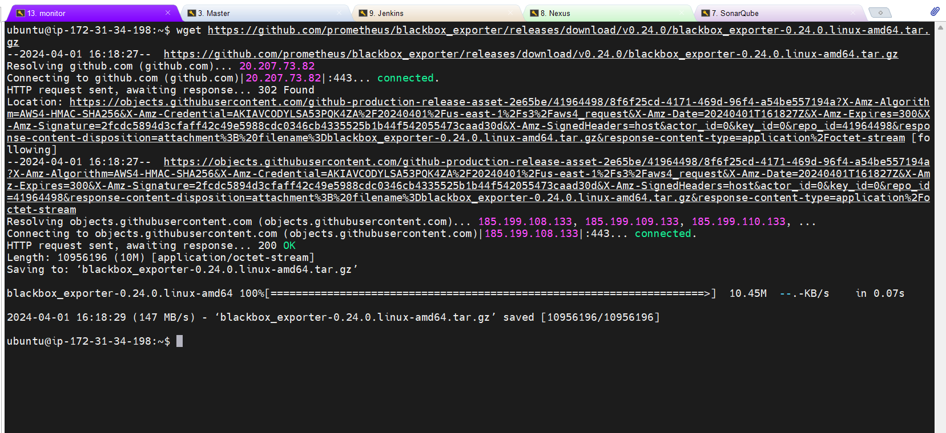

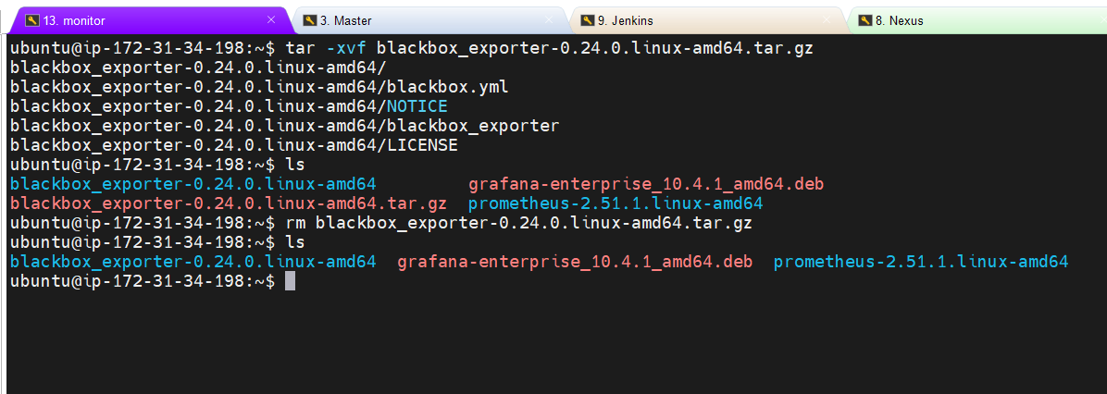

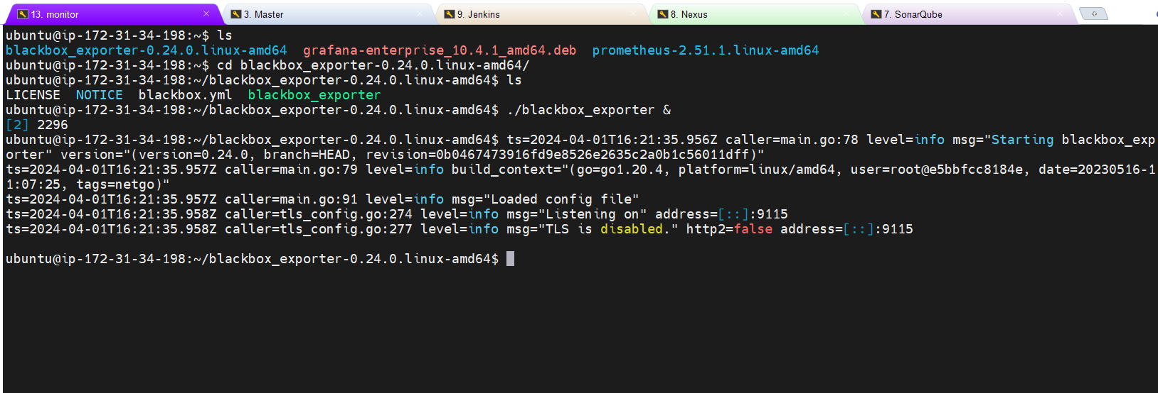

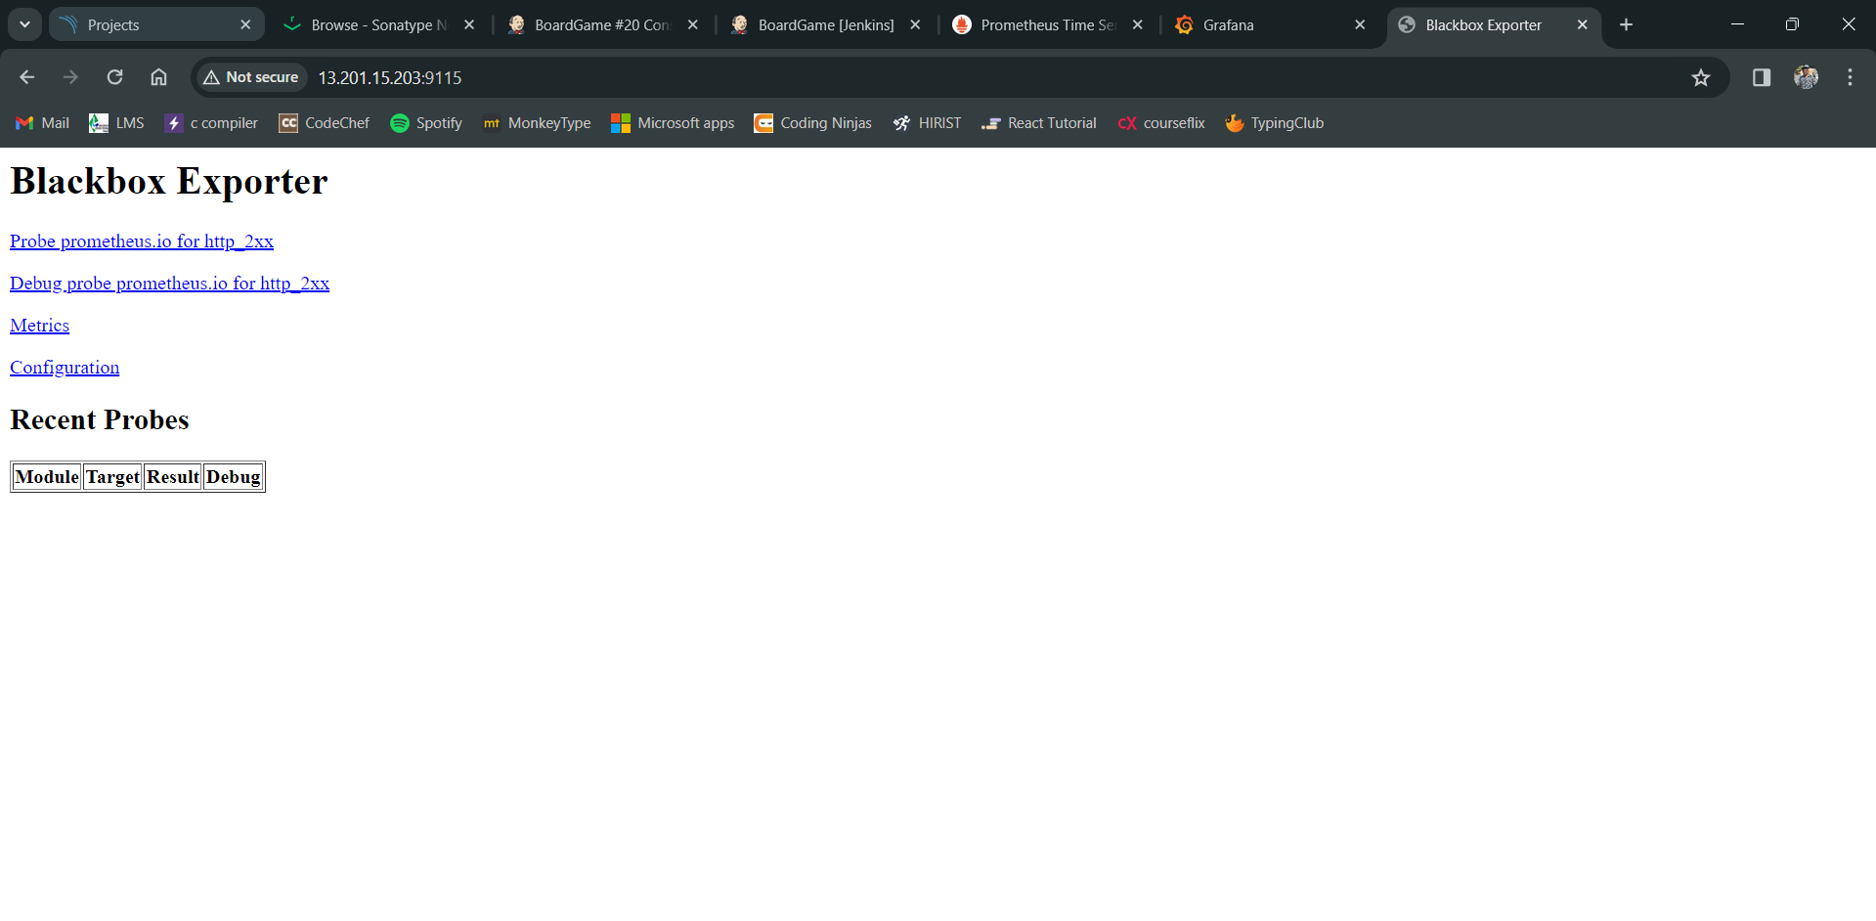

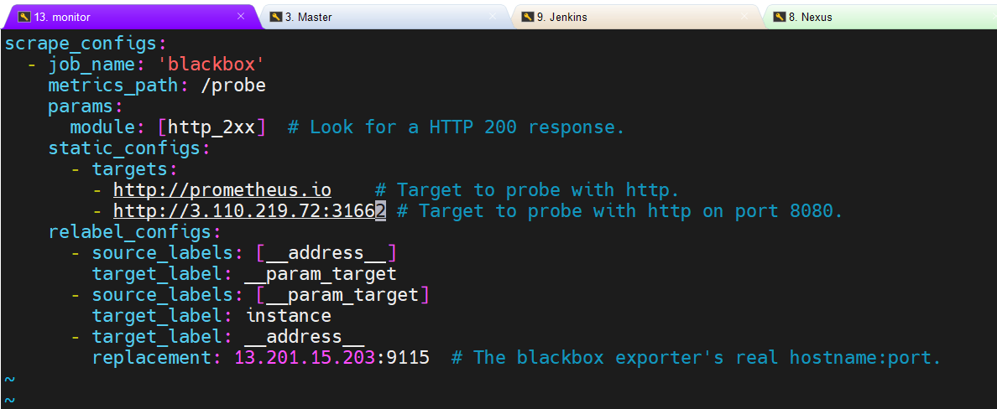

Restart Prometheus:

pgrep Prometheus

kill _____

./prometheus

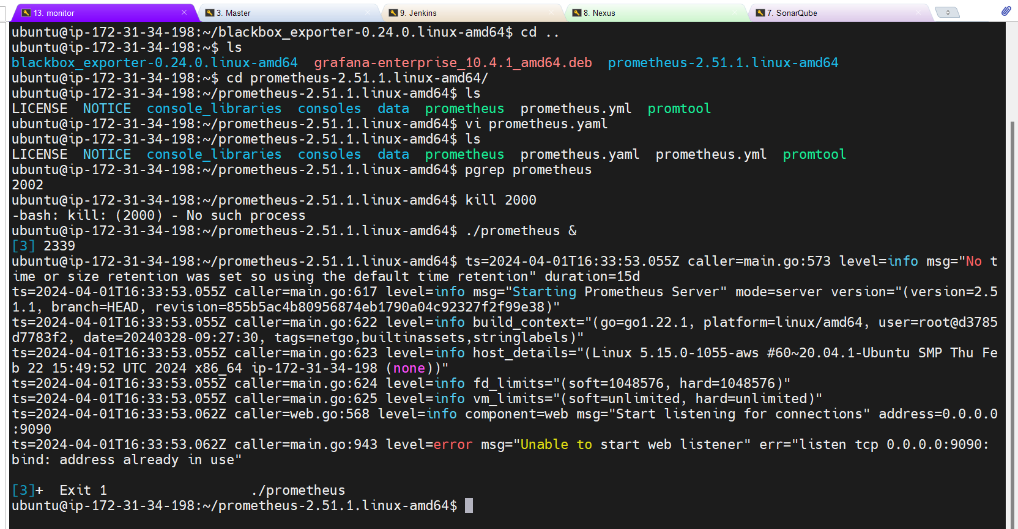

Adding Prometheus as data nsource to Grafana:

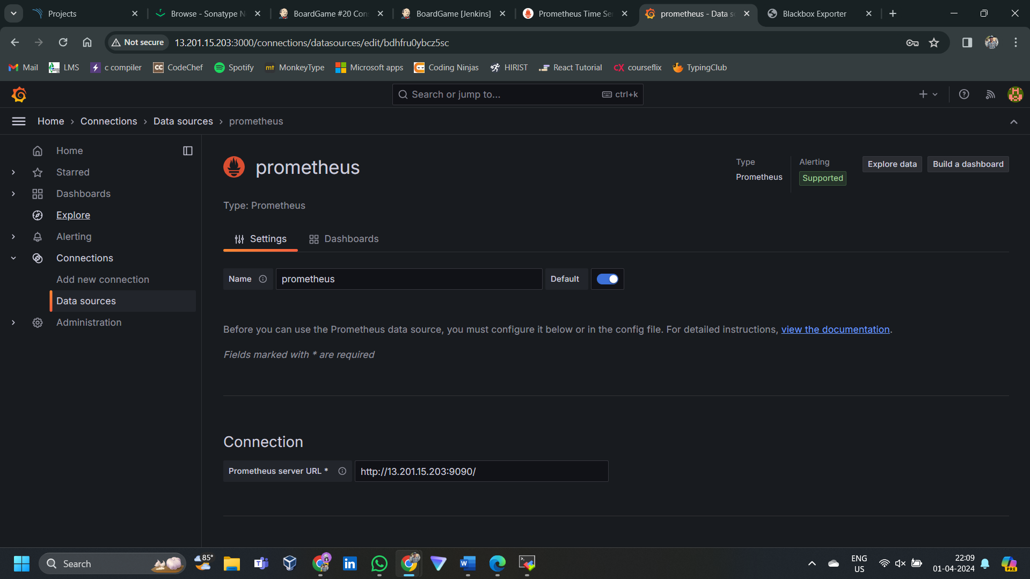

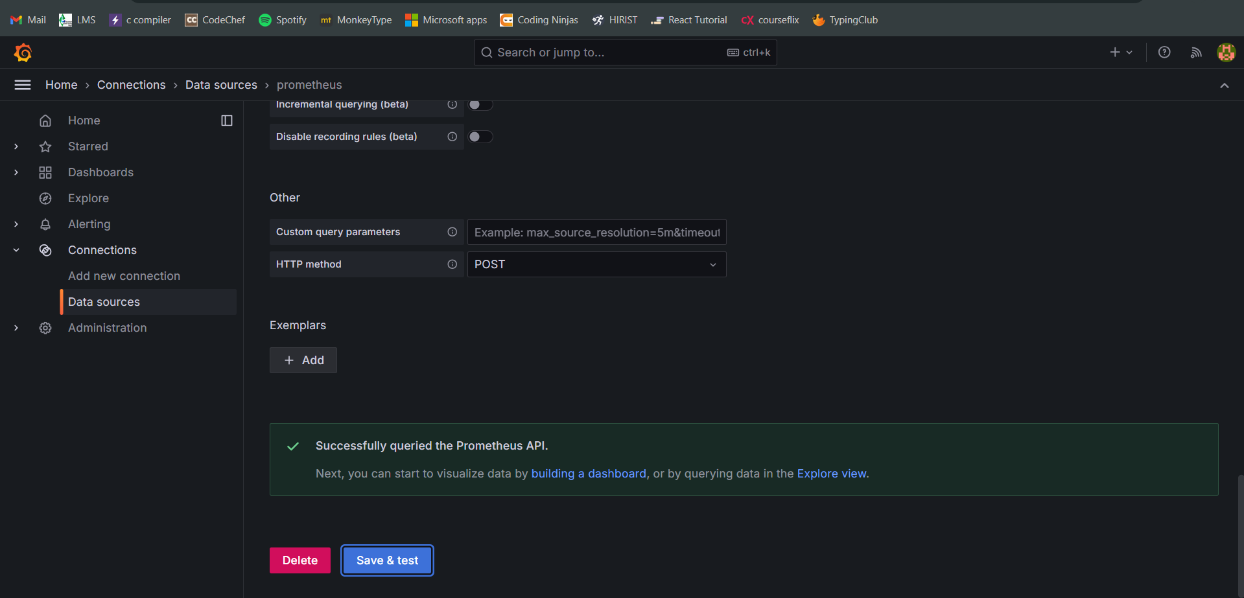

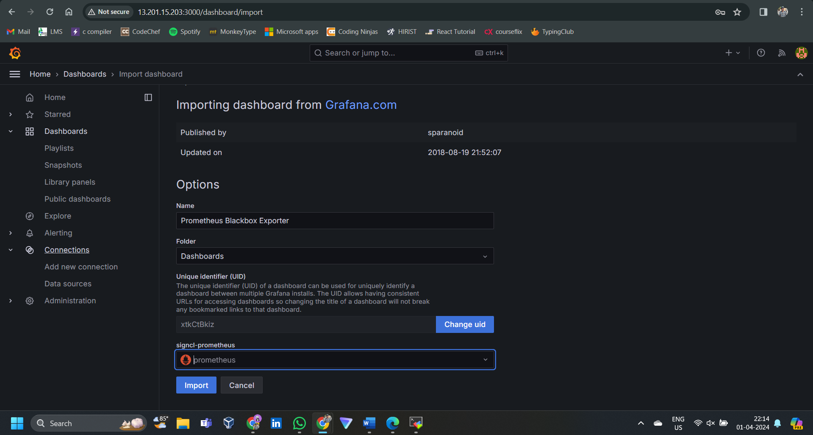

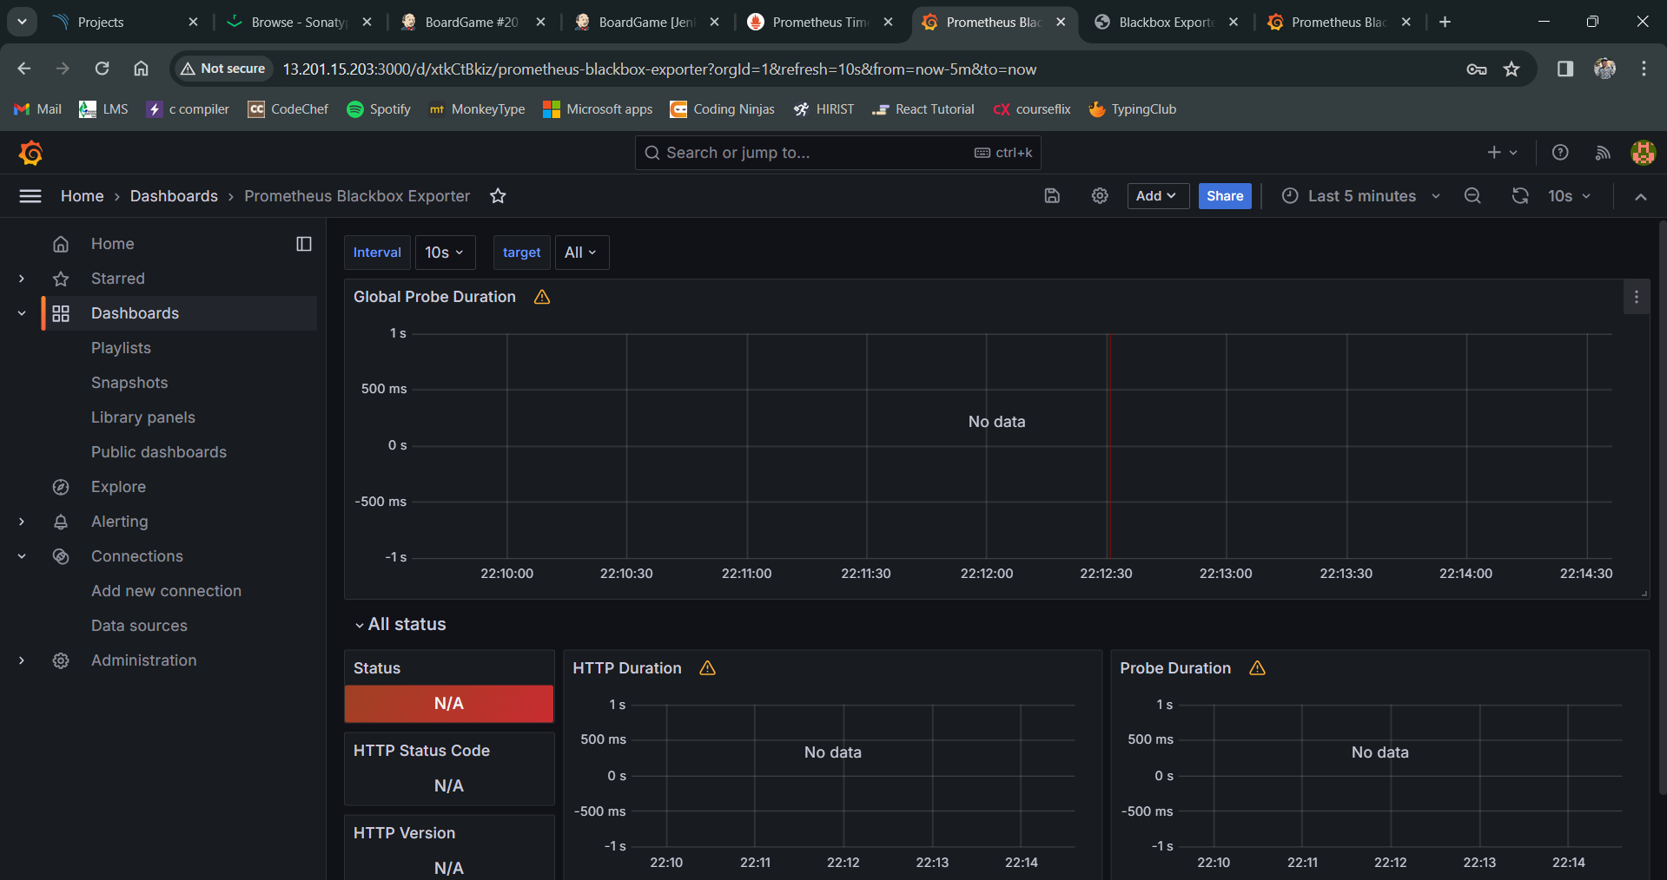

Monitor Jenkins:

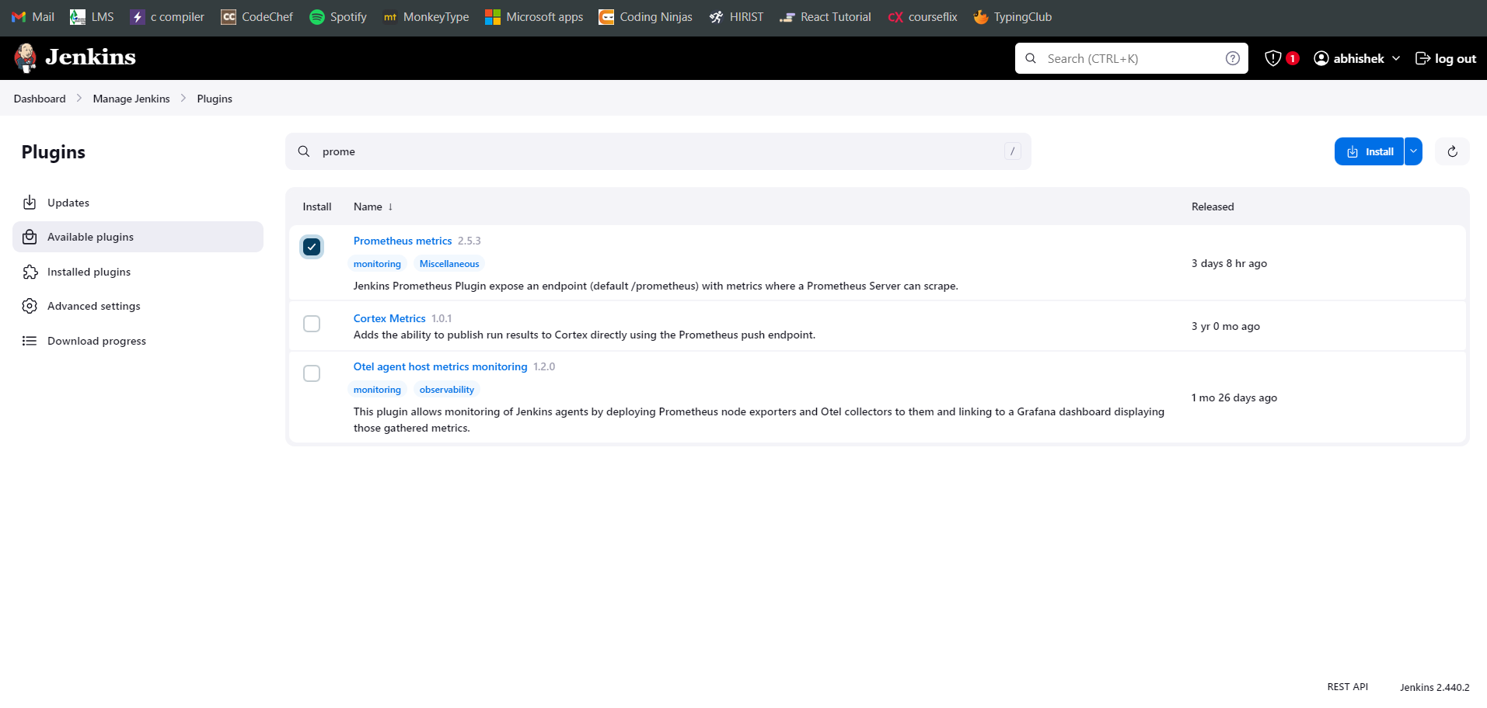

Download the Node Exporter:

